Lec 4 Spyder Test
No amp
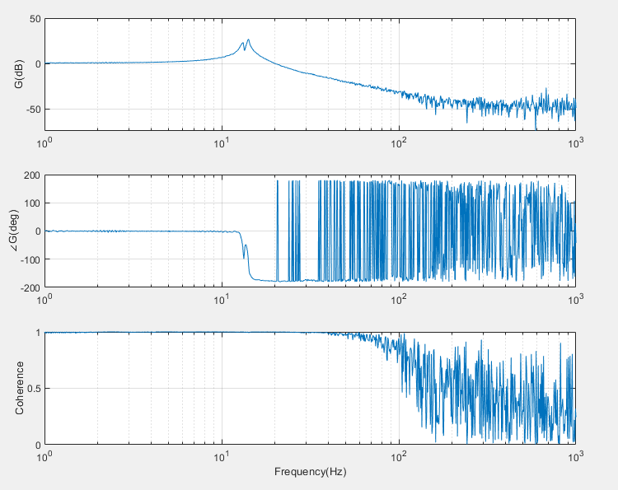
No amp
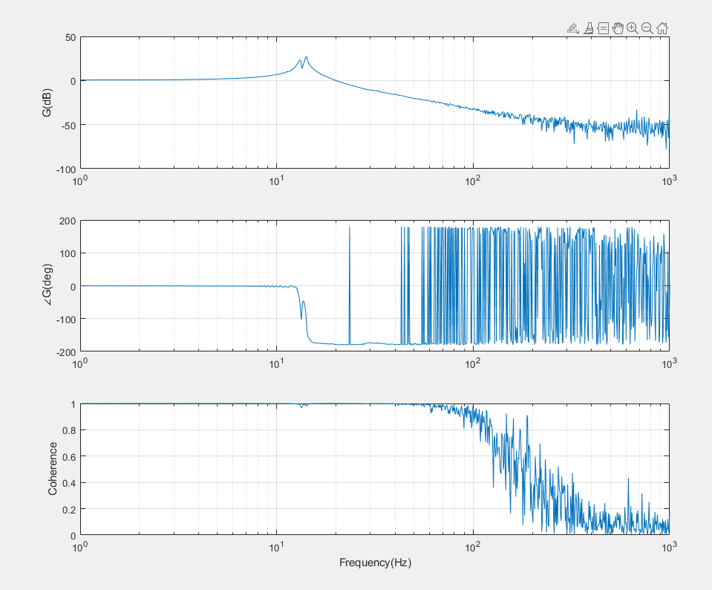
1e3 supposeldy
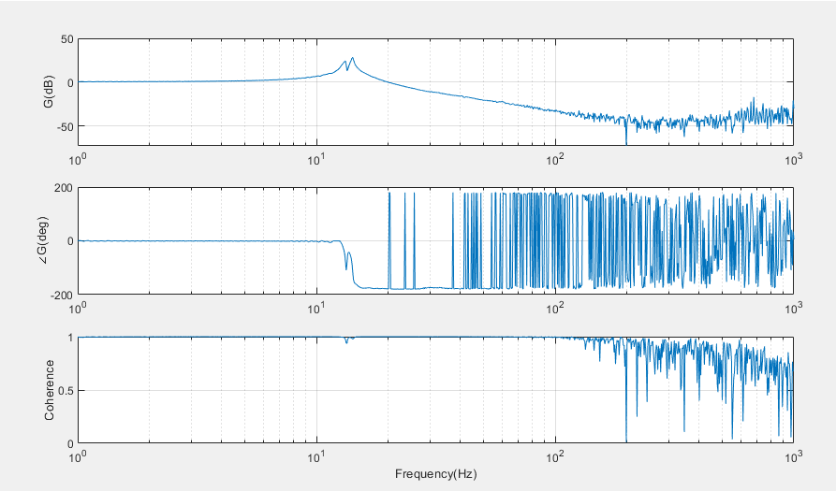

% ----- Parameters -----
amp_min = 1; % amplitude at start of ramp
amp_max = 1e2; % amplitude at end of ramp
ramp_start_frac = 0.3; % fraction of vector where ramp starts (30%)
% ----------------------

N = length(in);

% Define ramp start and end indices
start_idx = floor(ramp_start_frac * N); % start of ramp
end_idx = N; % end of ramp

% Initialize amplitude vector
amp = ones(N,1) * amp_min; % default amplitude = amp_min

% Logarithmic ramp
ramp_len = end_idx - start_idx + 1;
ramp_idx = 0:(ramp_len-1); % indices for ramp
amp_ramp = 10.^( log10(amp_min) + (log10(amp_max)-log10(amp_min)) * (ramp_idx/(ramp_len-1)) );

% Apply ramp
amp(start_idx:end_idx) = amp_ramp;

% Scale input
in_scaled = in .* amp;

% Optional: plot amplitude envelope
figure;
plot(amp);
xlabel('Sample index'); ylabel('Amplitude multiplier');
title('Logarithmic Amplitude Ramp');
grid on;

Chirp

tmax = 1s, ts = 30e6 =

1 Hz to 10 kHz (10e4)
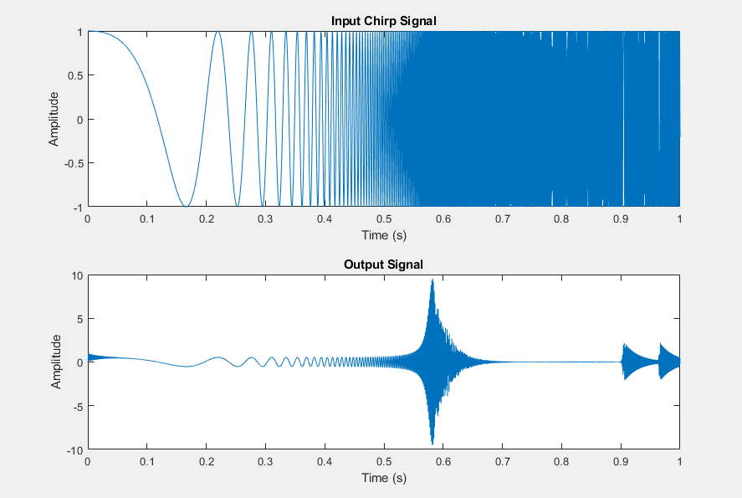

1 Hz to 100 kHz (10e5)
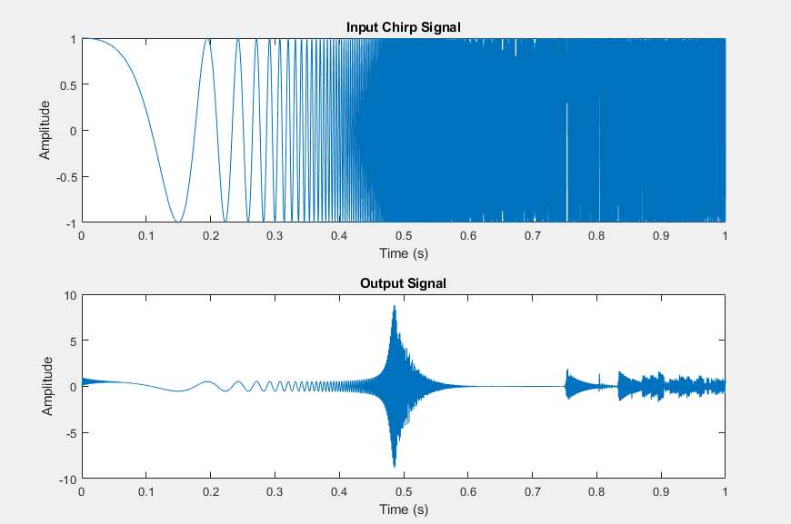

1 Hz to 1 MHz (10e6)
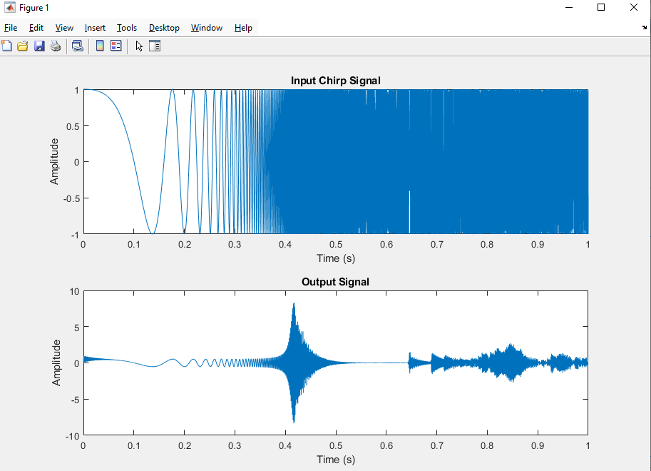

Testing time
Tmax = 1s

Tmax = 10s
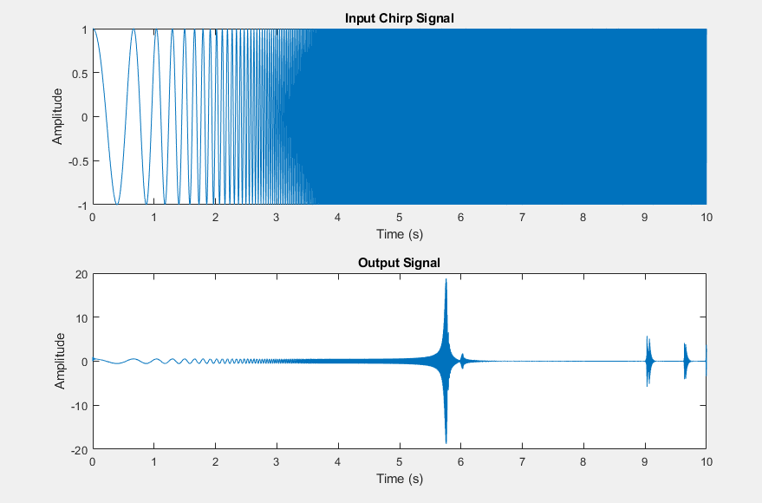

1Hz to 10 kHz, fs = 10*fmax, tmax = 30s
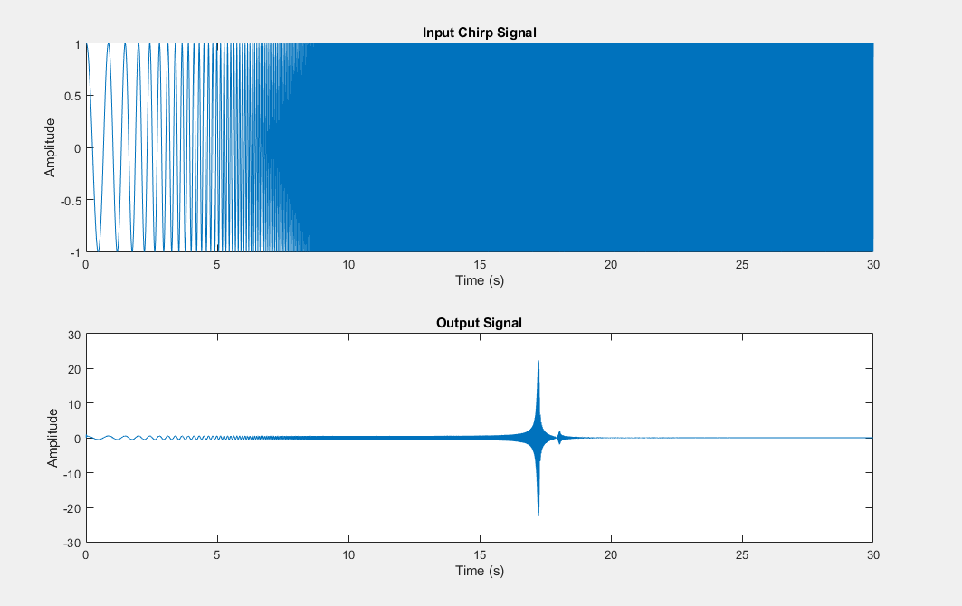
(tfestimate didn’t compute, probably too much information)
looks like no meaningful information for first 15s or so, can probably start from higher than 1hz

10 Hz to 10 kHz, fs = 10*fmax, tmax = 30s
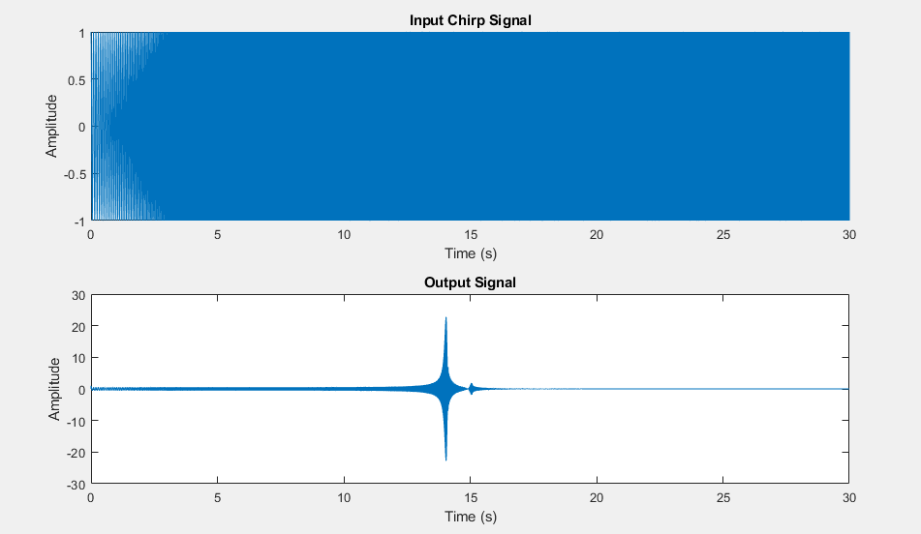
(still no bode plot)

10 Hz to 1 kHz, tmax = 5s (try to get it to run)
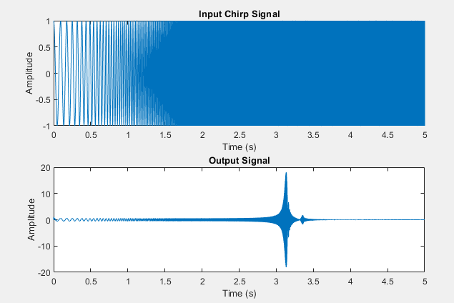

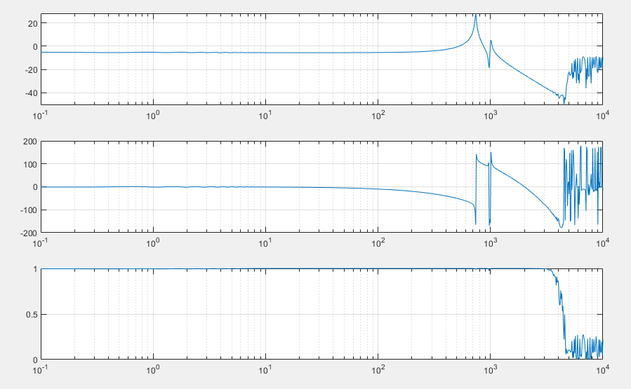
Finally bode plot generates within <20s

10 Hz to 10 kHz, tmax = 5s (GOOD)
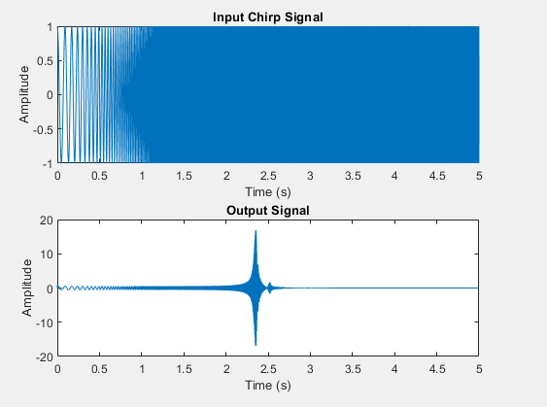
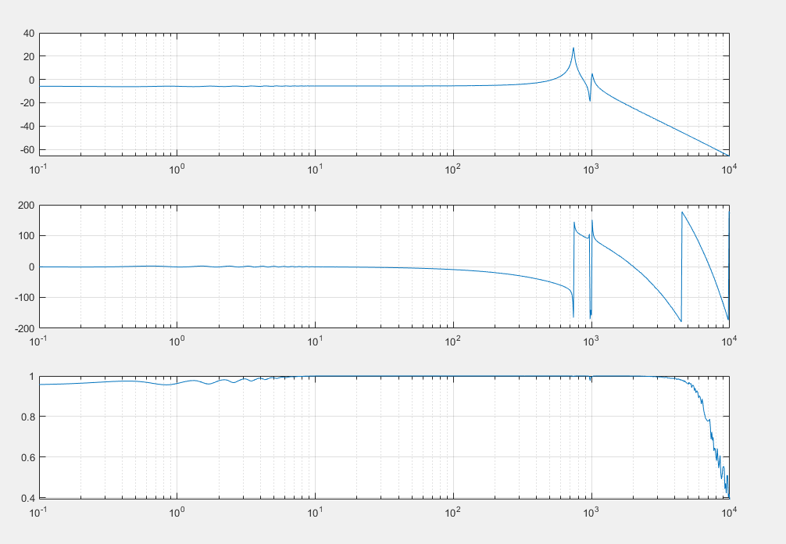
(took ~1min to solve but we got there)

100 Hz to 10 kHz, tmax = 5s ; tfestimate(2,4)
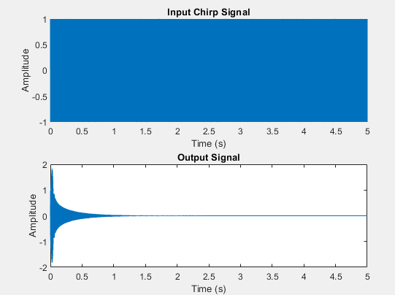
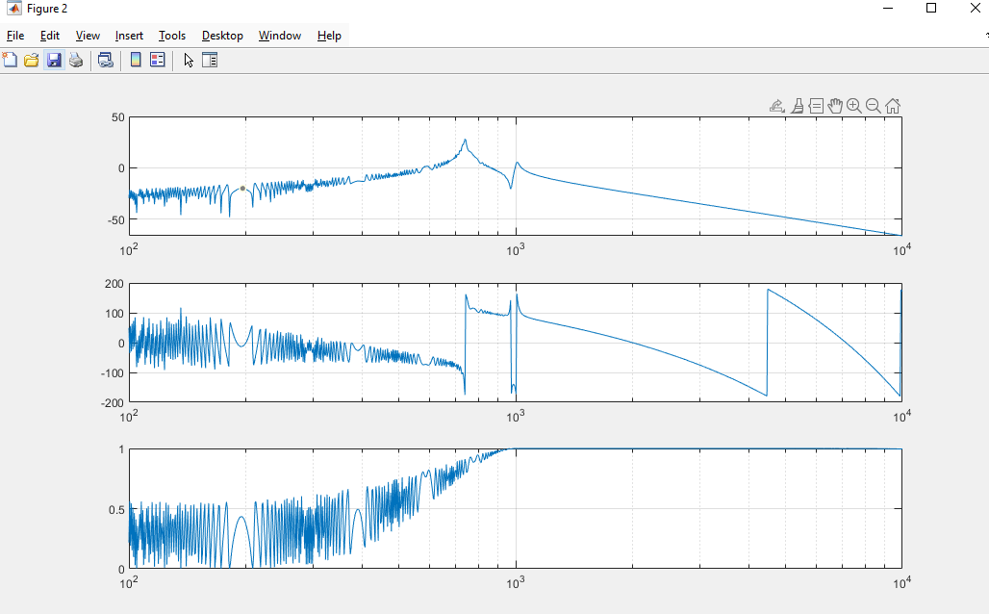
Took ~2min to compute
Complete garbage, so lets stick to 10Hz minimum lol

10 Hz to 10 kHz, tmax = 5s ; tfestimate(1,4)

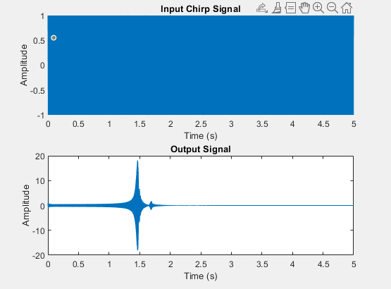
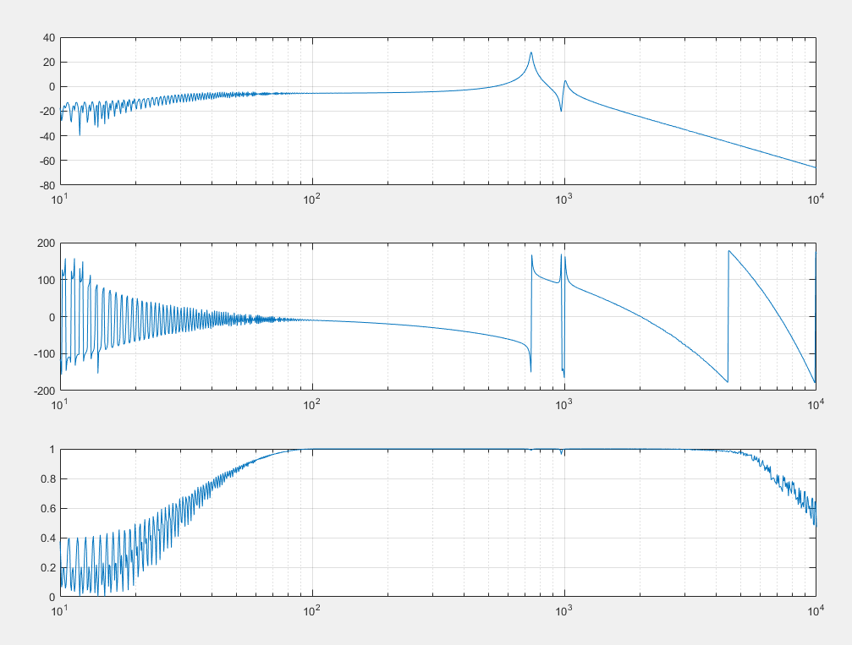
This is kinda cooked so we should keep tfestimate(-1,4)

10 Hz to 100 kHz, tmax = 5s ; tfestimate(-1,5)
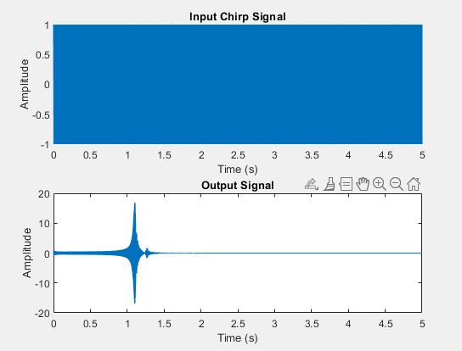
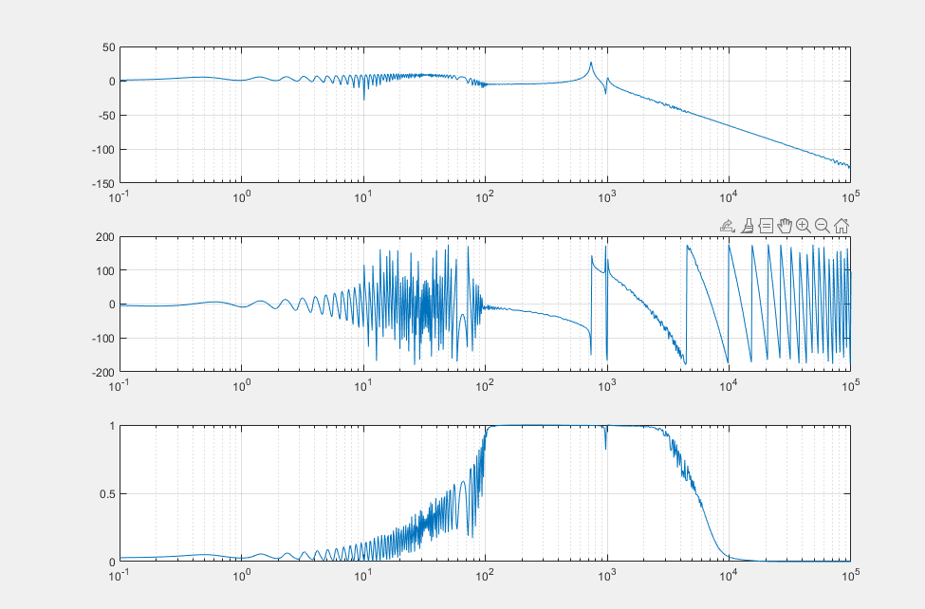
Took like 30mins to compute and it’s garbage, so probably stick to 10^4

(bad) 10 Hz to 10 kHz, tmax = 5, tfestimate(-1,4)

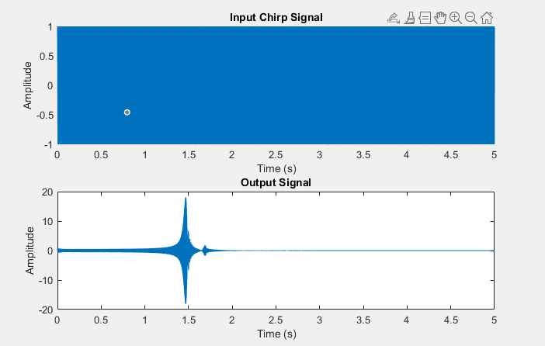
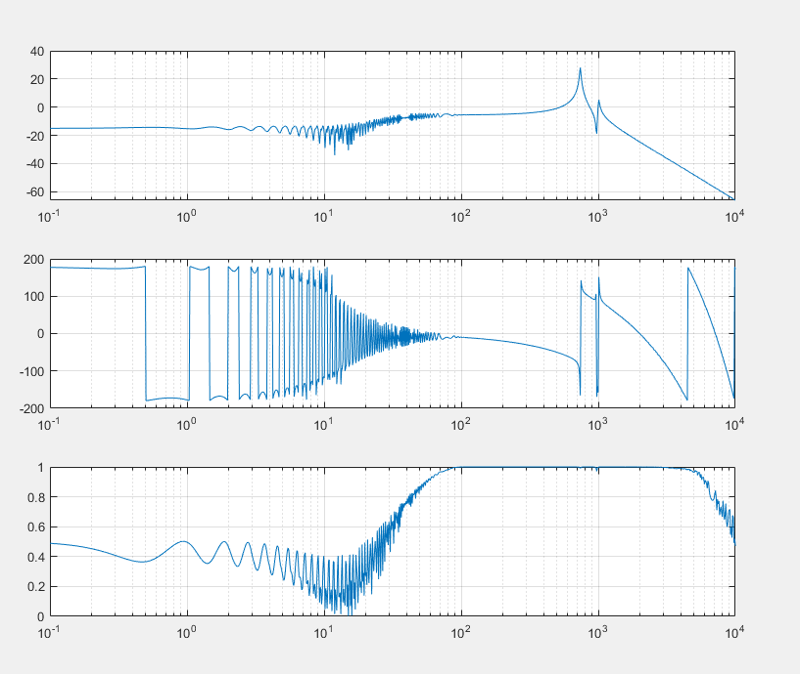

1 to 10e4, tmax = 5, tfestimate(-1,4)
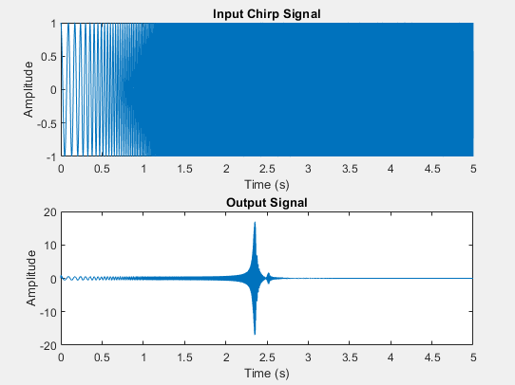
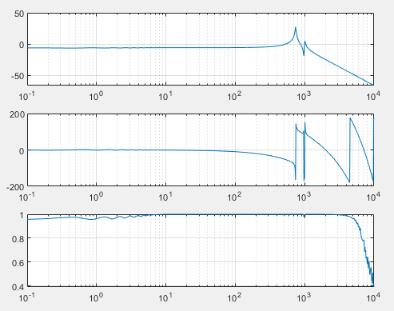

10 to 1e4, tmax = 5, tfestimate(-1,4)
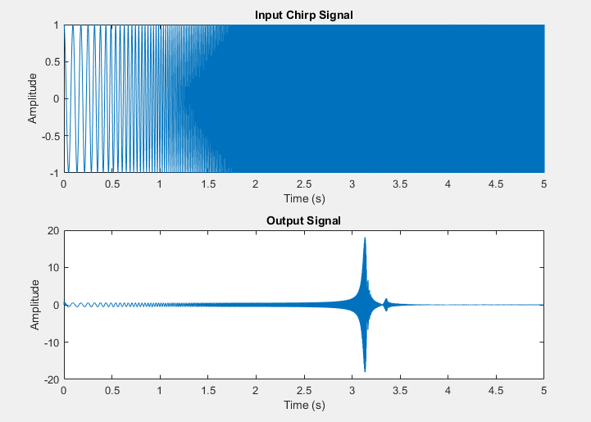
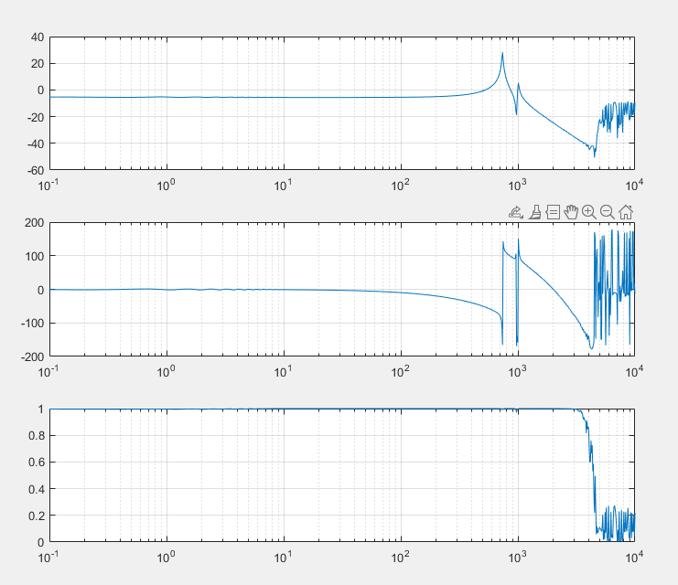
20s to compile

10 to 1e4, tmax = 5, tfestimate(1,4)
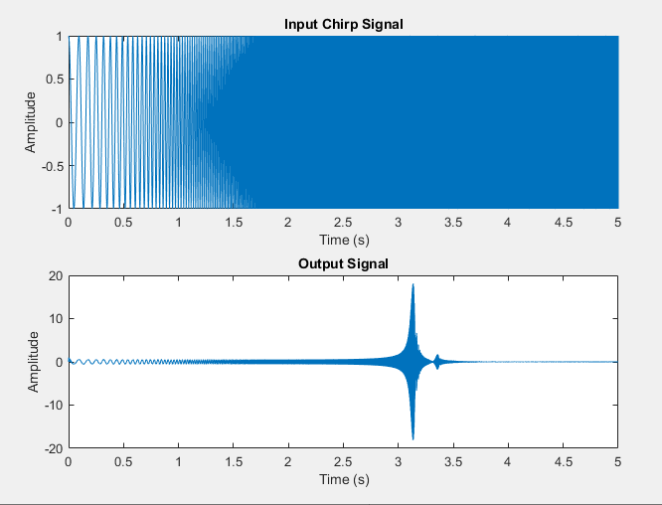
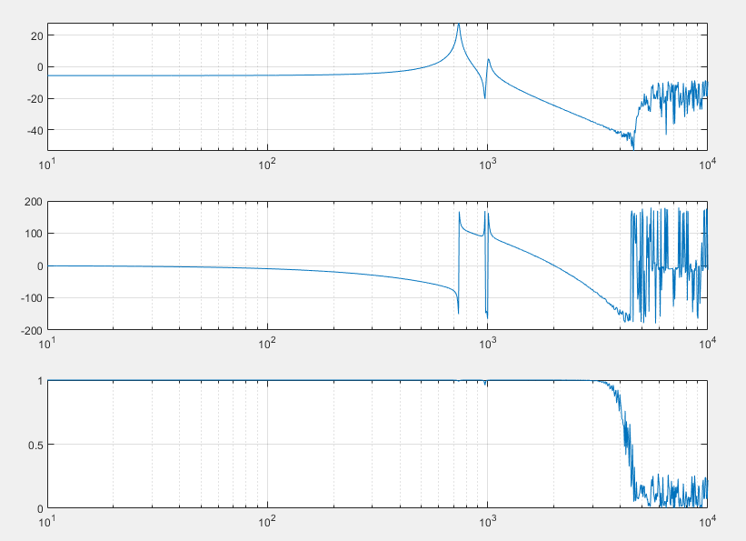

Playing with scaling input

10 to 1e4, tmax = 5, tfestimate(1,4), hard 10x (1e3 to 1e4)
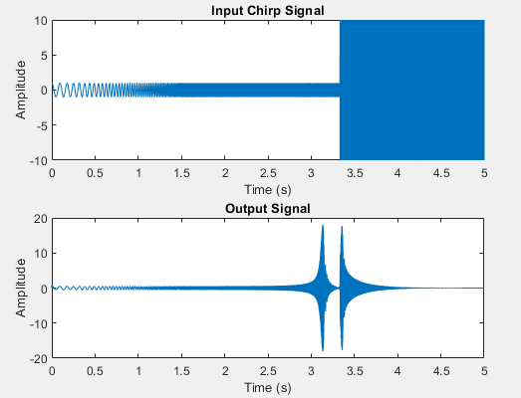
Definitely bad

10 to 1e4, tmax = 5, tfestimate(1,4), linear 10x (1e3 to 1e4)
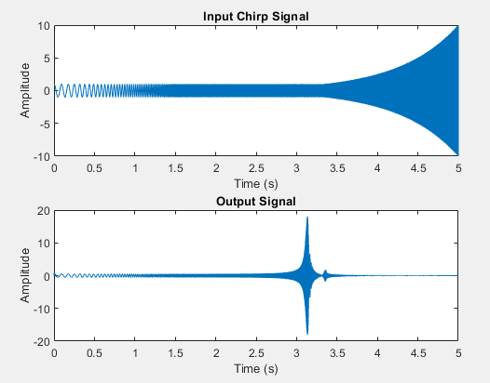
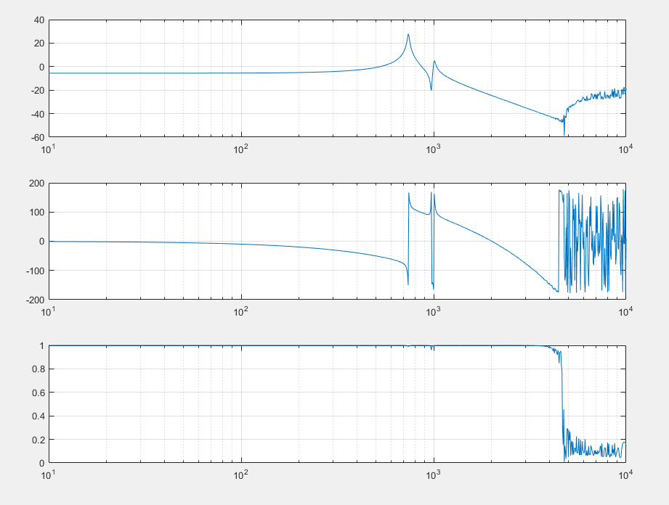

10 to 1e4, tmax = 5, tfestimate(1,4), log 10x (1e3 to 1e4)
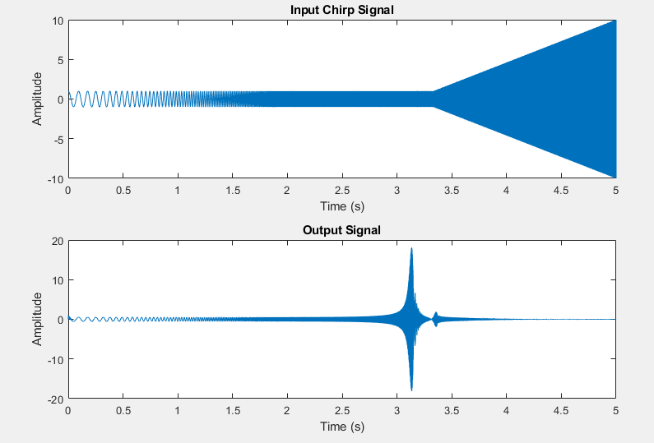
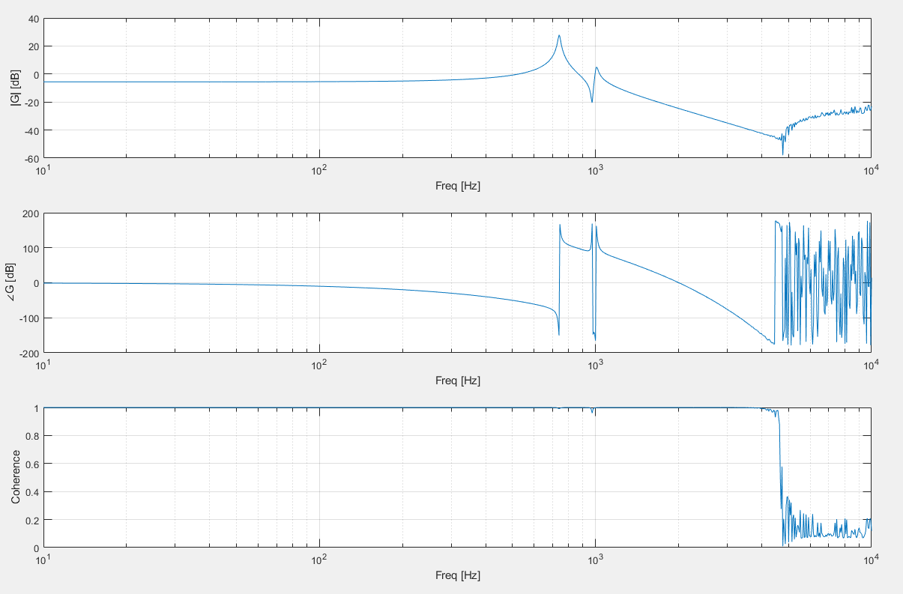

10 to 1e4, tmax = 5, tfestimate(1,4), log 100x (1e3 to 1e4)
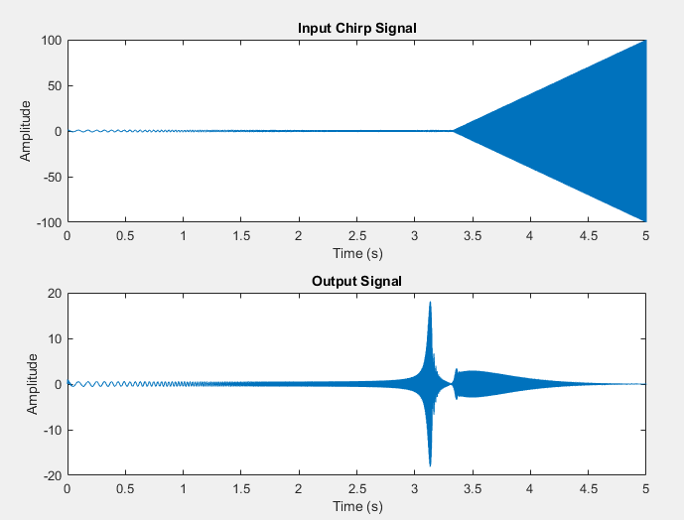
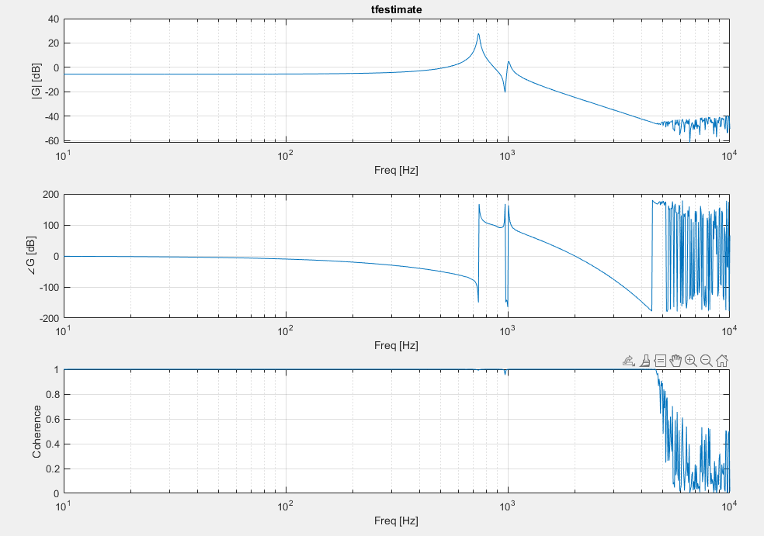

10 to 1e4, tmax = 5, tfestimate(1,4), log 100x (2e3 to 1e4)
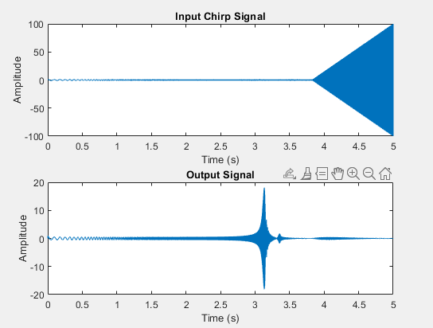
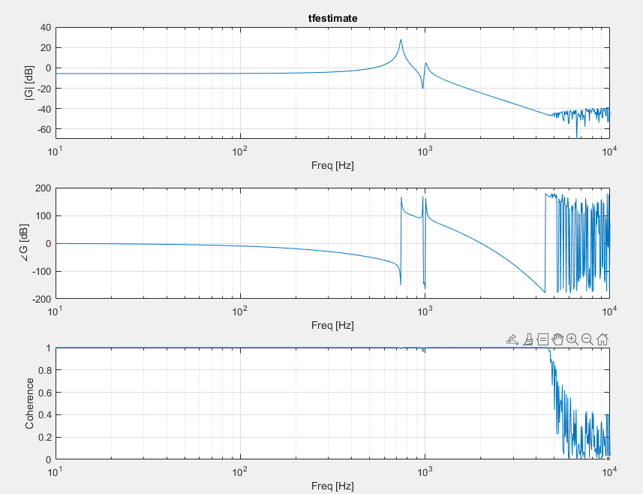

10 to 1e4, tmax = 5, tfestimate(1,4), log 1000x (2e3 to 1e4)
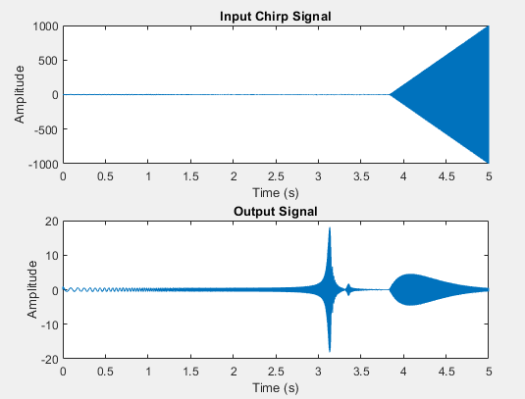
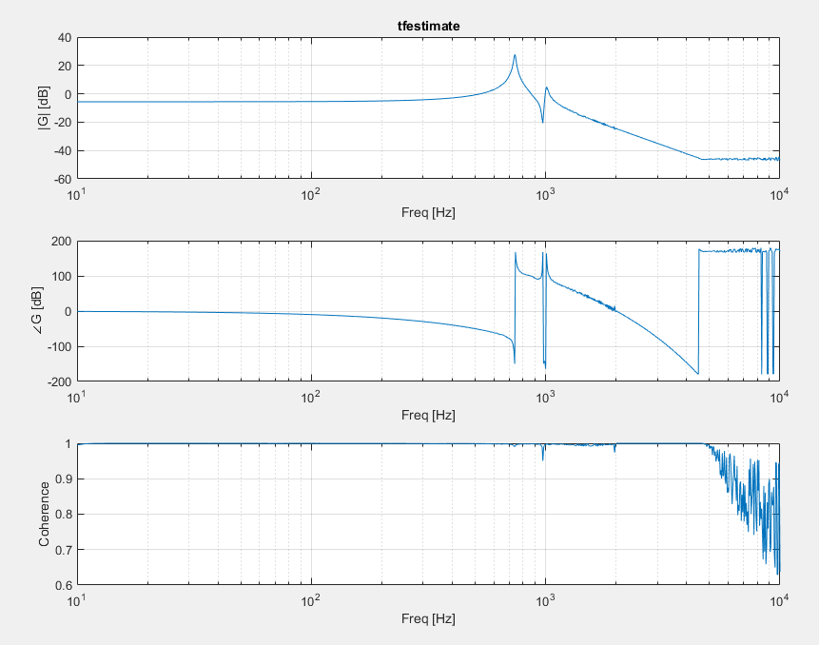

10 to 1e4, tmax = 5, tfestimate(1,4), log 1e4 (2e3 to 1e4)
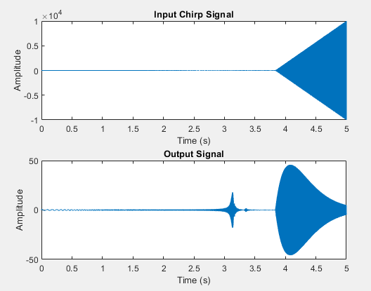
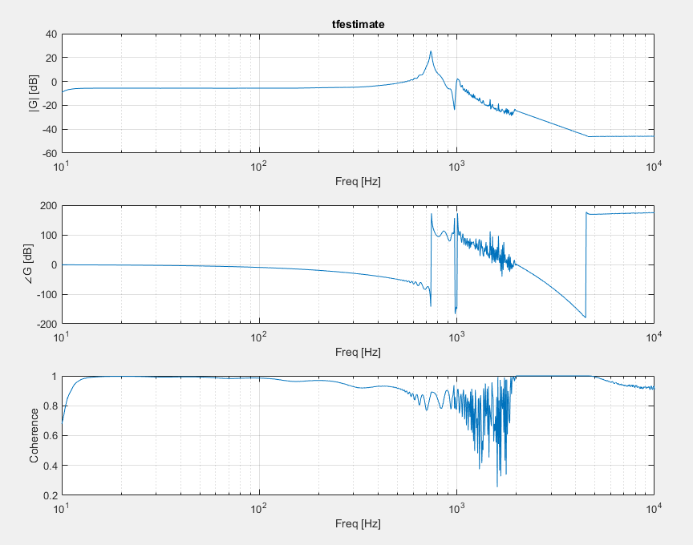
Uhhh wtf
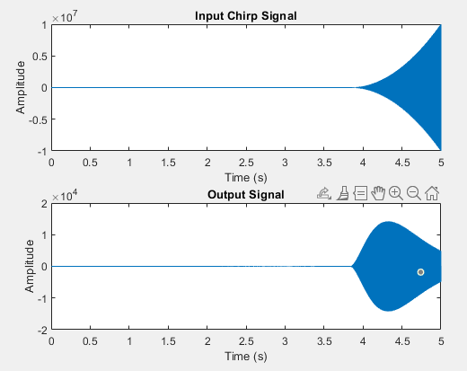
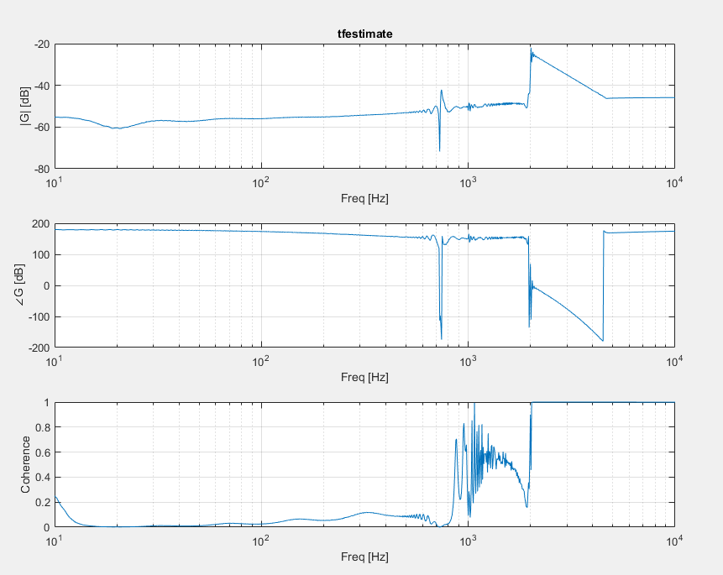

10 to 1e4, tmax = 5, tfestimate(1,4), log 1e3 (3e3 to 1e4)
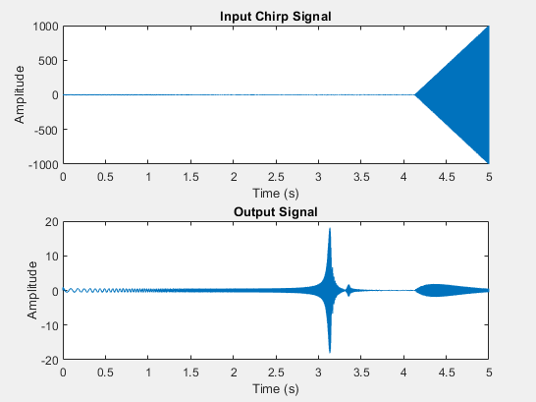

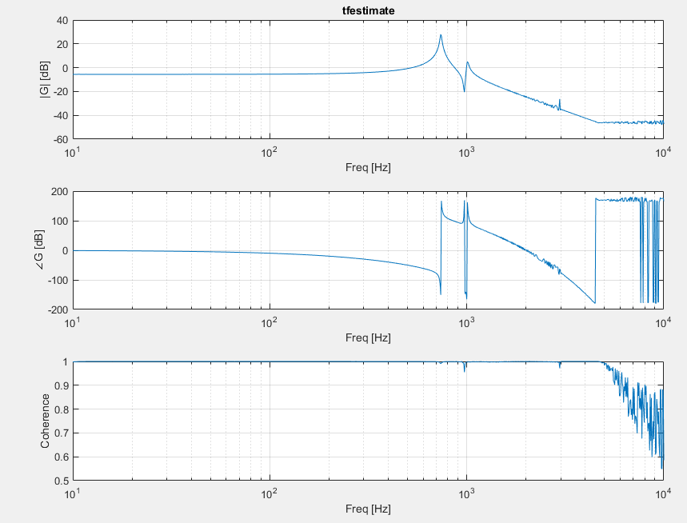
10 to 1e4, tmax = 5, tfestimate(1,4), log 1e4 (3e3 to 1e4)
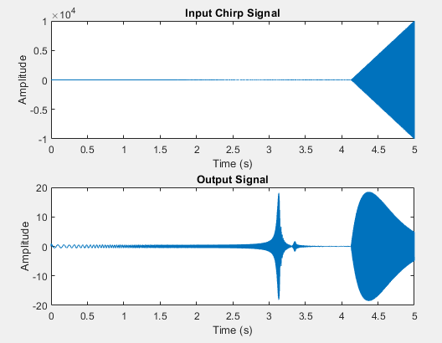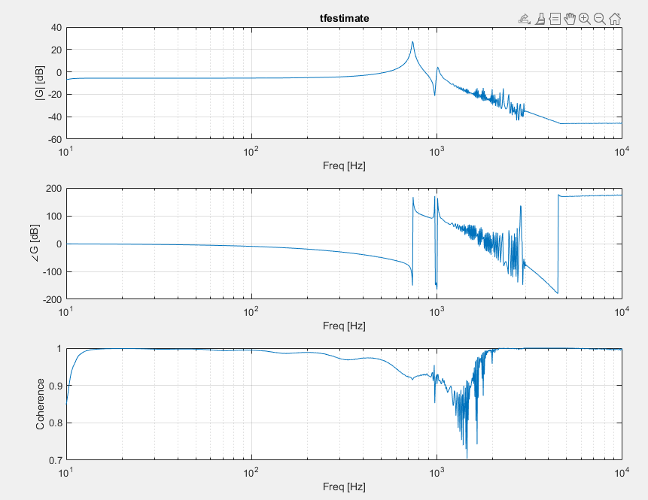

10 to 1e5, tmax = 5, tfestimate(1,5), log 1e3 (2e3 to 1e4)
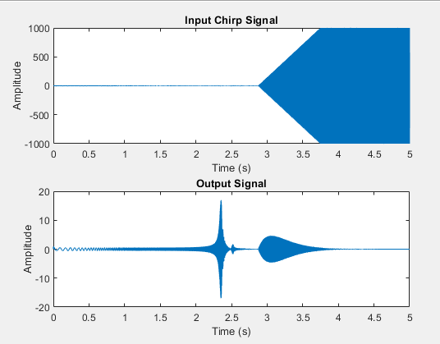
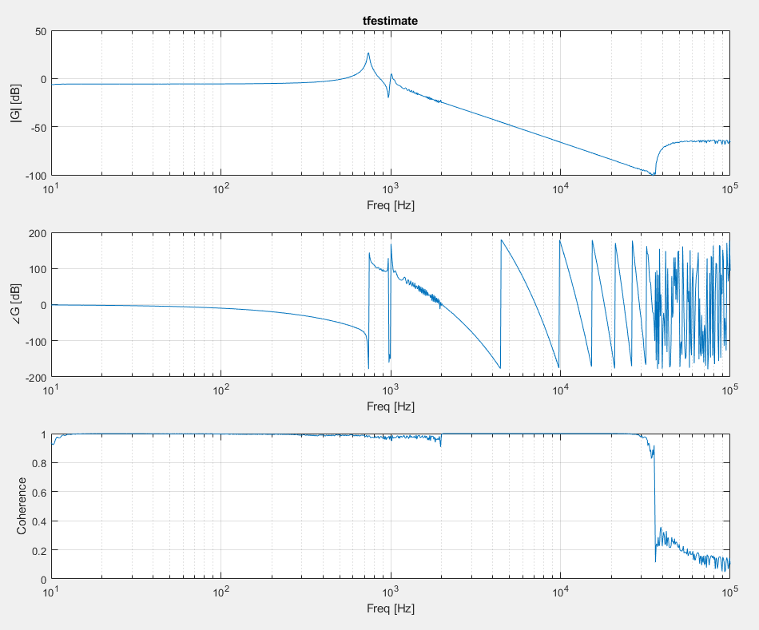
(took maybe 2mins)

10 to 1e5, tmax = 5, tfestimate(1,5), log 1e4 (2e3 to 1e5)
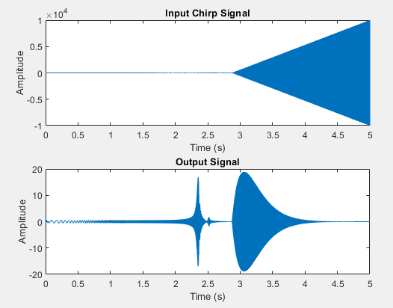
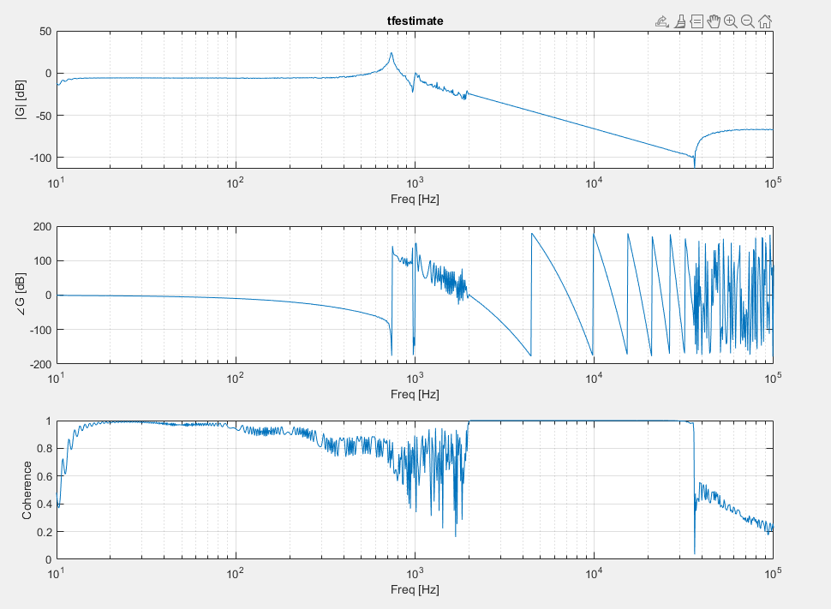(3.5 minutes for this garbage)

Sample Time

10 to 1e4, 10s, log 1e3 (2e3 to 1e4)
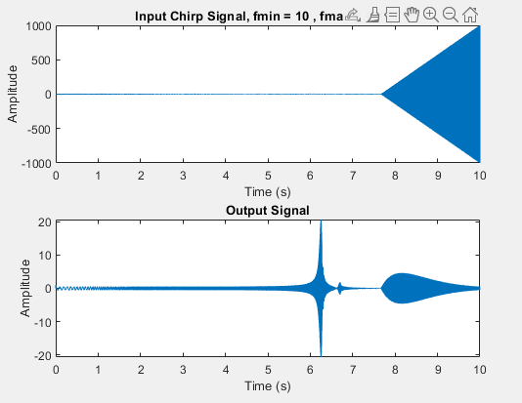
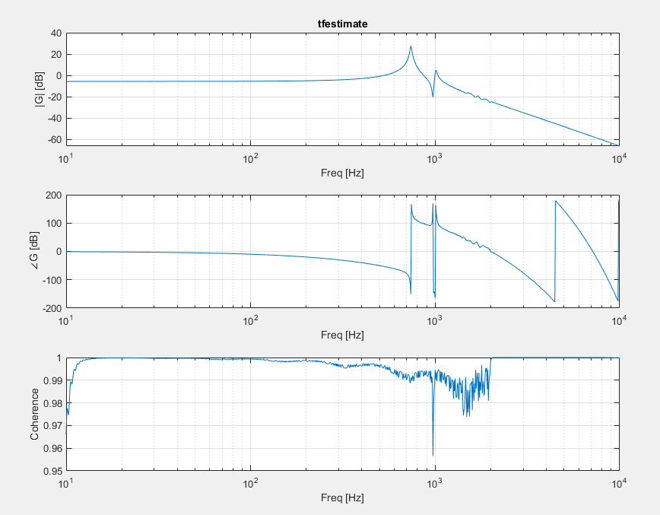

10 to 1e4, 10s, log 1e3 (1e3 to 1e4)
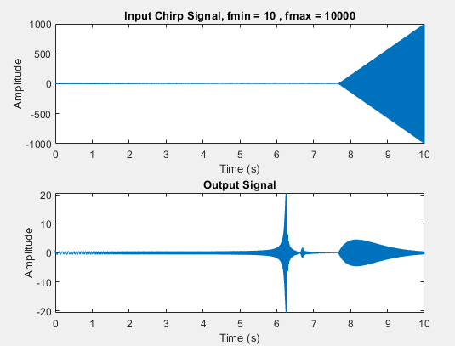
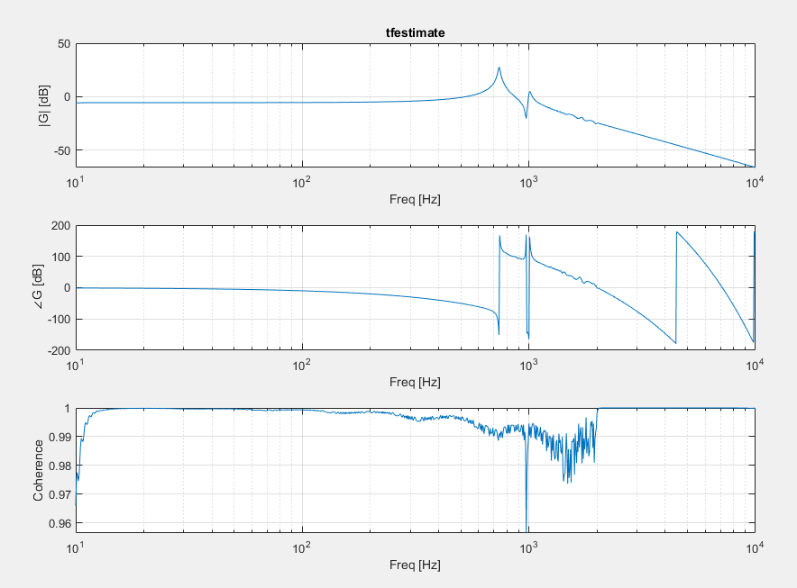

10 to 1e4, 10s, no scaling
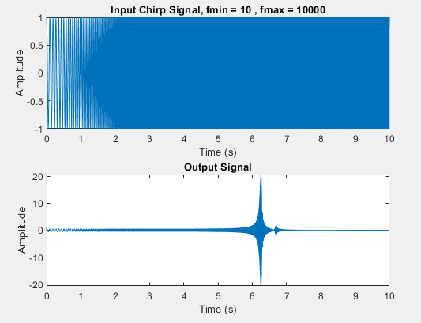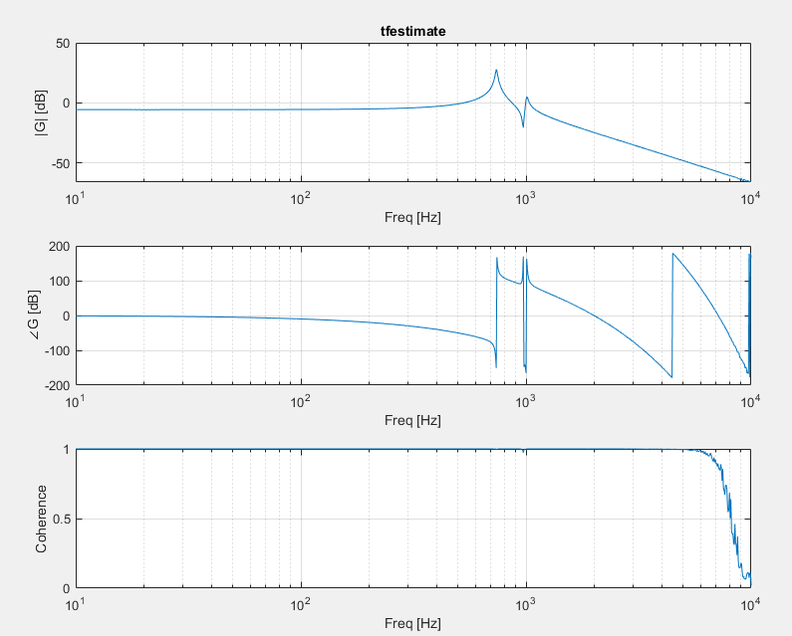

10 to 1e4, 10s, log 1e1 (2e3 to 1e4)
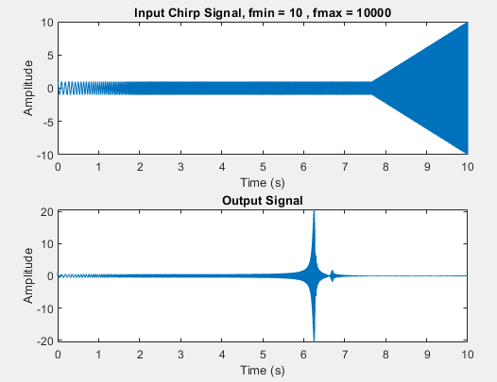
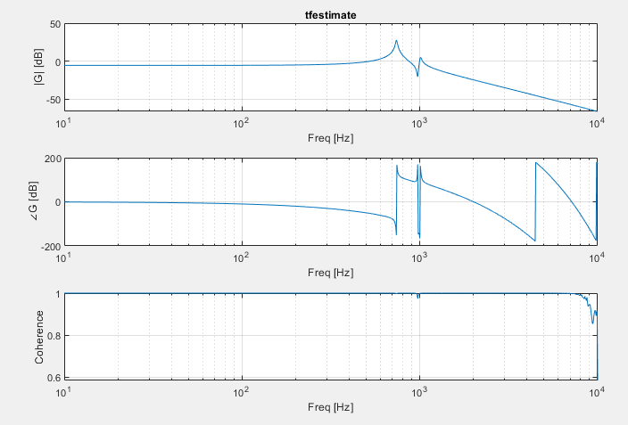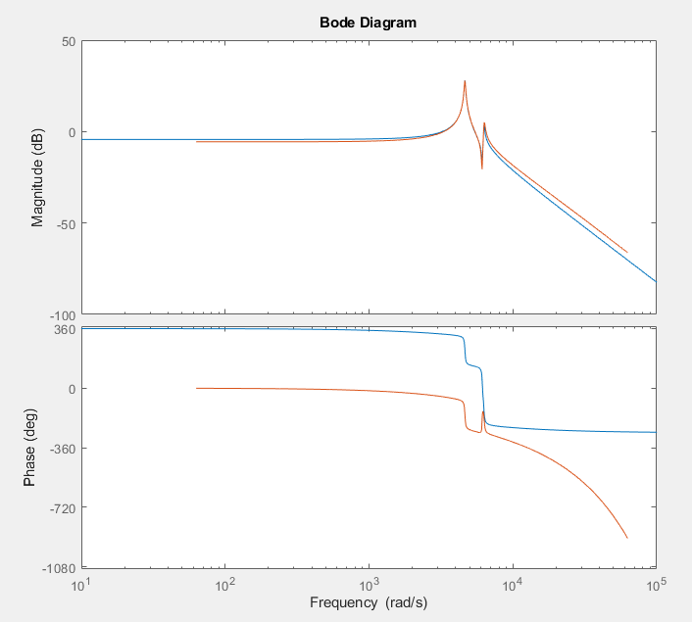

10 to 1e4, 10s, log 1e2 (2e3 to 1e4)
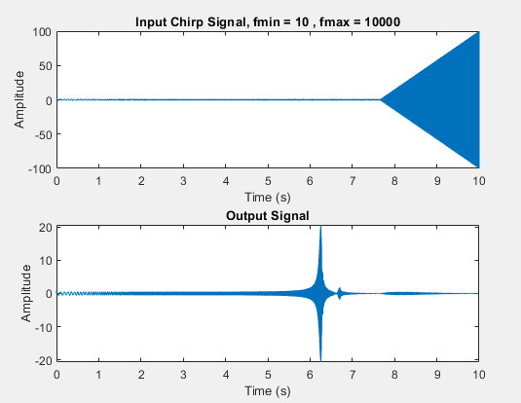
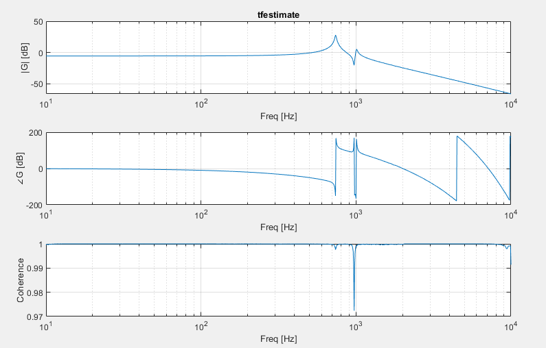

10 to 1e5, 10s, log 1e2 (2e3 to 1e4)
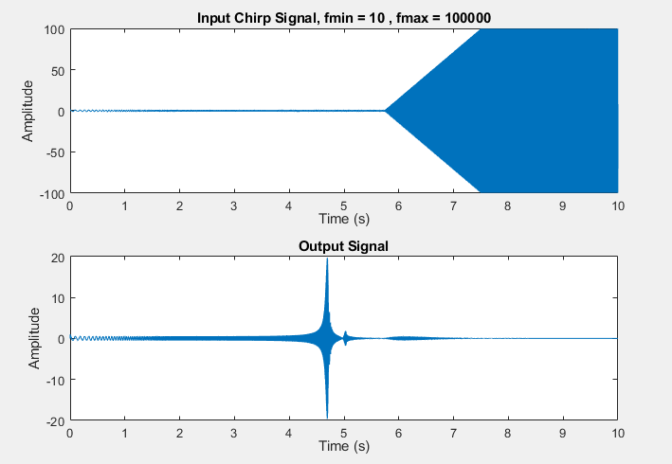
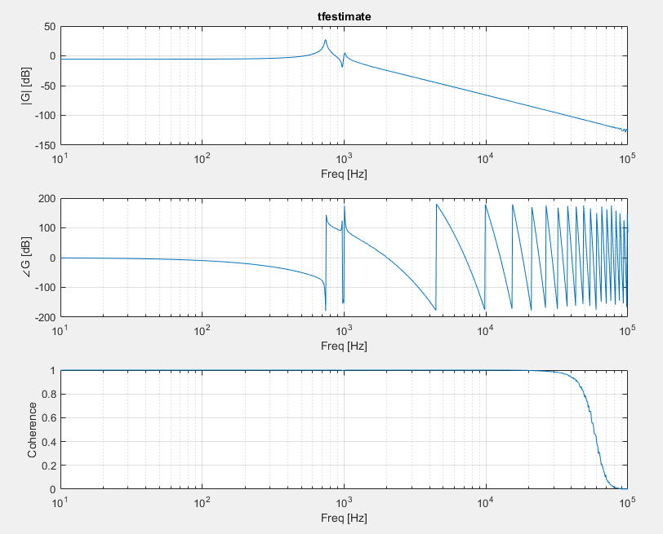
Unlikely that there are modes past 1e4
Frd
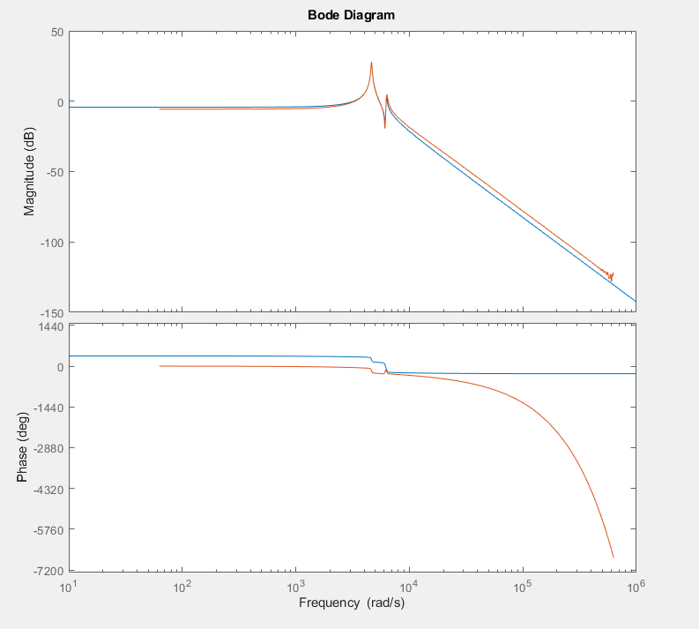
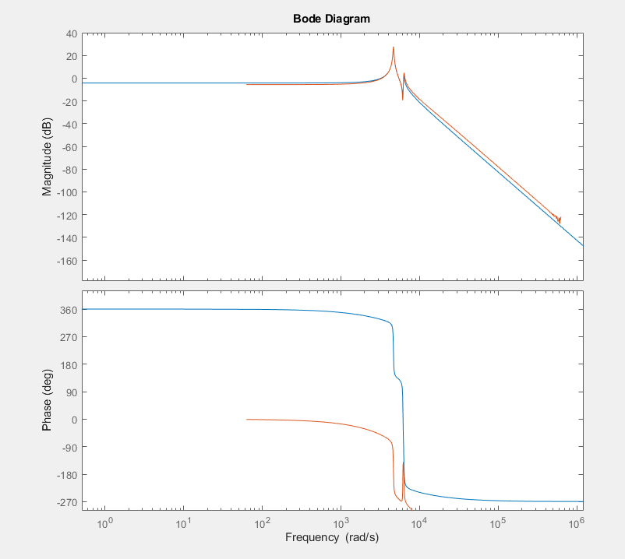

Windowing Chirp

No scaling
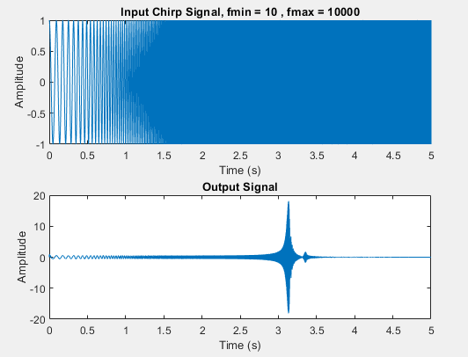
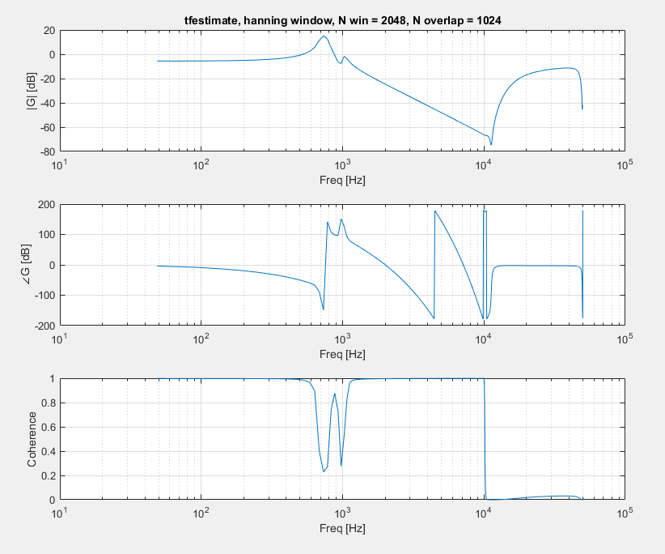
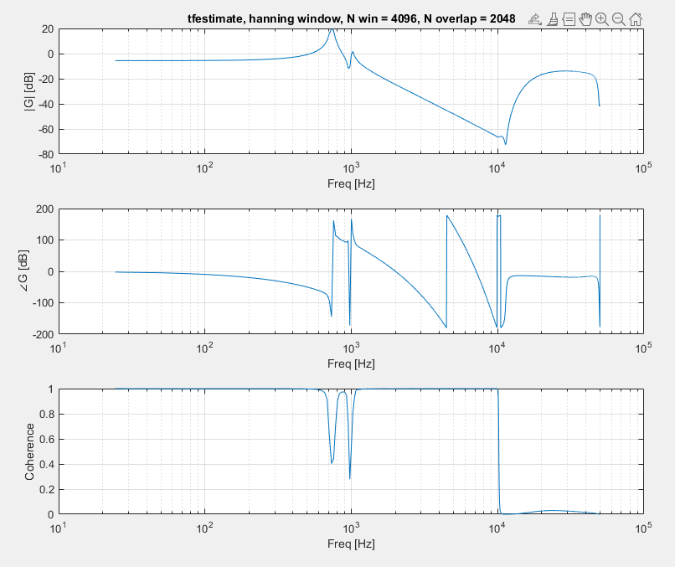
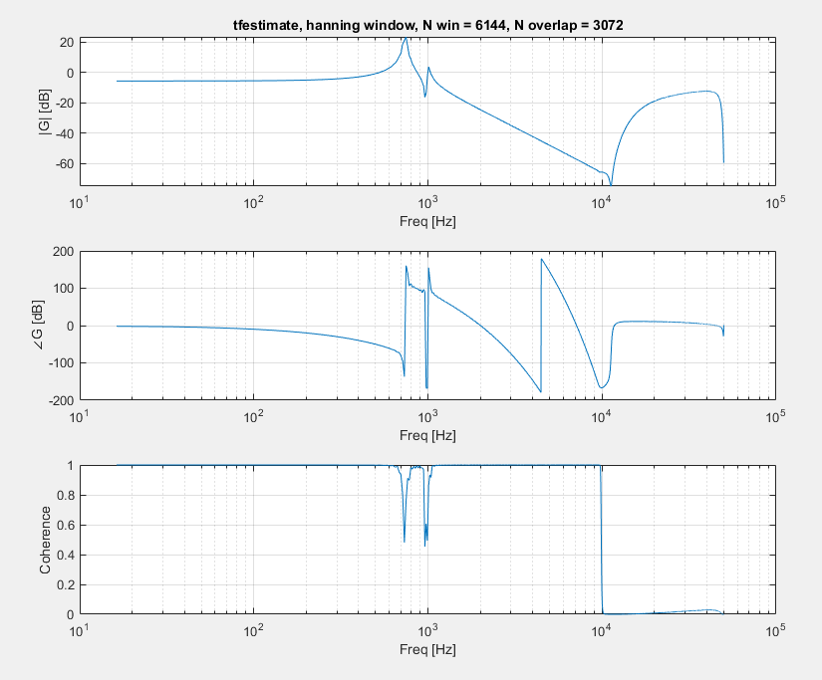
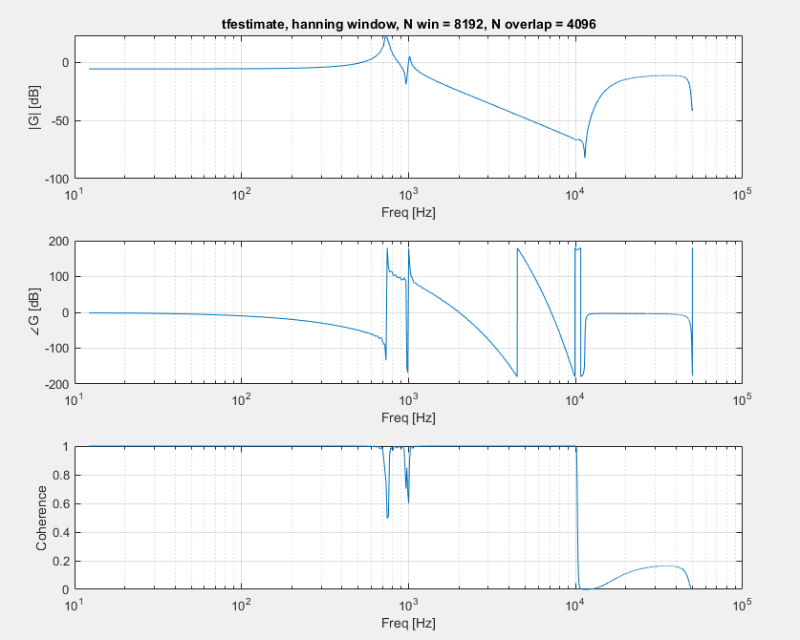

10 to 1e4, tmax = 5, log 1e3 (2e3 to 1e4)
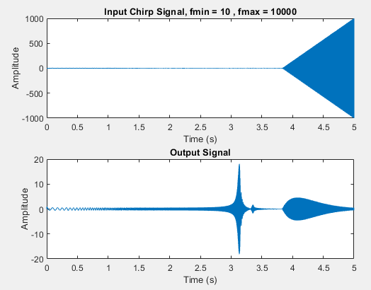
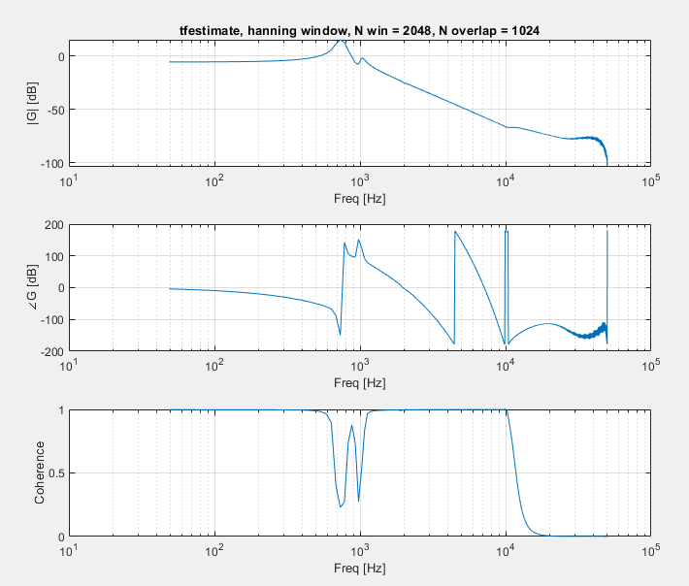
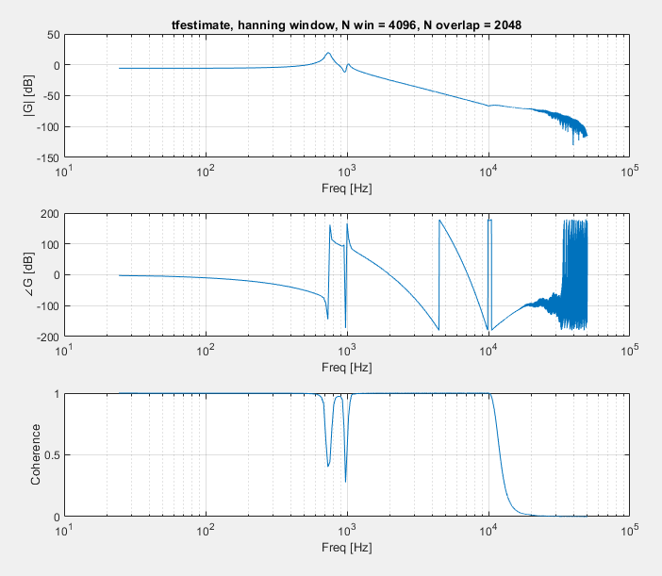
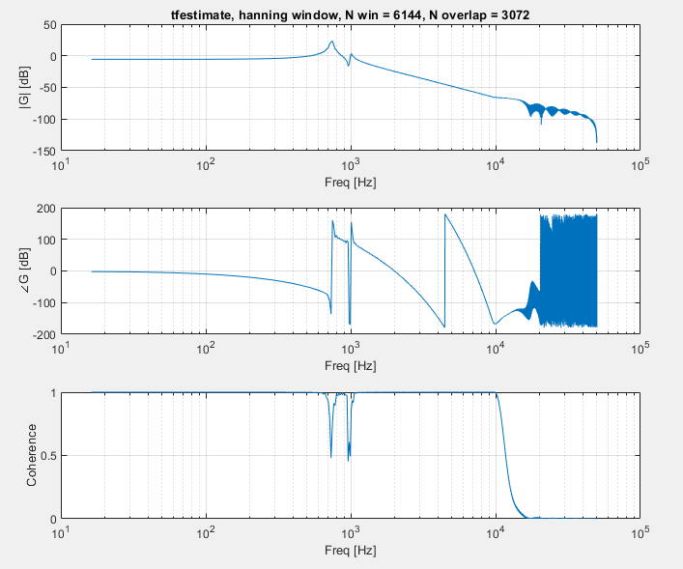

10 to 1e5, tmax = 5, log 1e3 (2e3 to 1e4)
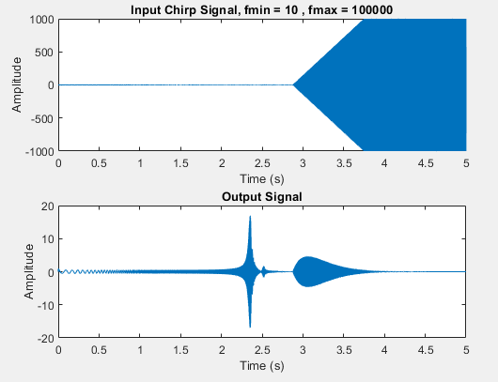
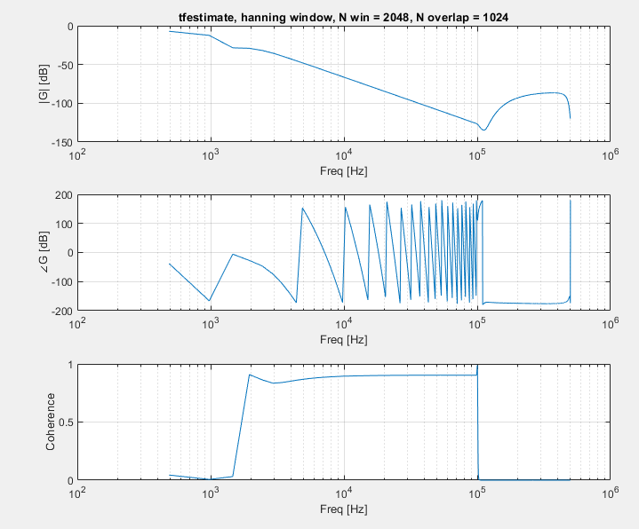
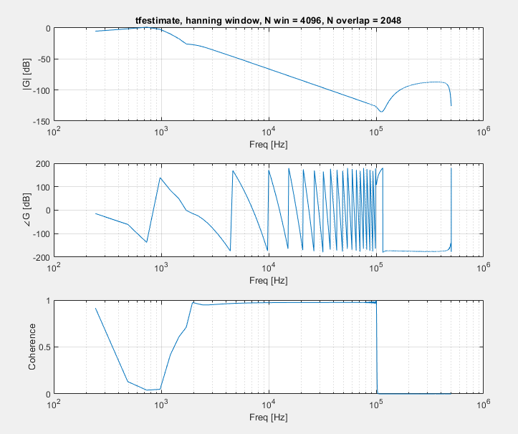
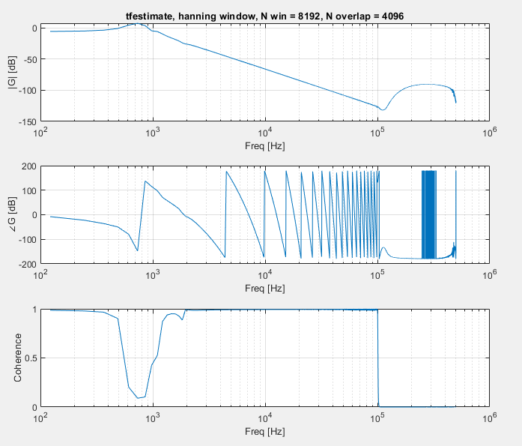

Hanning window (don’t use)
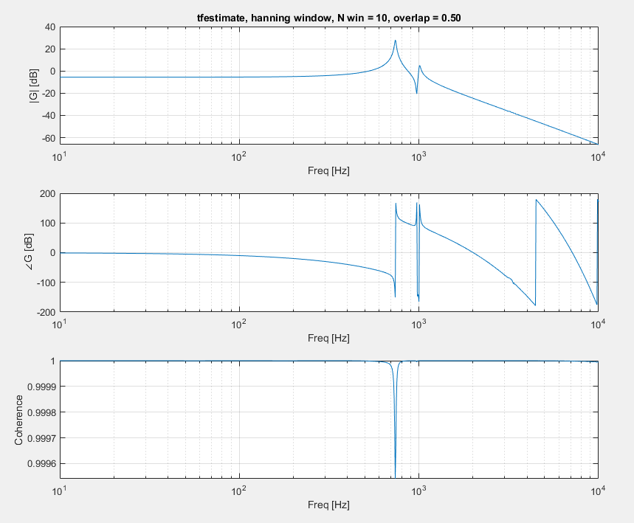

Rectangular window
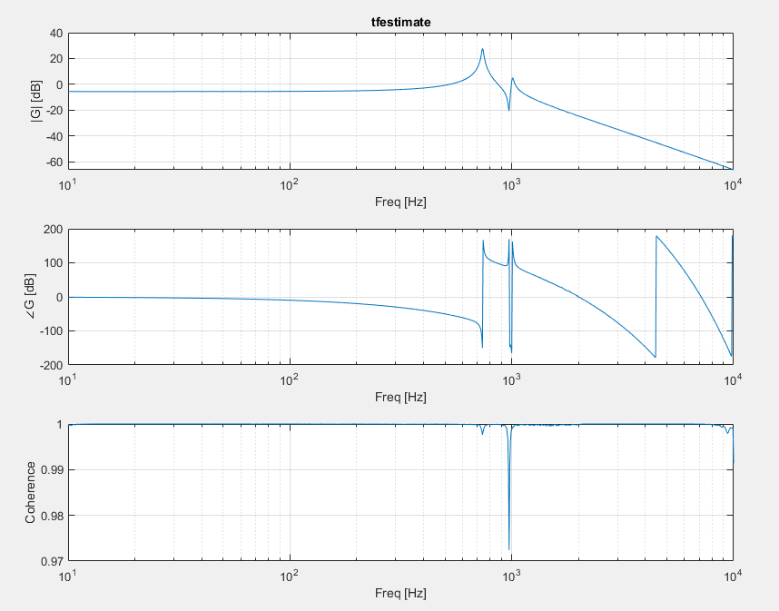
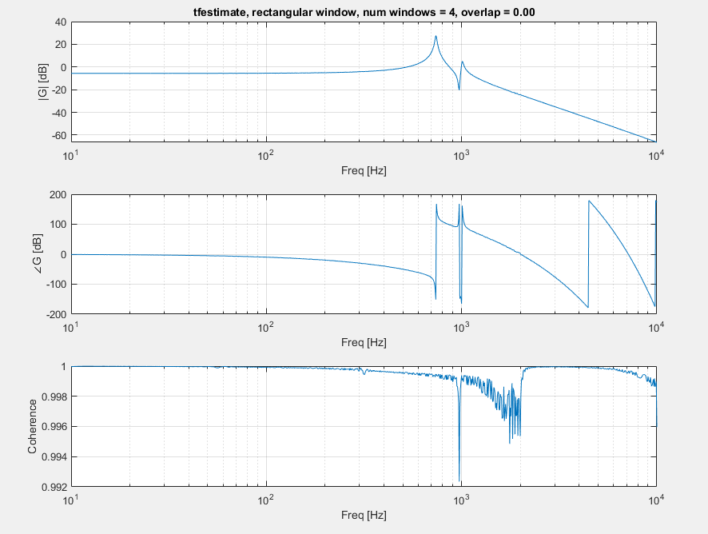
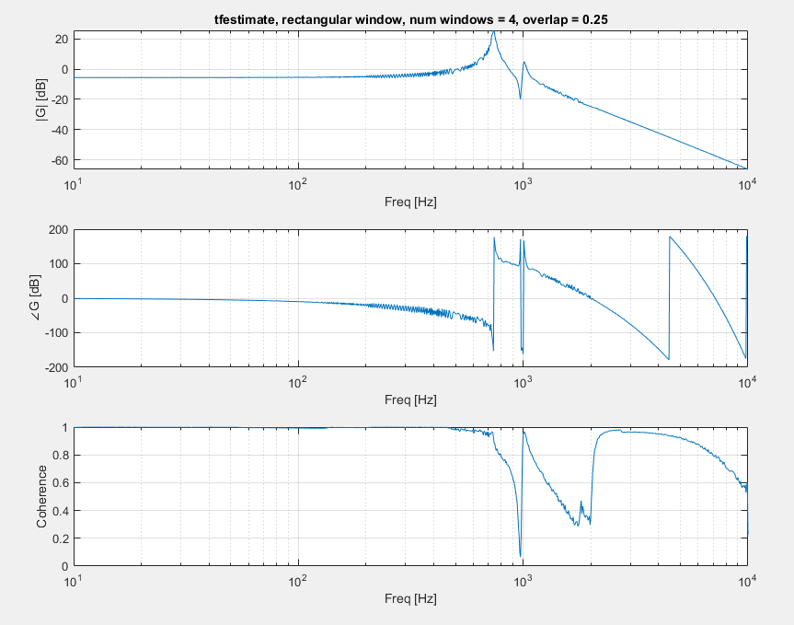
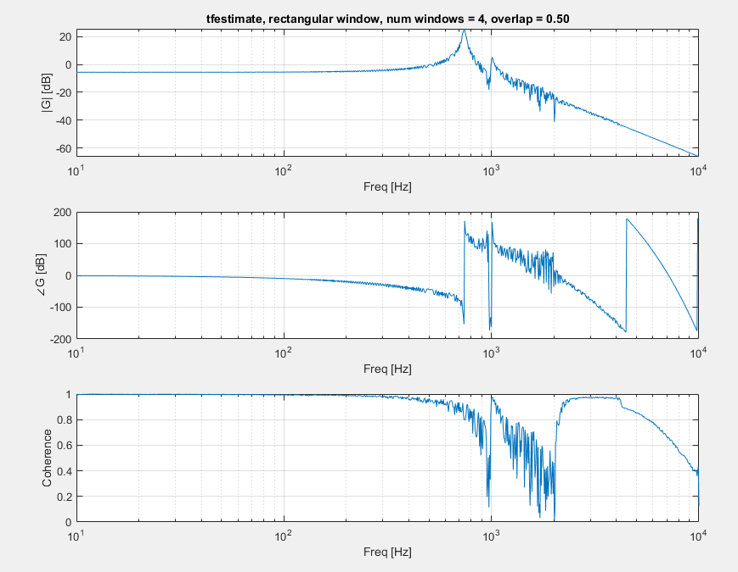
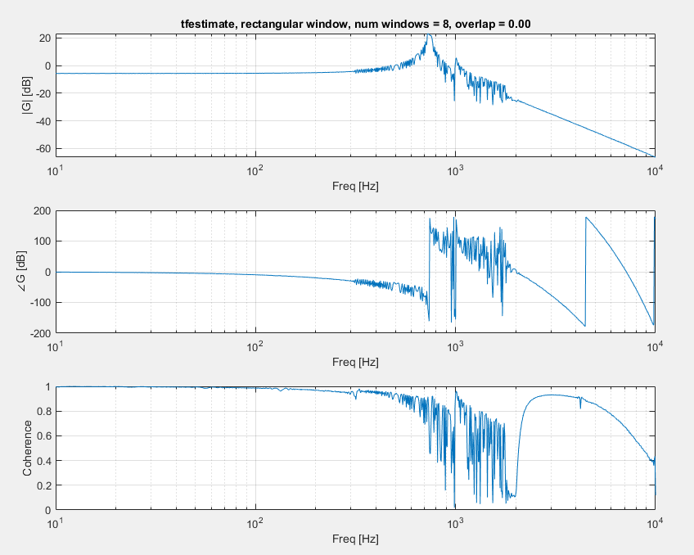
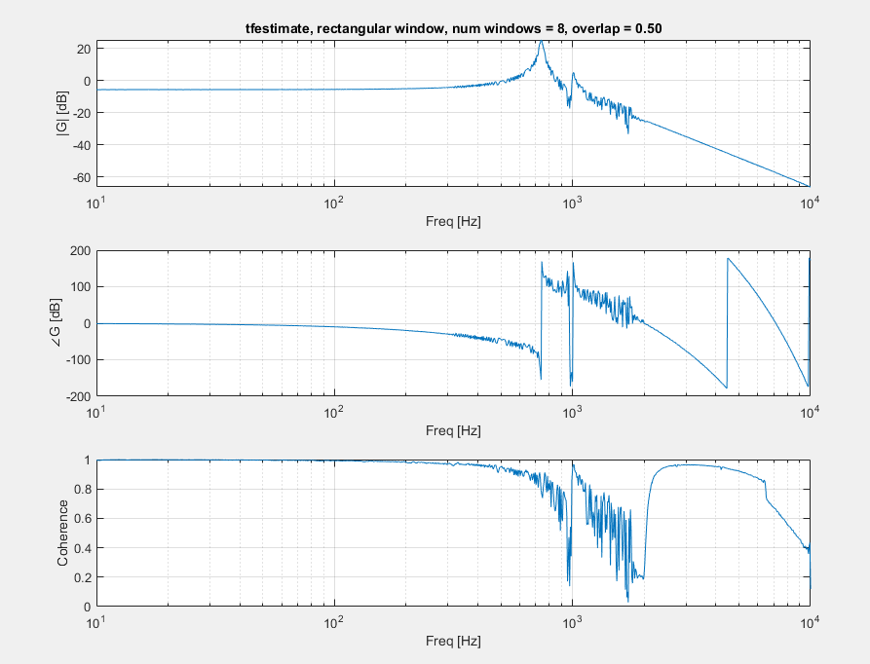
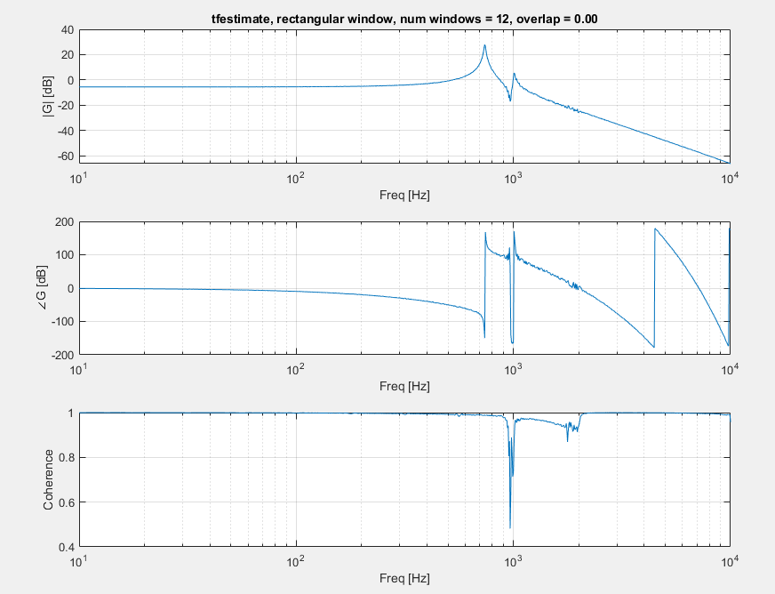
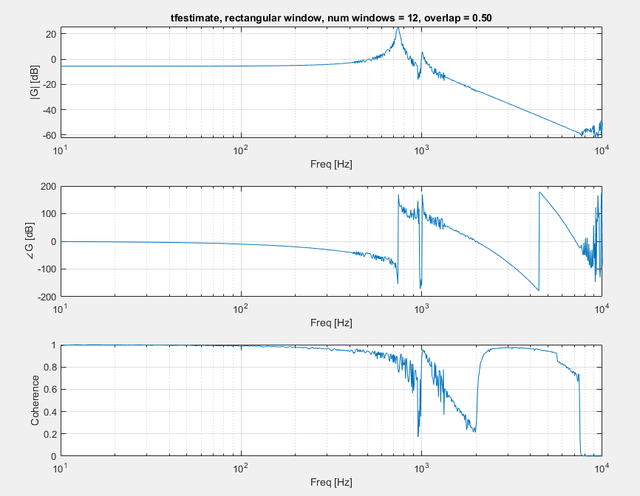
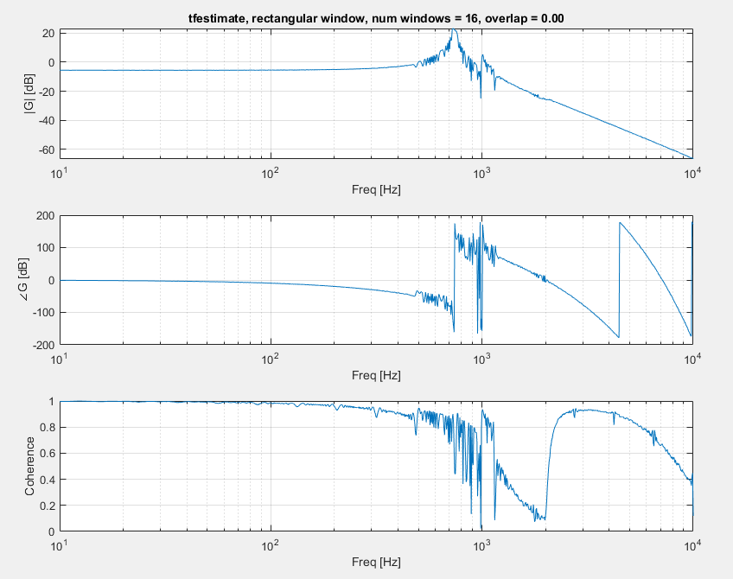
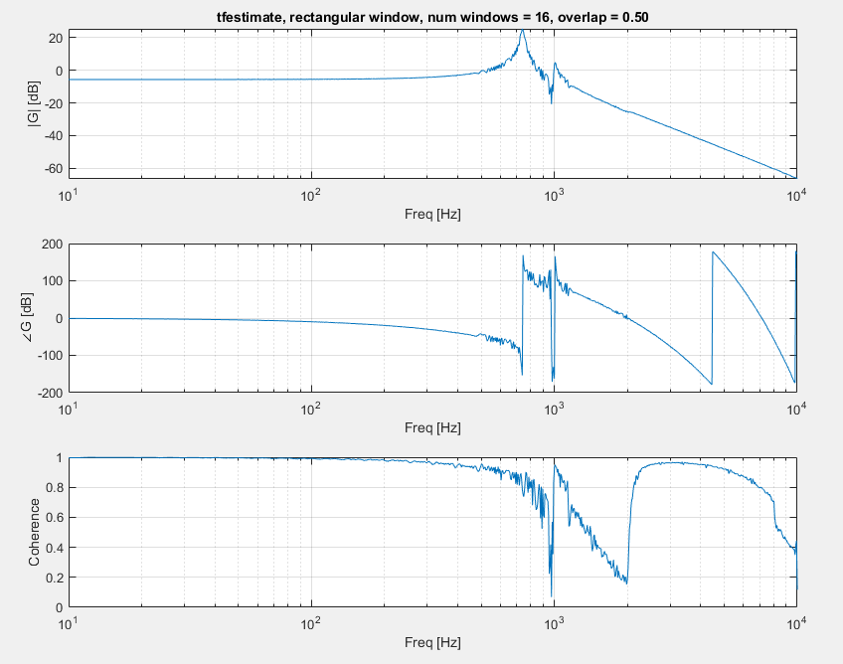
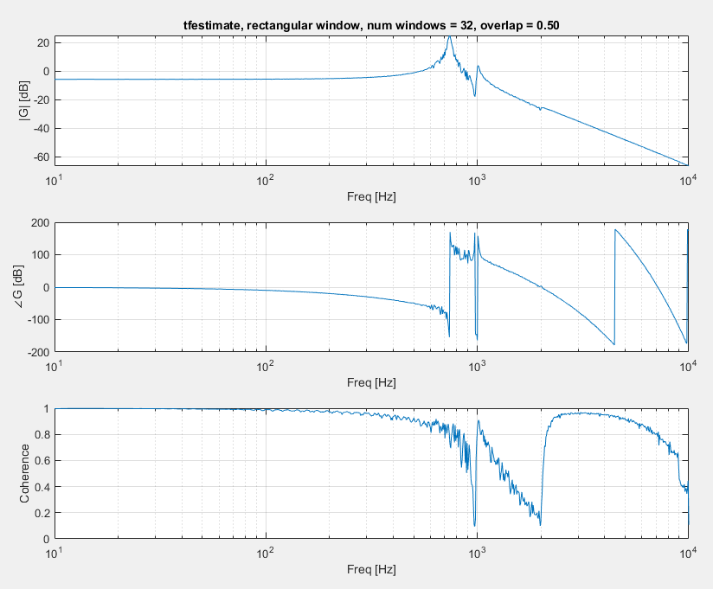

True windowing at 30e-6
No scaling
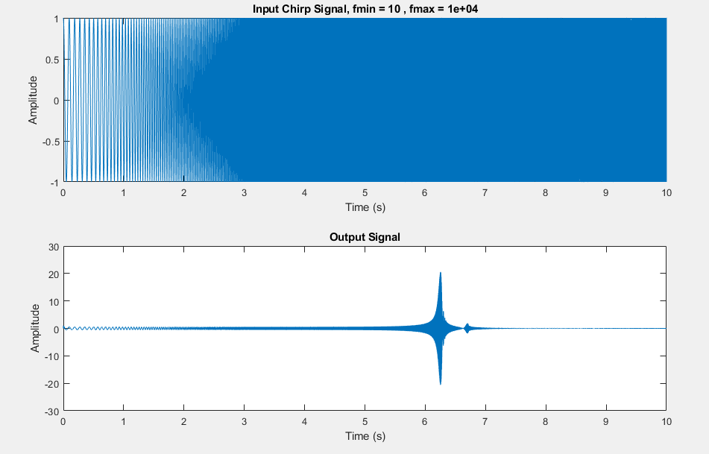
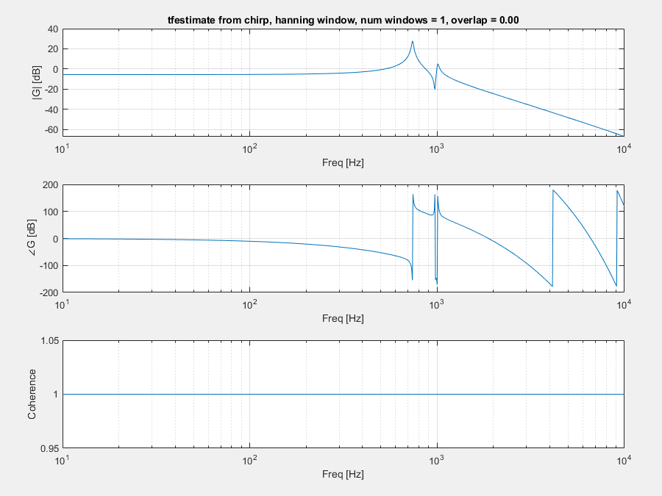
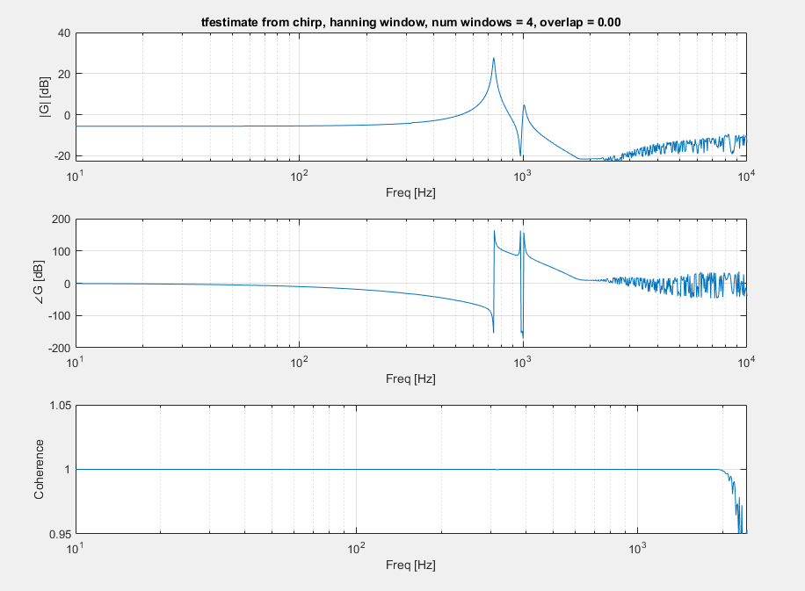
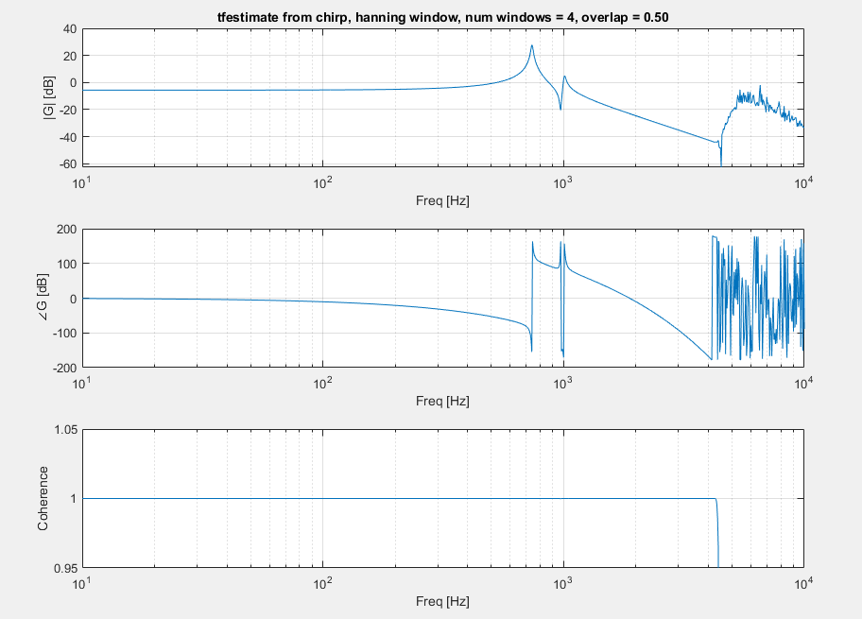
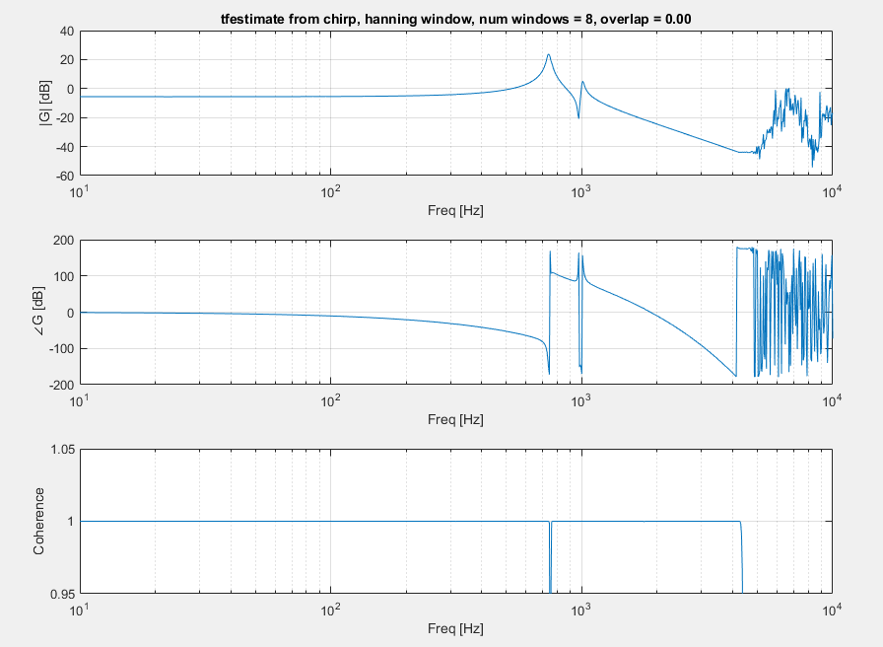

Windowing with scaling
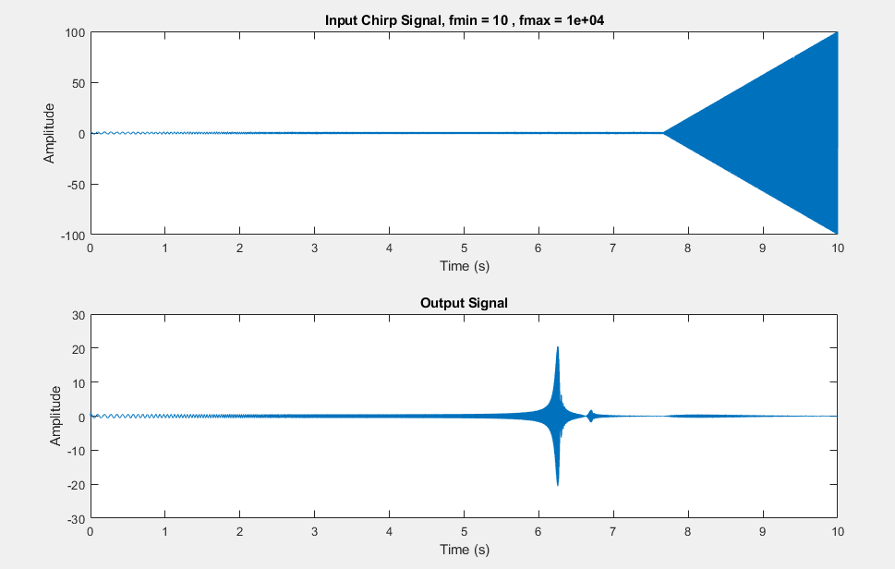
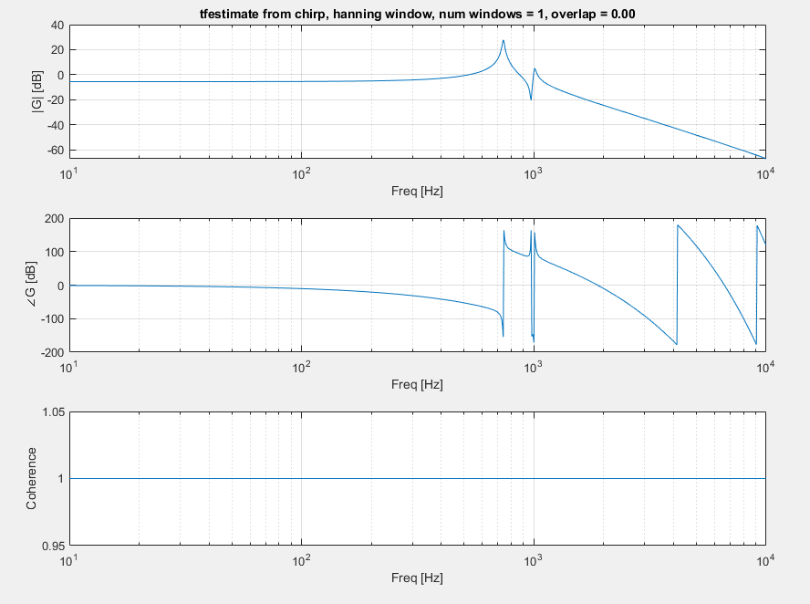
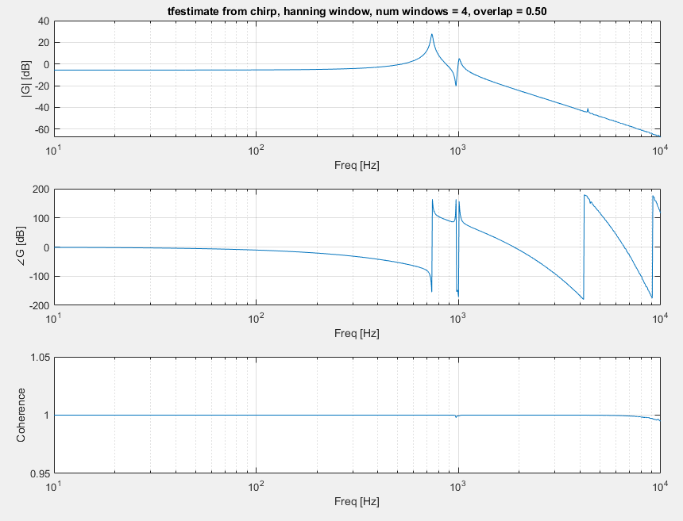
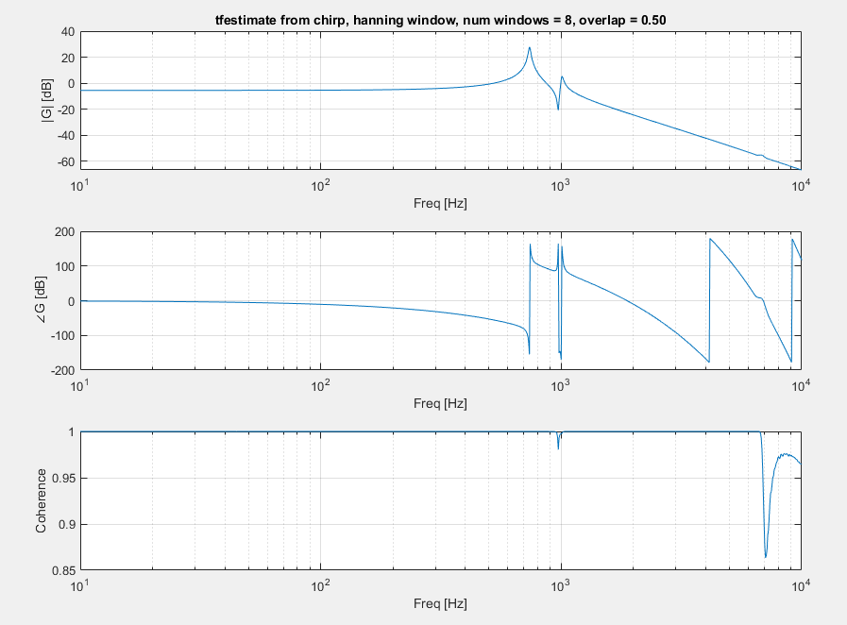

Multiple Chirps
4 chirps
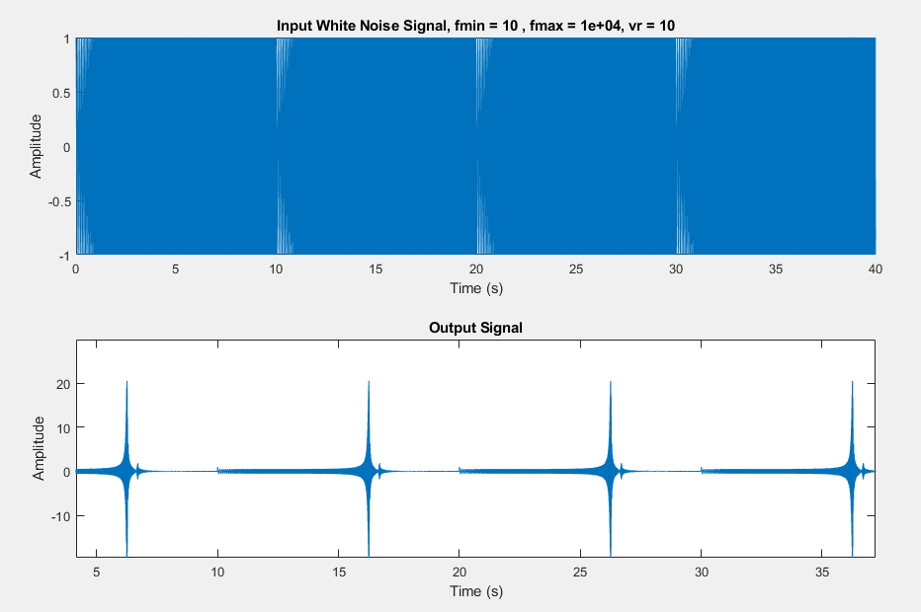
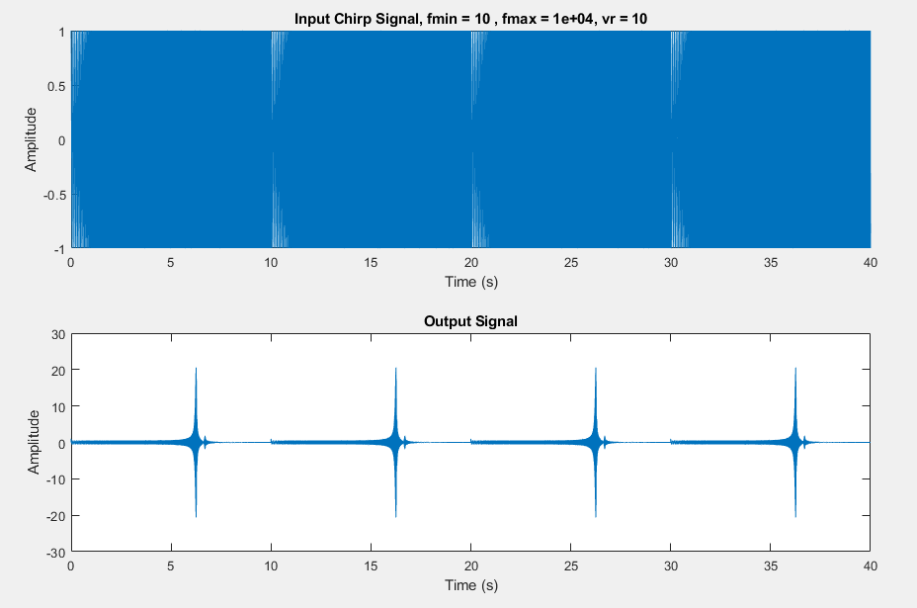
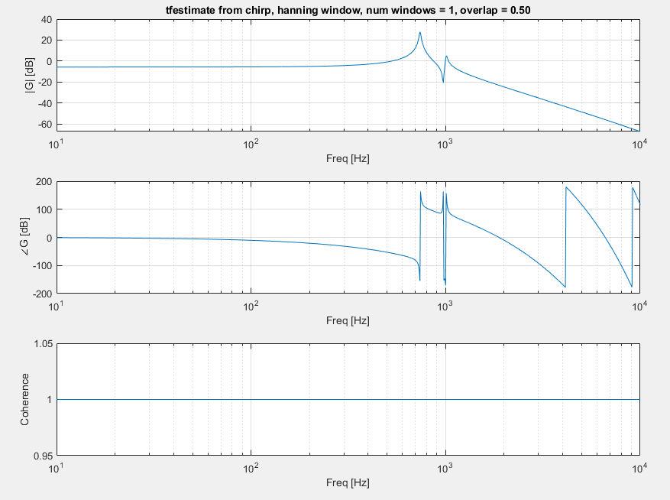
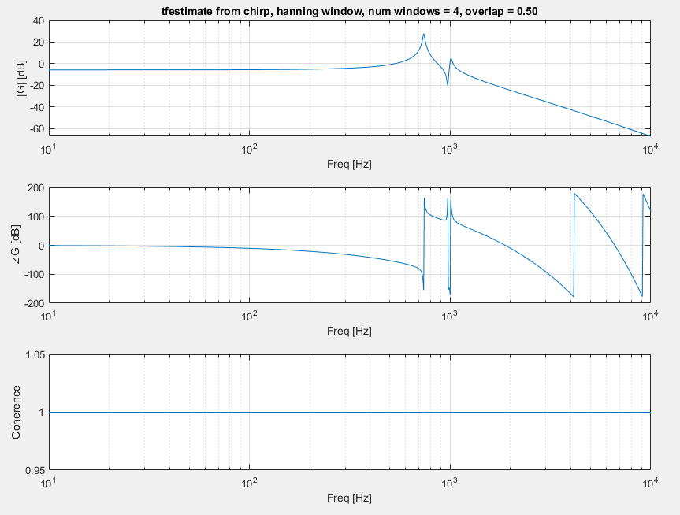
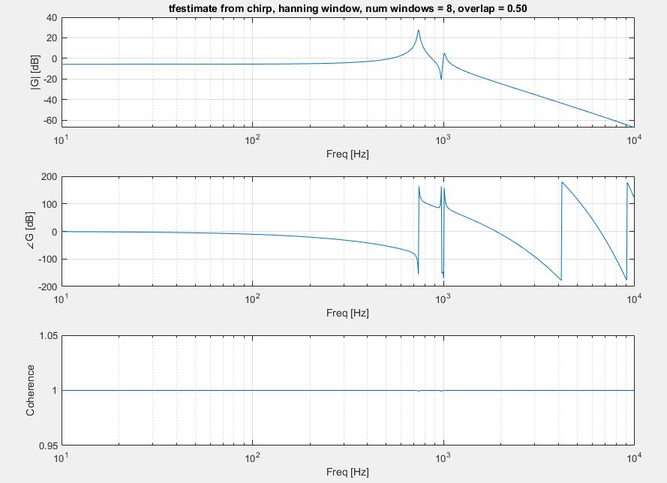
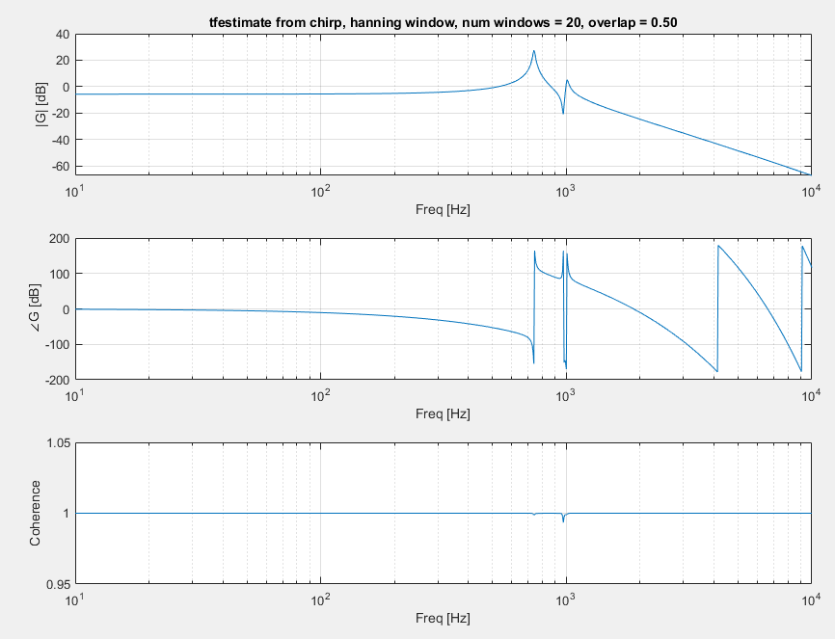

White Noise

Fs = 1e5, tmax = 5, vr = 1, tfestimate(1,4)
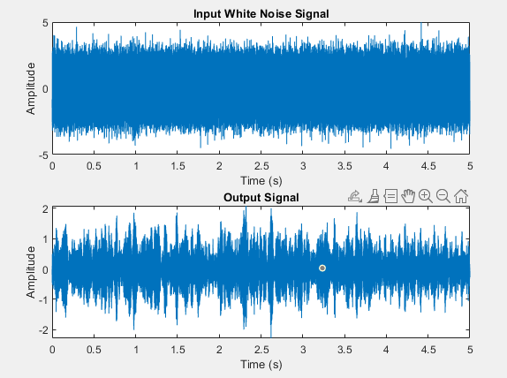
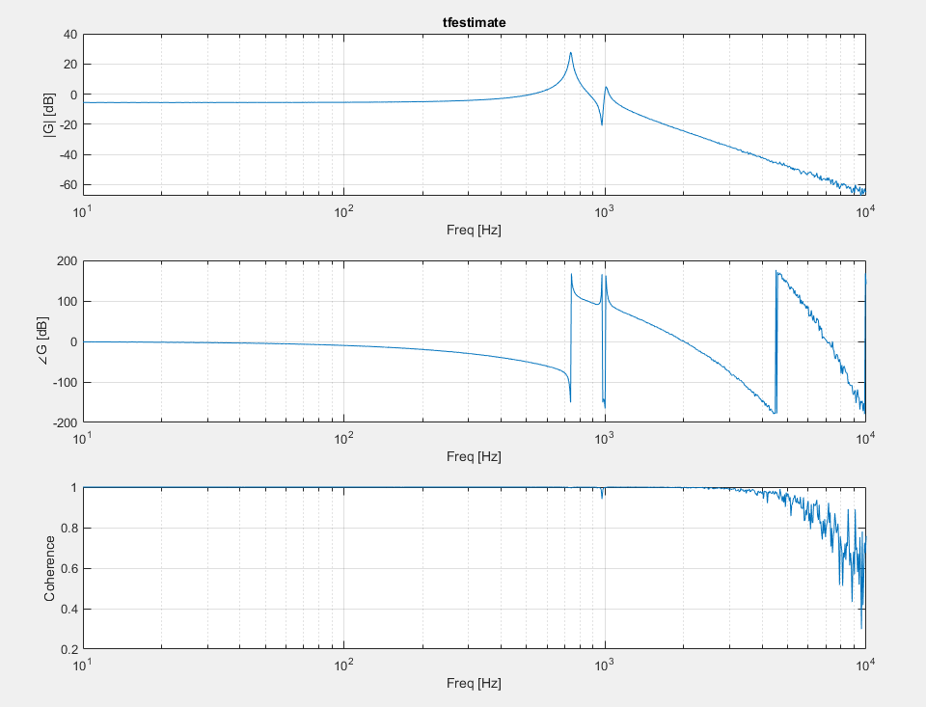

Fs = 1e5, tmax = 5, vr = 1, tfestimate(-1,4)
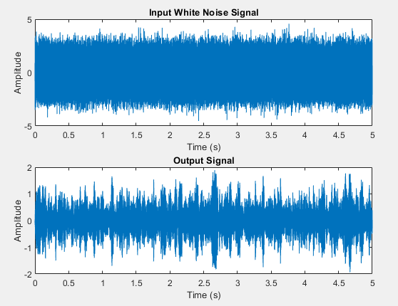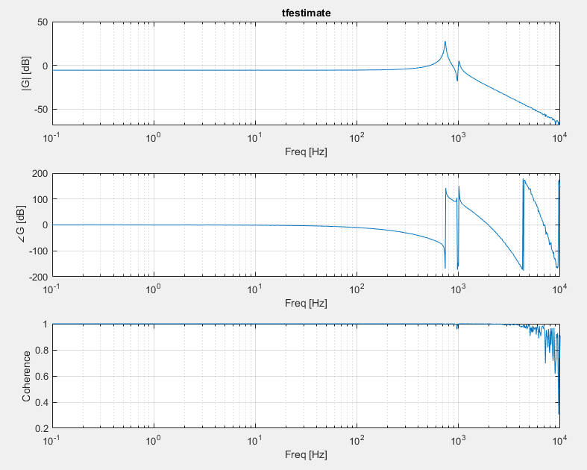

Fs = 1e5, tmax = 5, vr = 5, tfestimate(-1,4)
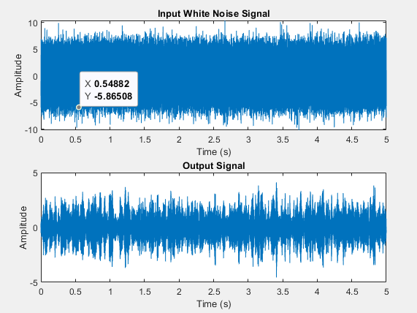

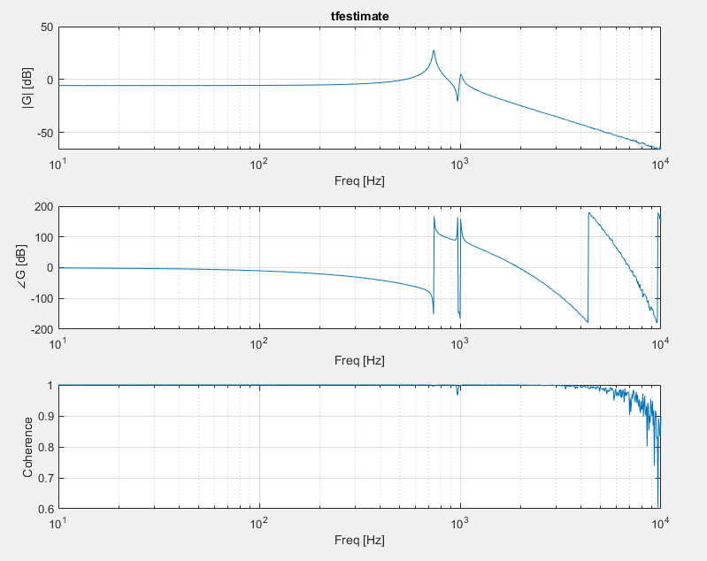
Fs = 1e5, tmax = 5, vr = 10, tfestimate(-1,4)
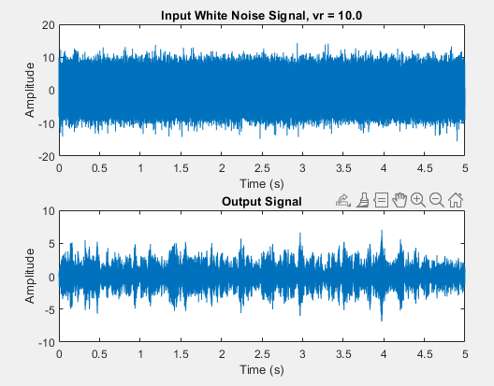
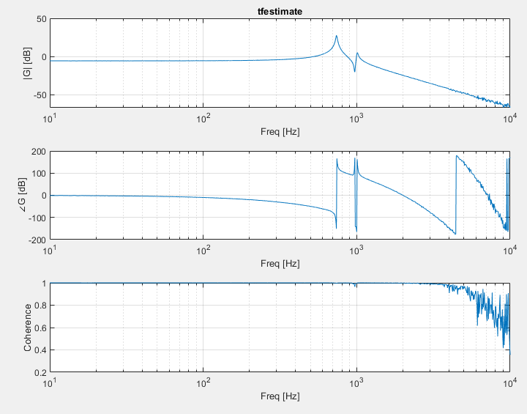

Windowing

Fs = 1e5, tmax = 5, vr = 10,
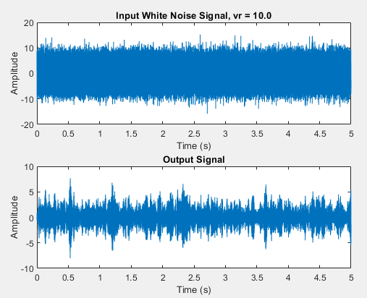
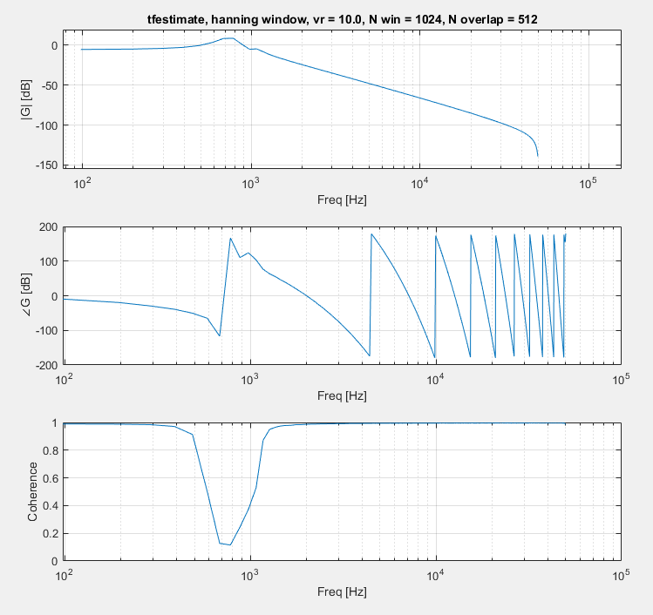
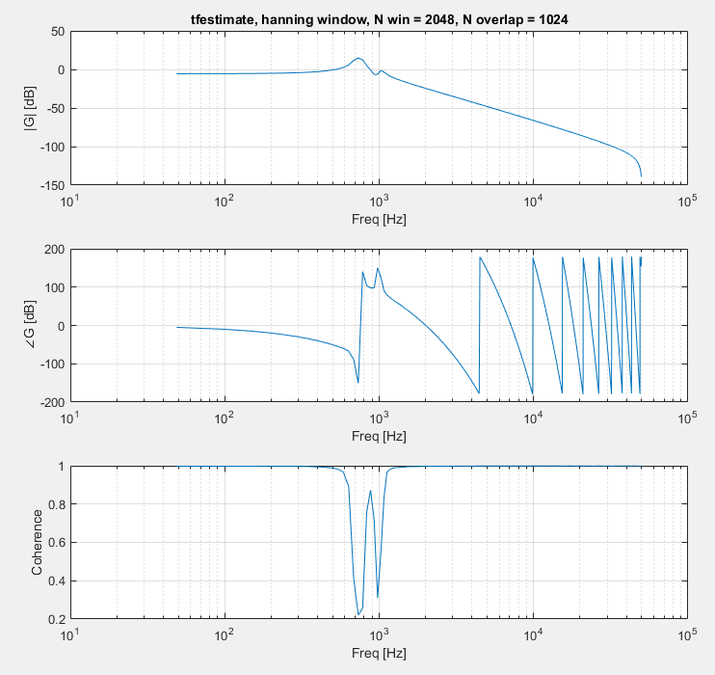
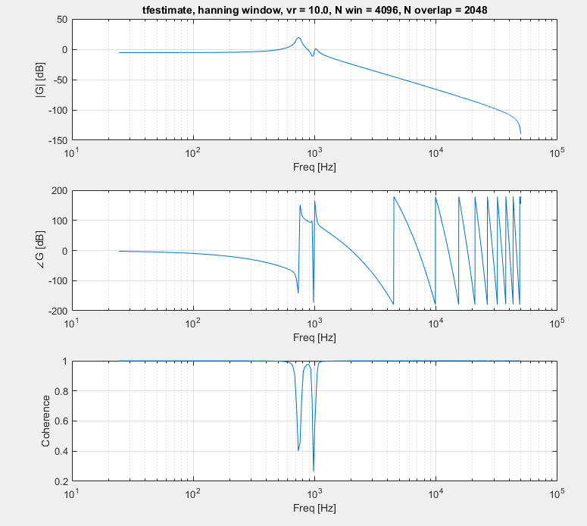
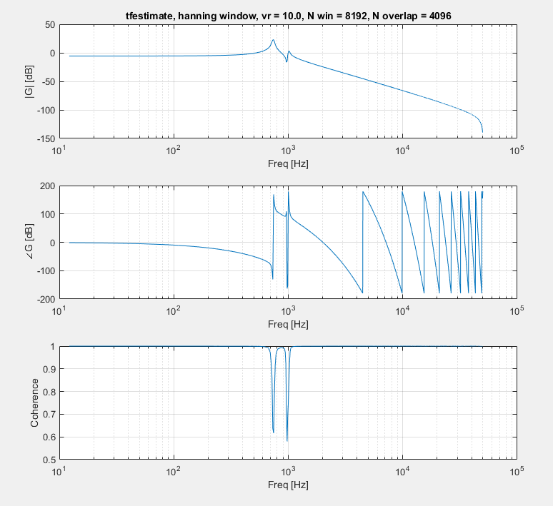

Proper Hanning
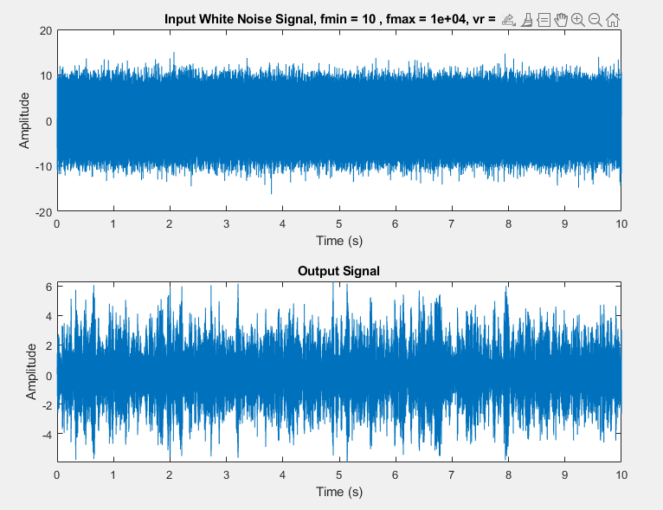
No windowing
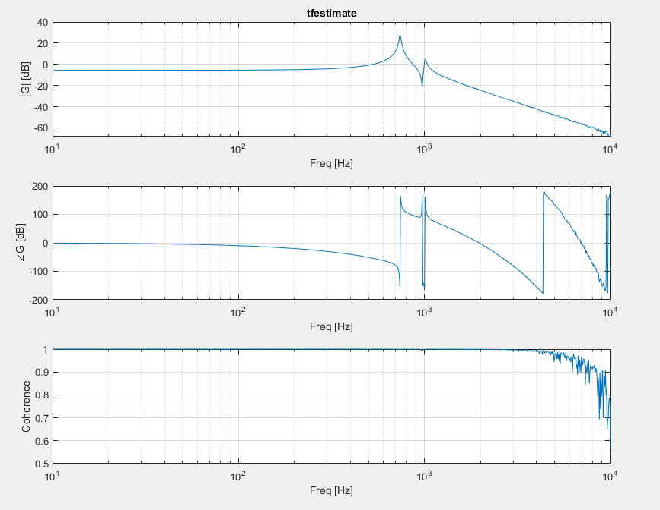
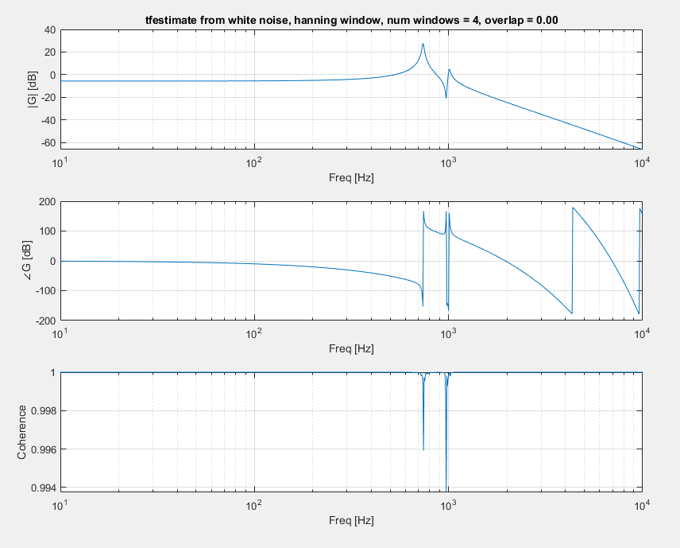
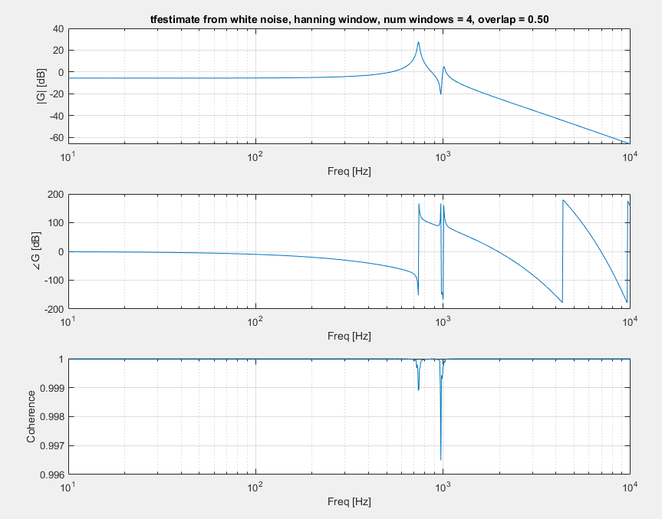
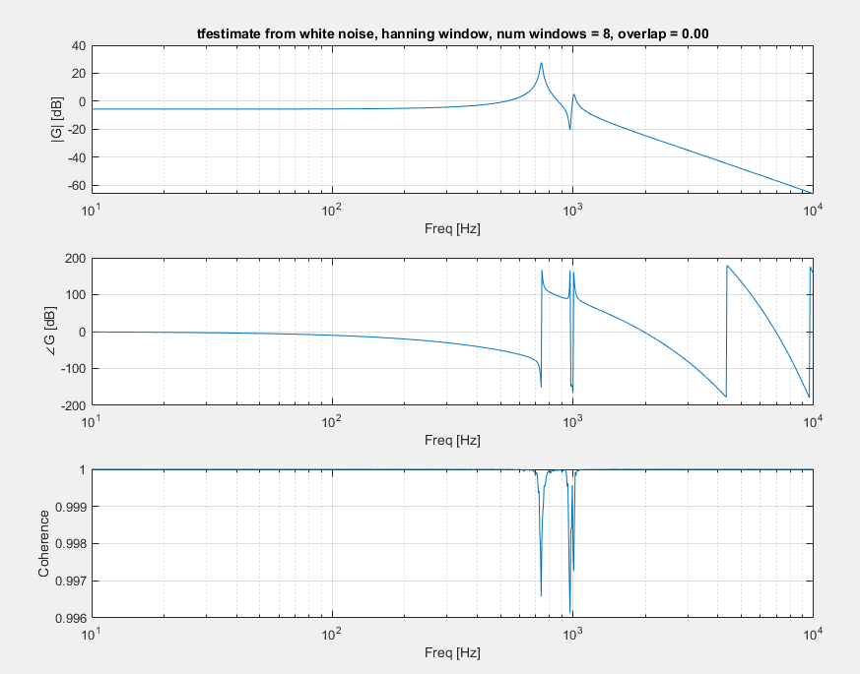
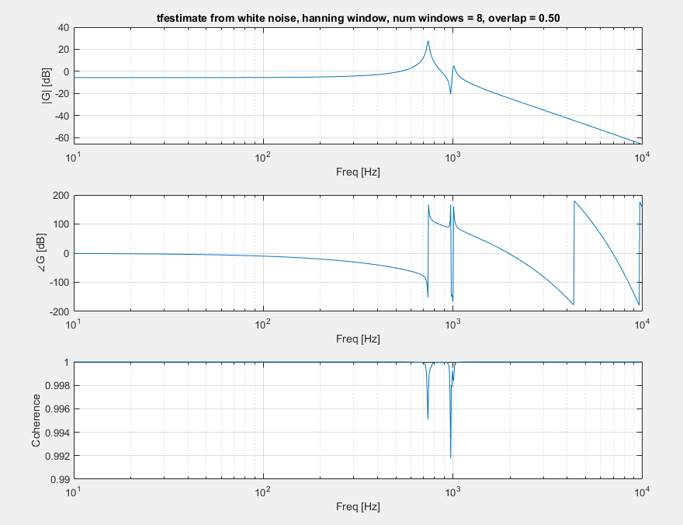
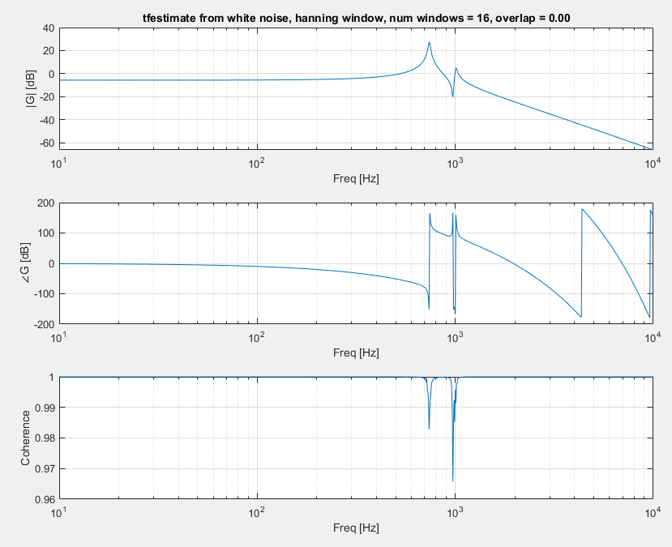
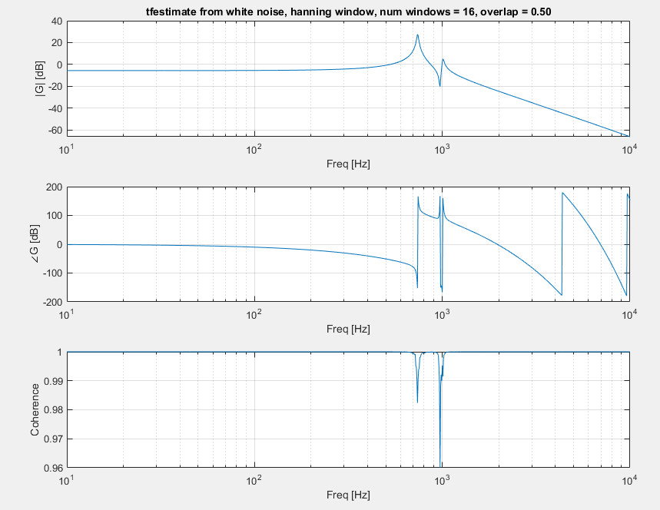
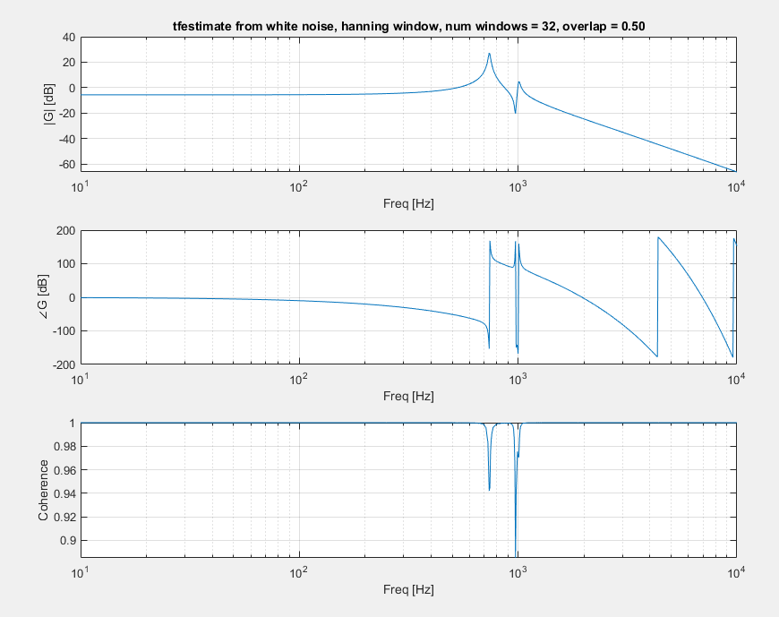
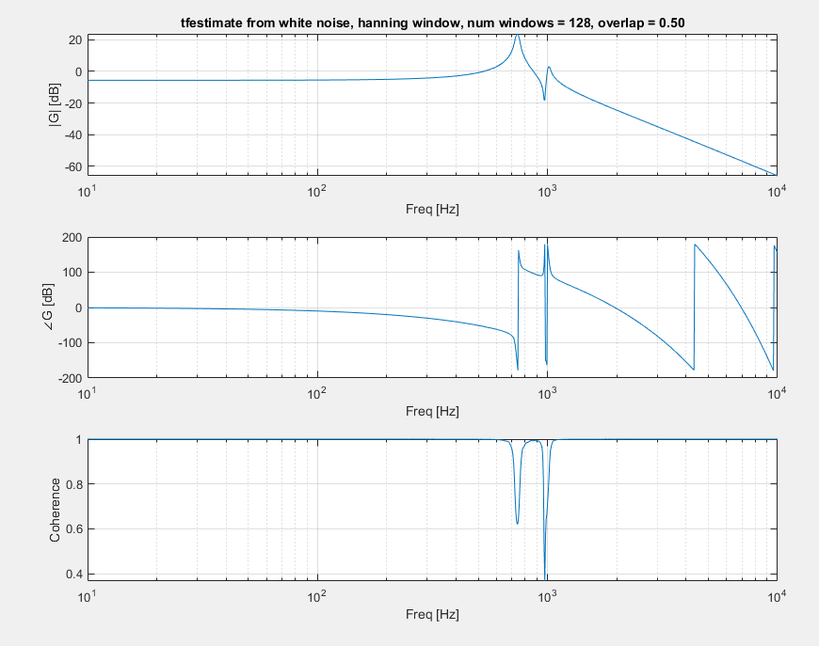

True Test of Windowing, ts = 30us
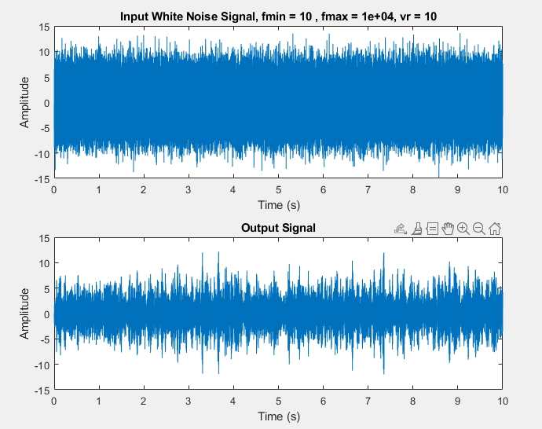

Jesse’s theory of everything
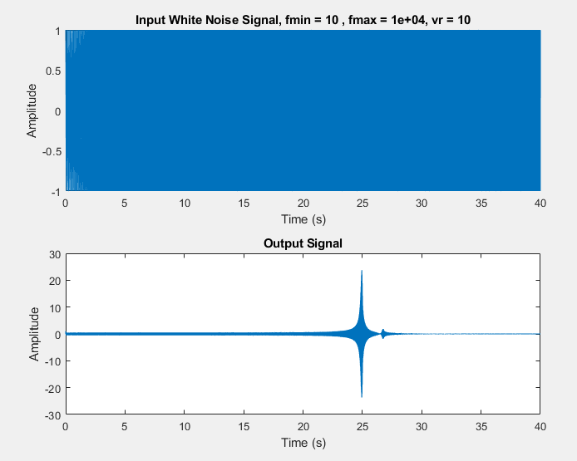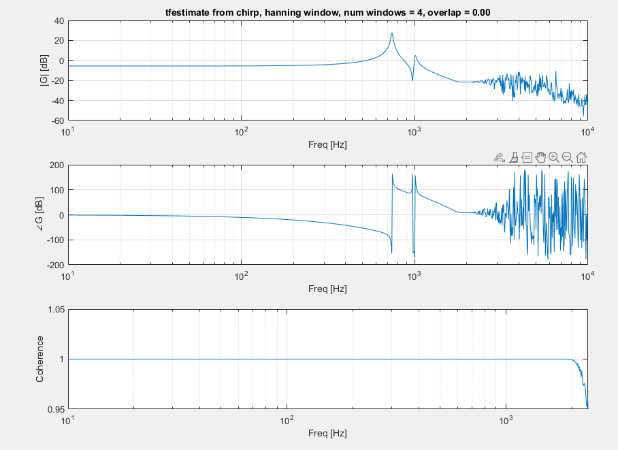

One last check for higher order modes
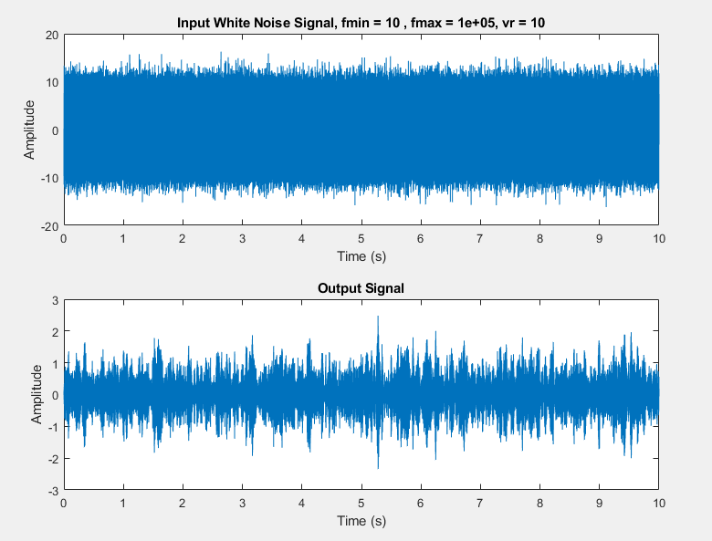
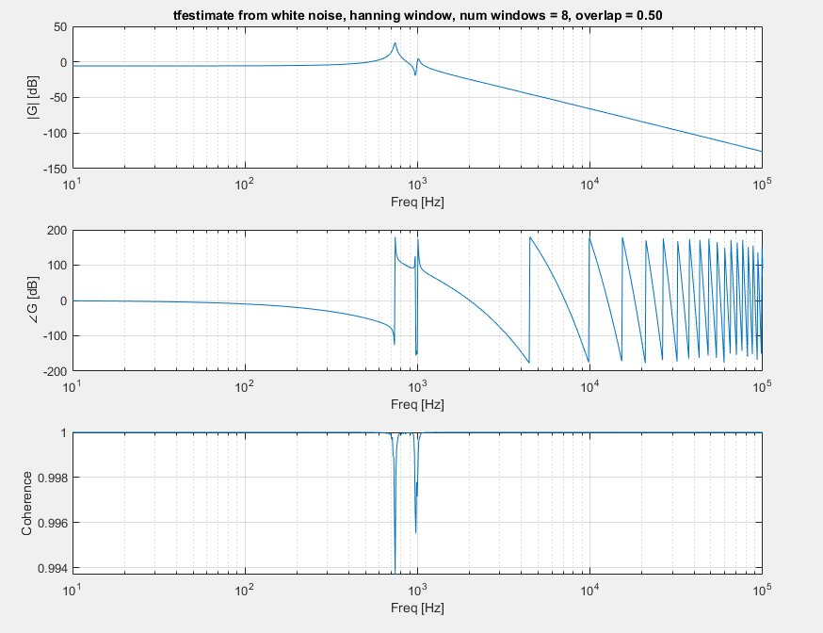
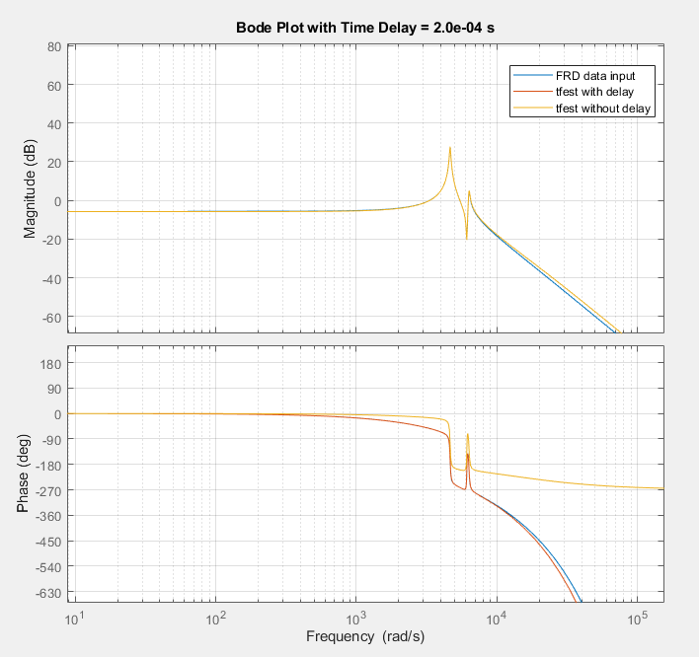

Tfest
Idk what I’m doing
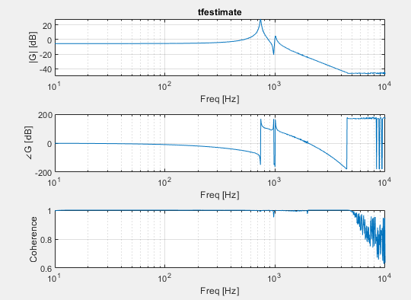
Using 2nd line, 4 poles 2 zeros
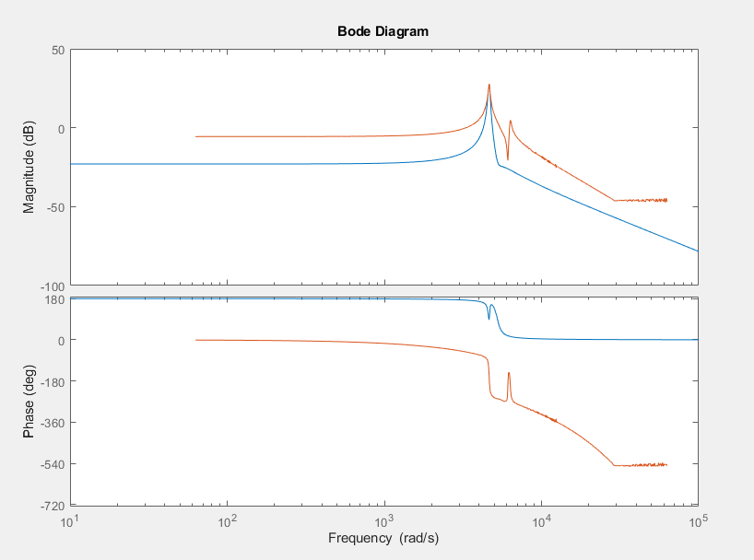
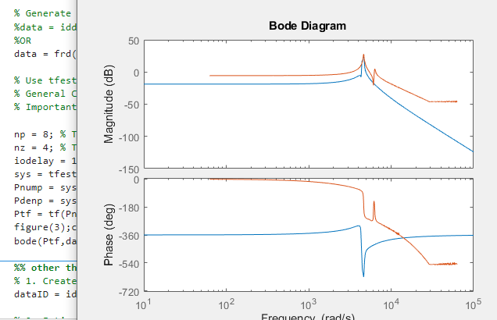
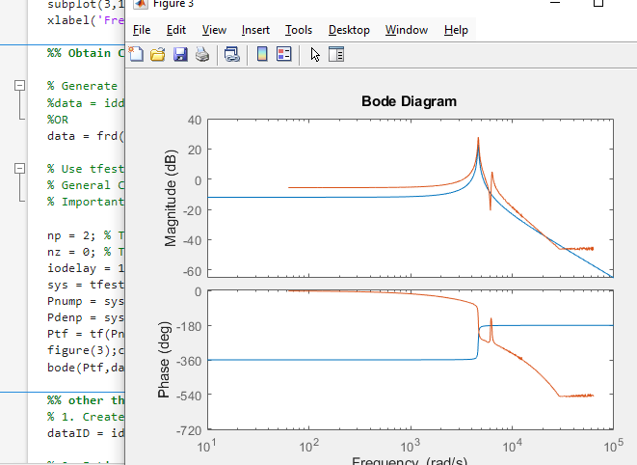
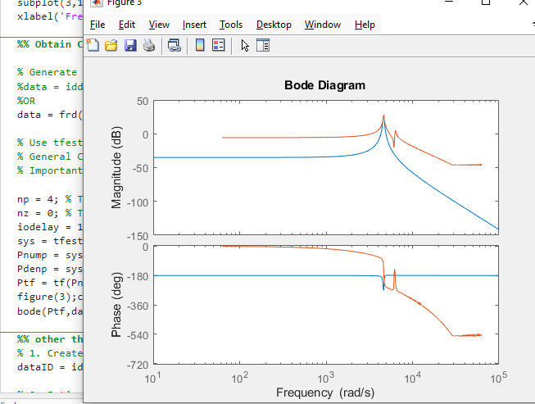
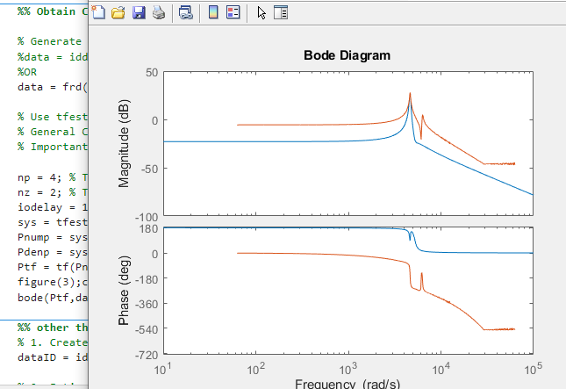

No scaling
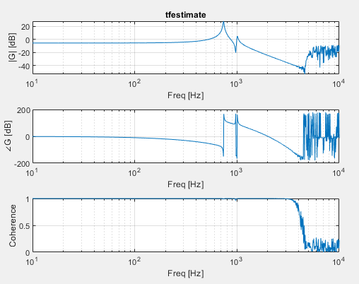
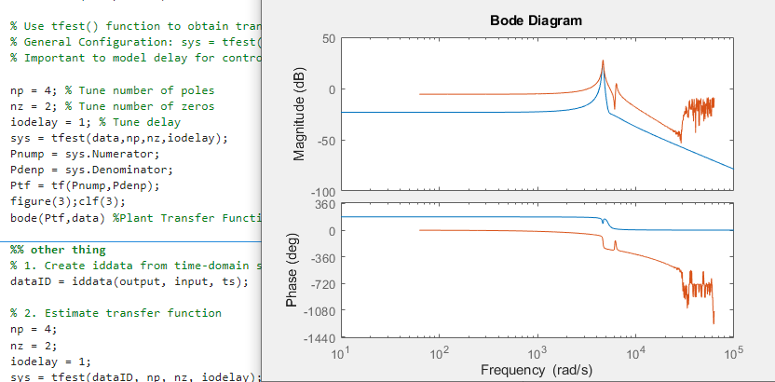

Using first like (iddata)

Uhhh thanks gpt
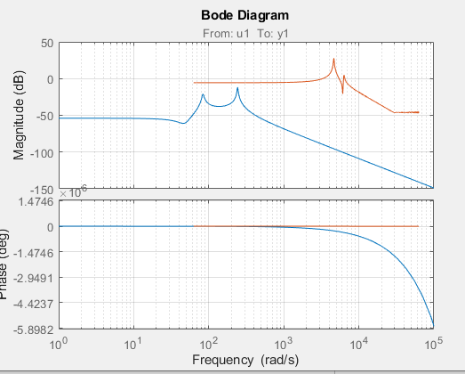
Error in JX_MSD2025_Part1_SystemIdentification (line 136)
bode(Ptf,data) %Plant Transfer Function from Identification

Unrecognized function or variable 'dataFRD'.

Error in JX_MSD2025_Part1_SystemIdentification (line 149)
bode(sys, dataFRD); % overlay fitted model and measured data

Tuning iodelay

1e-3, 5p3z
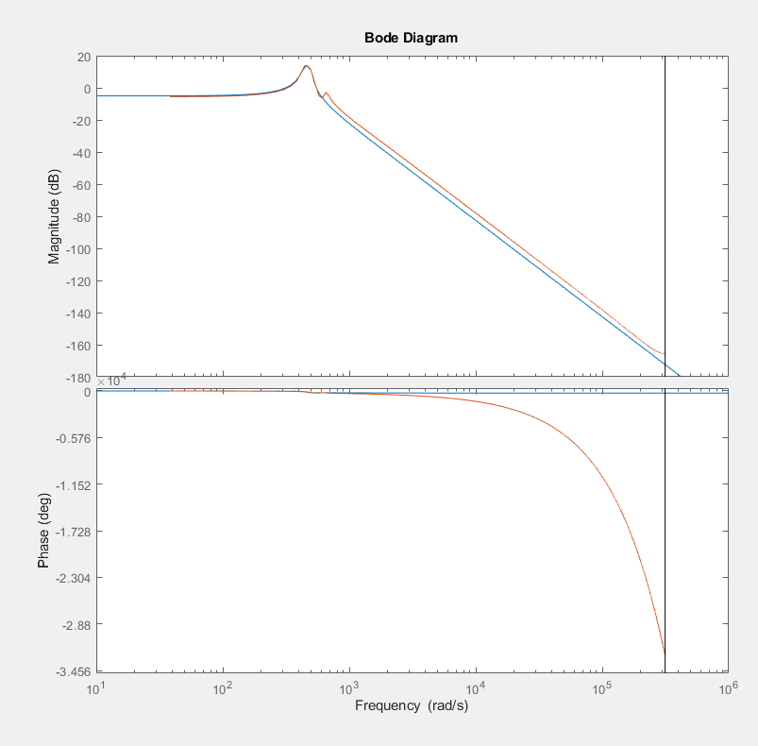

1e-4, actually good result with white noise
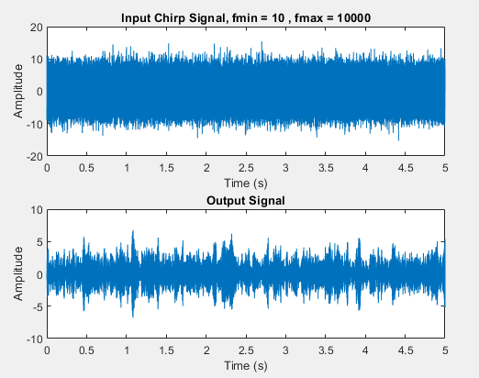
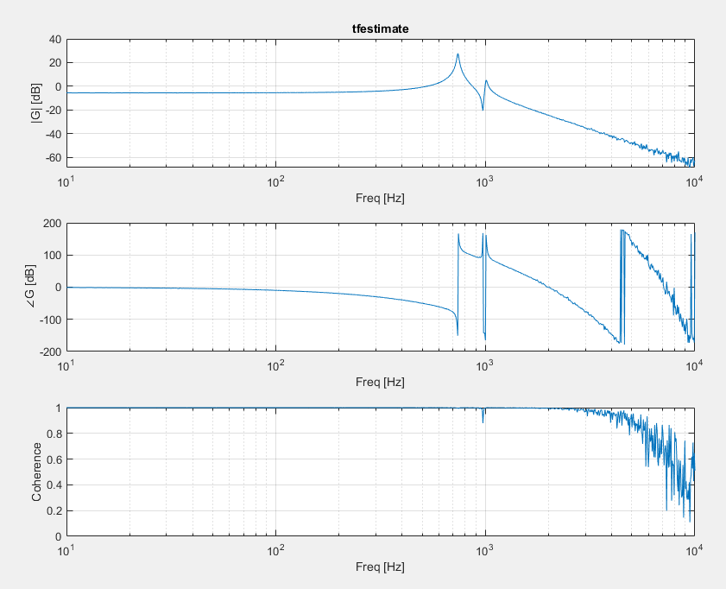
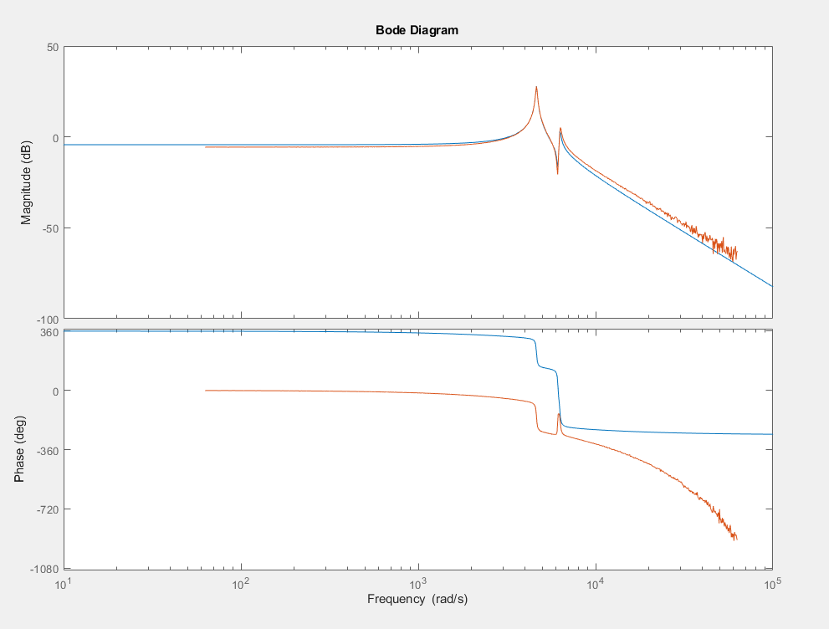

10 to 1e4 chirp, 10s, log 1e2 (2e4 to 1e4), no windowing
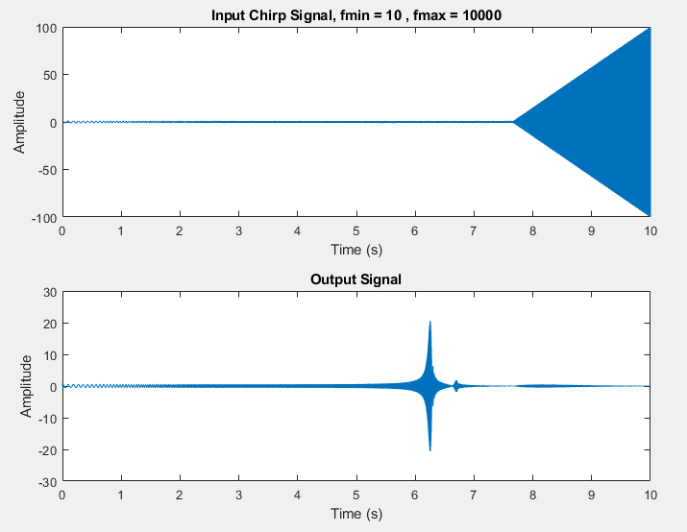
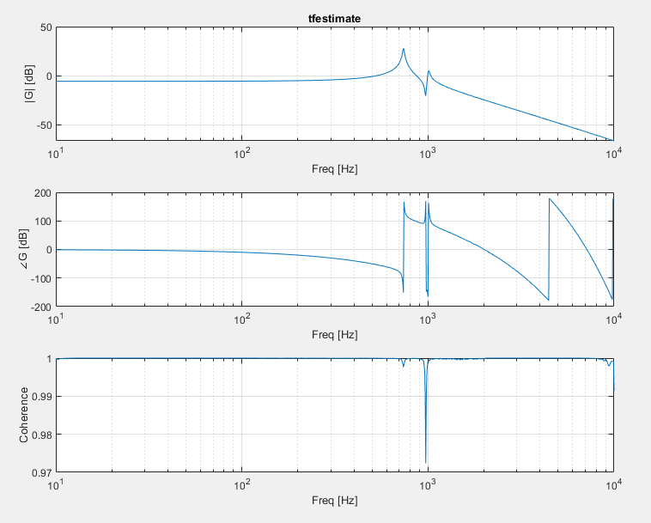

Iodelay = 1
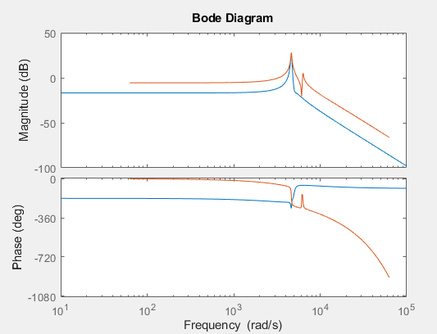
Iodelay = 1e-1
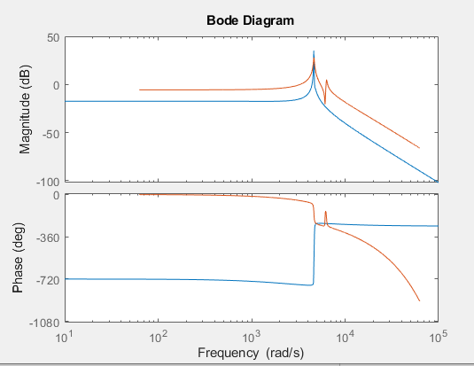
Iodelay = 1e-2
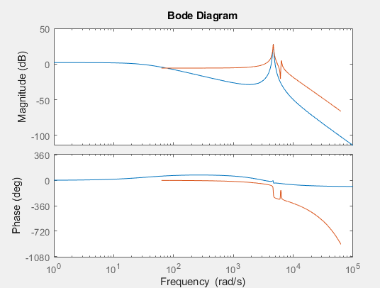
Iodelay = 1e-3
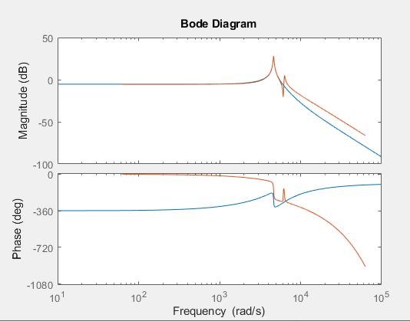
Iodelay = 1e-5
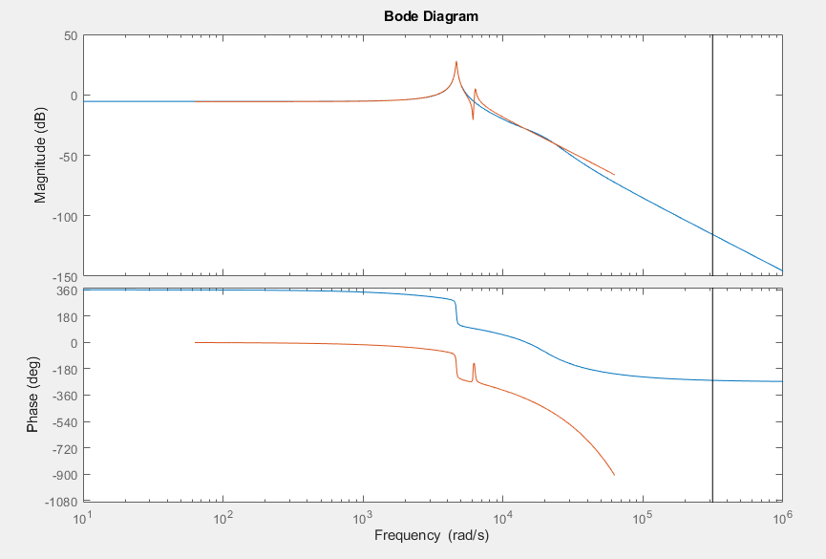
Iodelay = 0
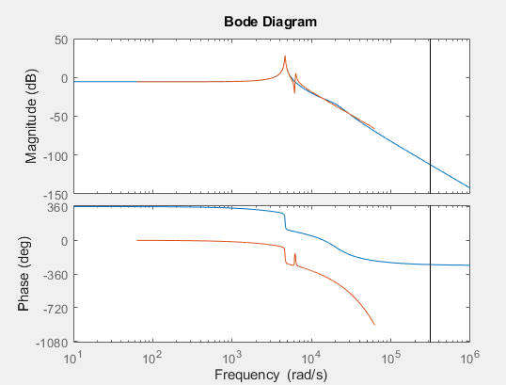

Iodelay = 1e-4
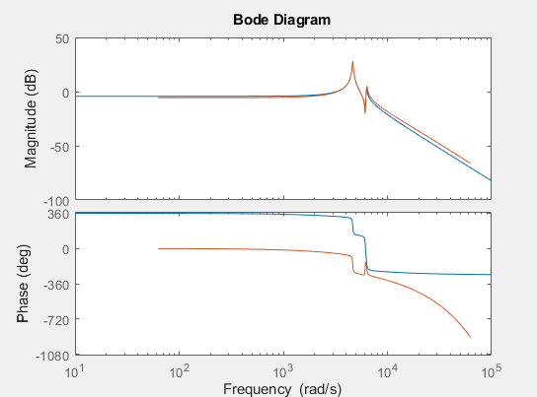
Iodelay = 1.5e-4
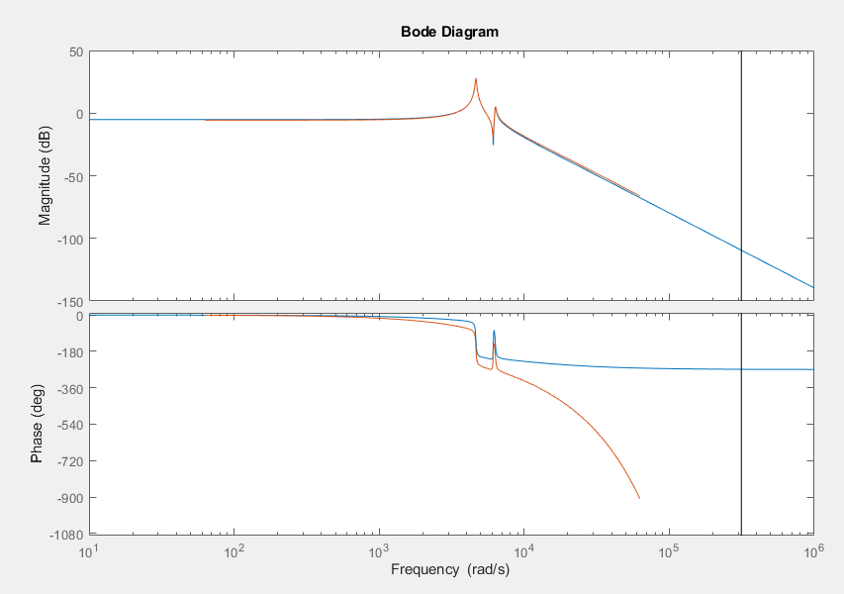

Iodelay = 2e-4
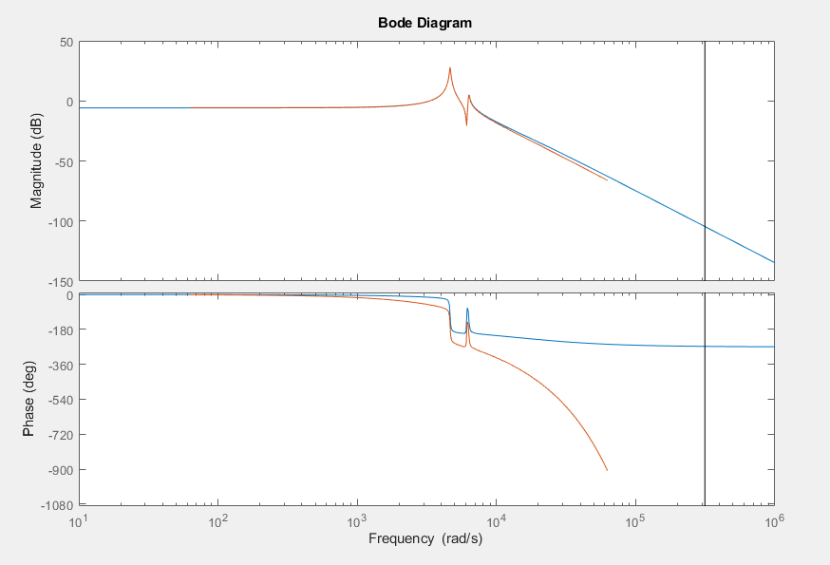

Iodelay = 2.5e-4
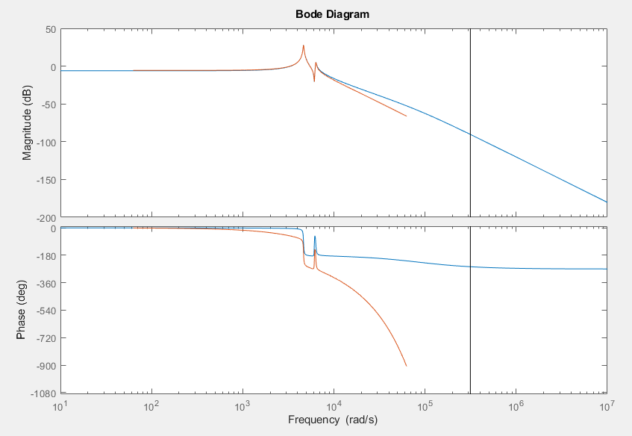
Iodelay = 3e-4
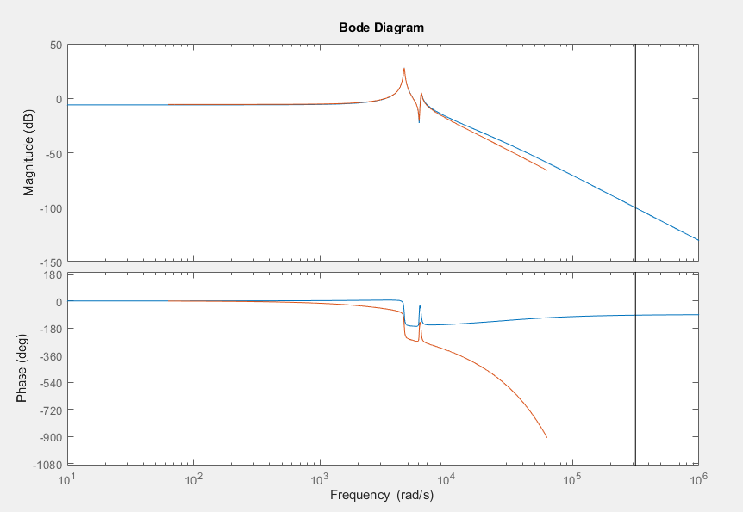
Iodelay = 4e-4
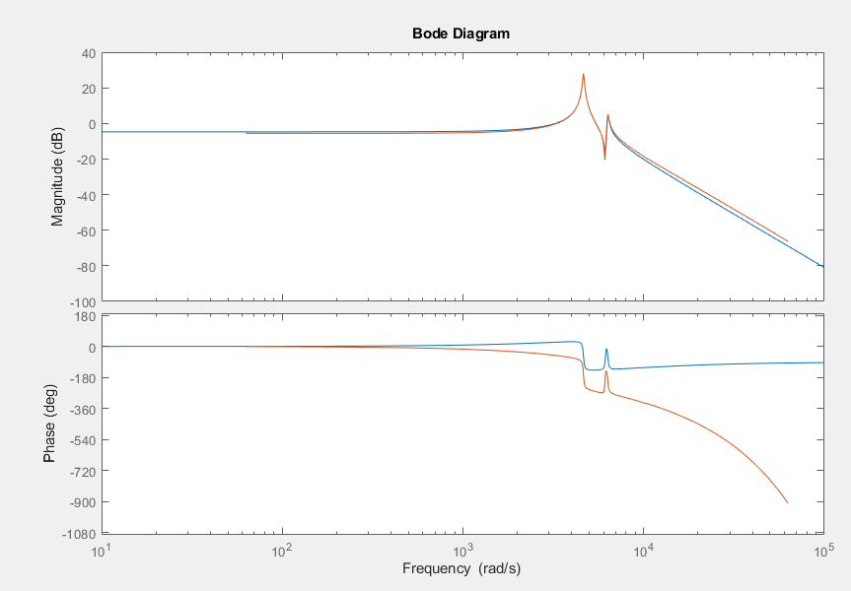
Iodelay = 5e-4
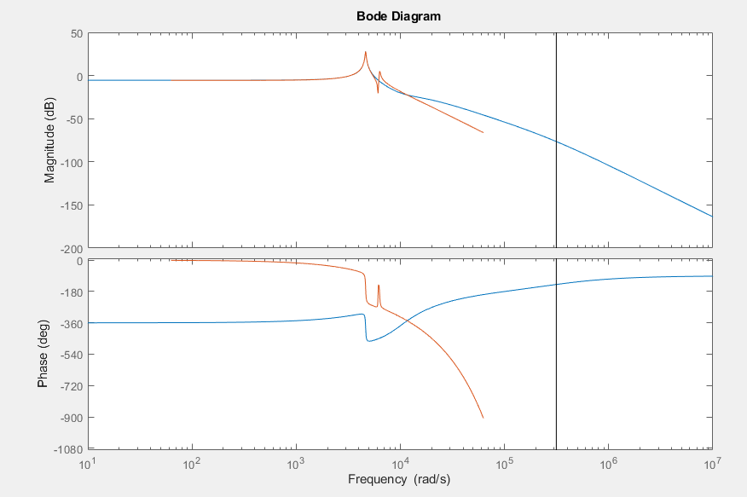
Iodelay 9e-5
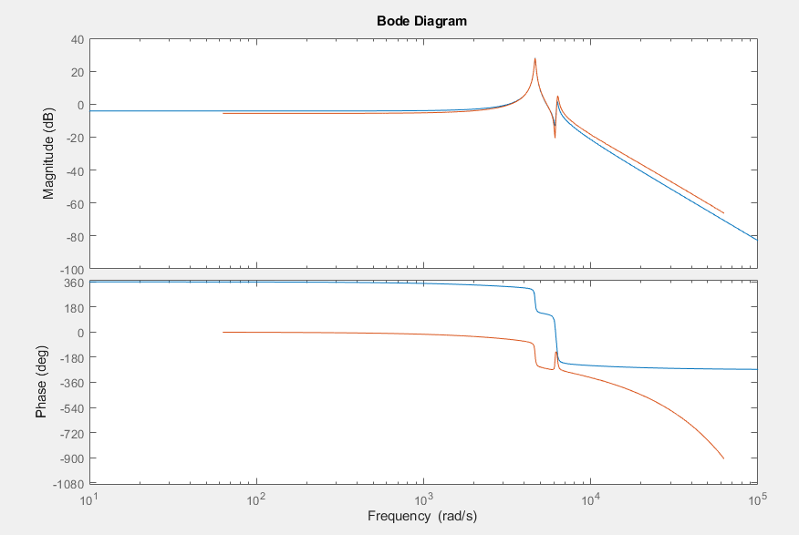
Iodelay 8e-5
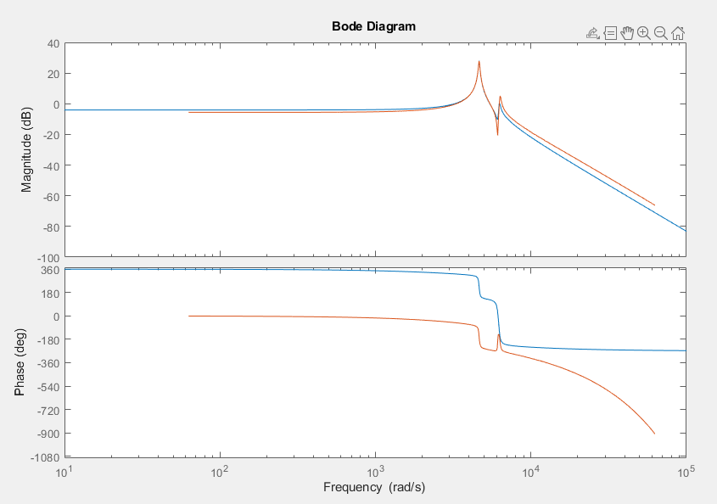
Iodelay 7e-5
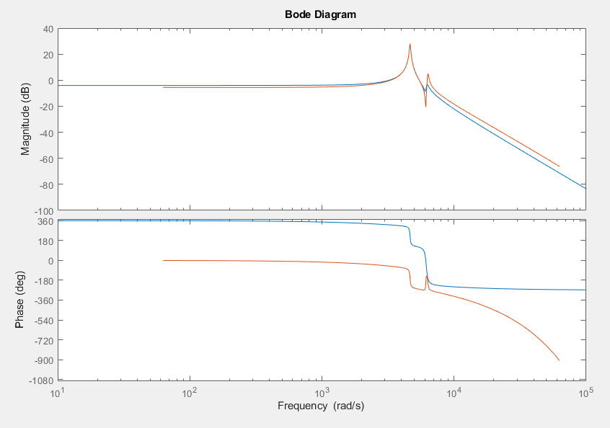

White noise, tuning poles & zeros
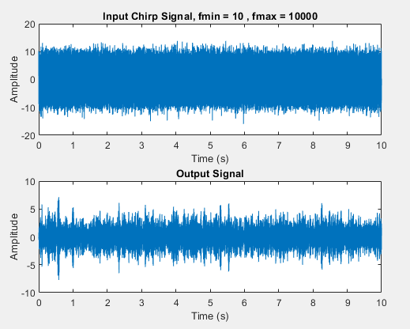
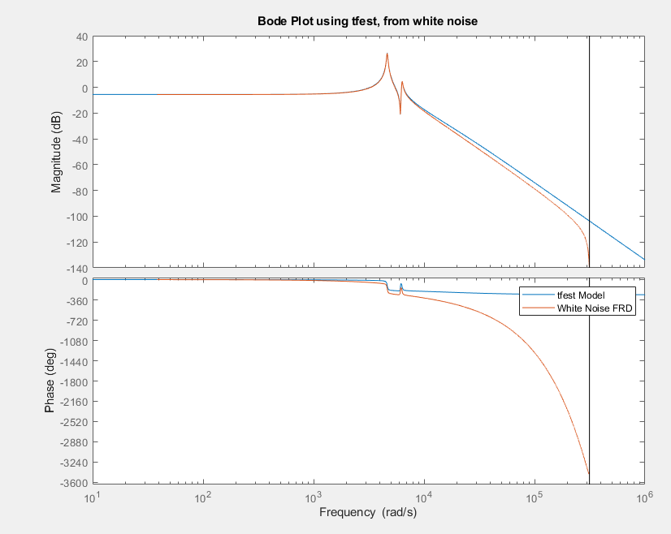
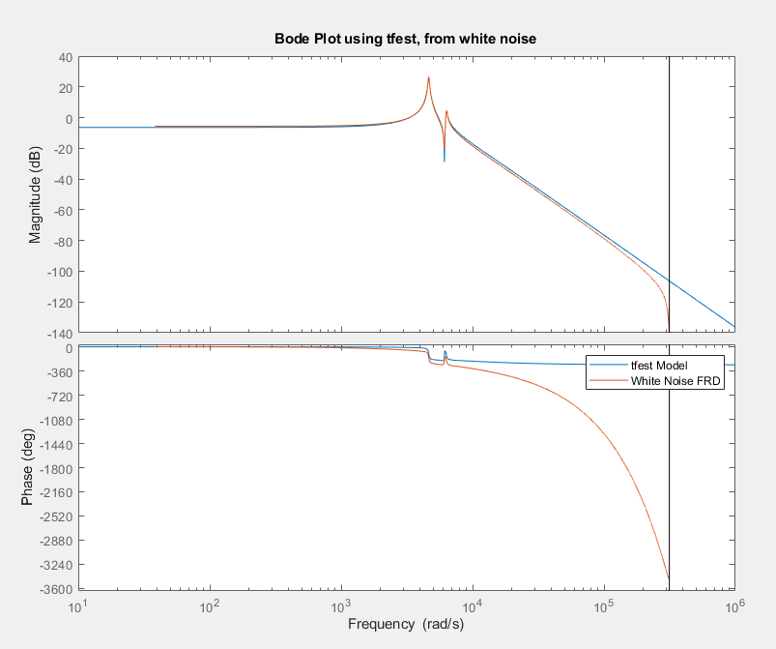

Chirp, tuning poles & zeros
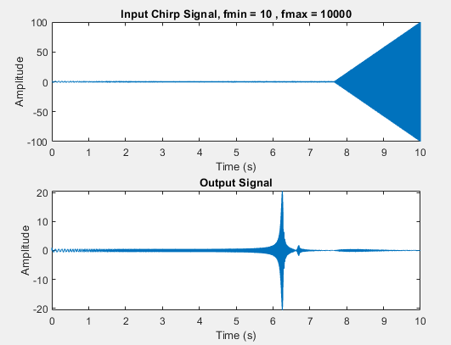
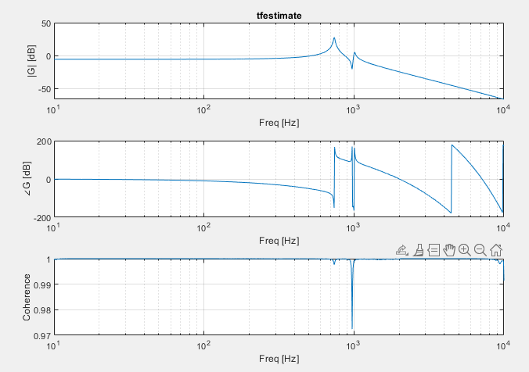
5p 2z
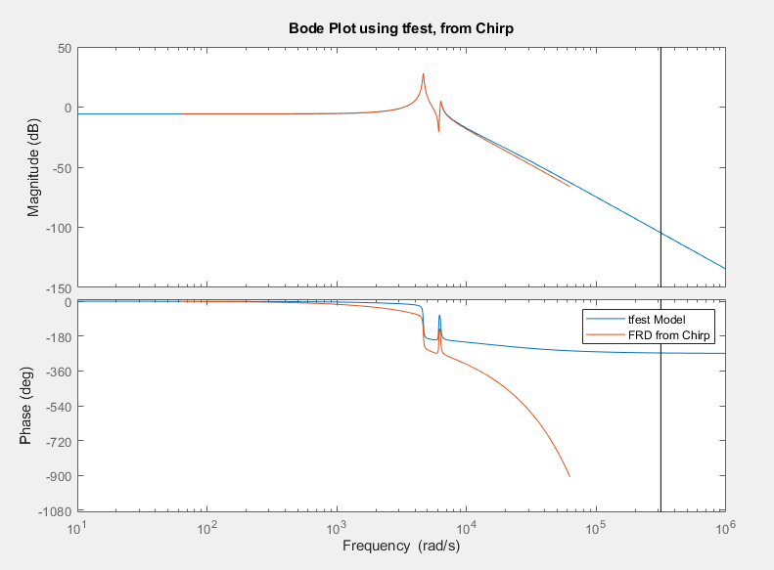
6p3z
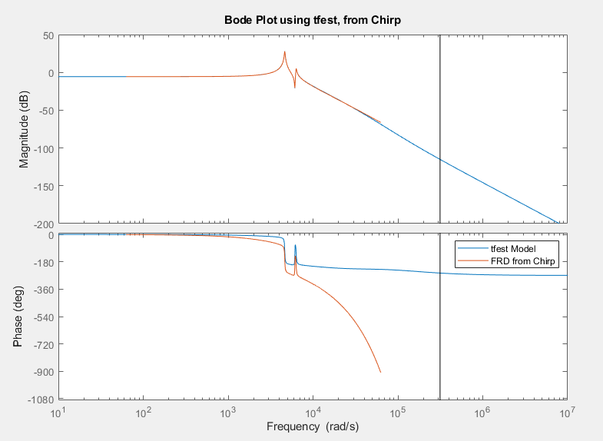
7p4z
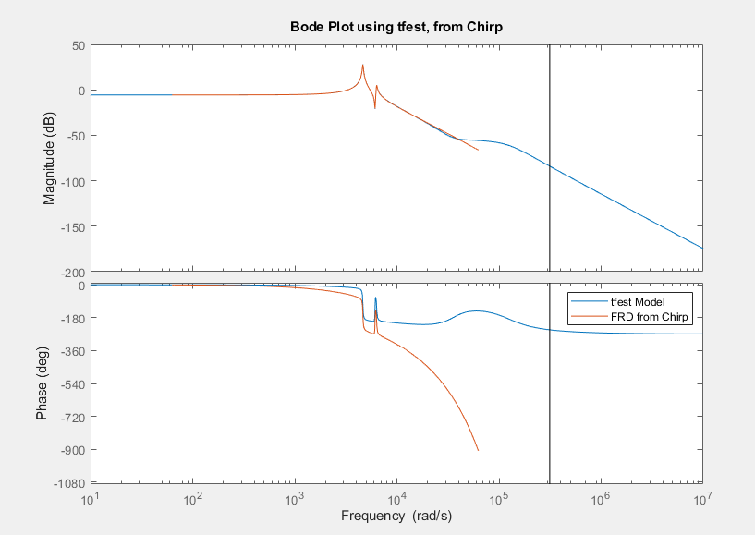

Final checks with 30e-6
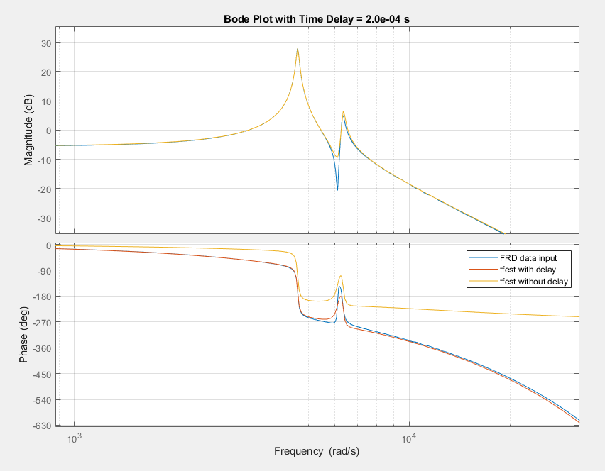
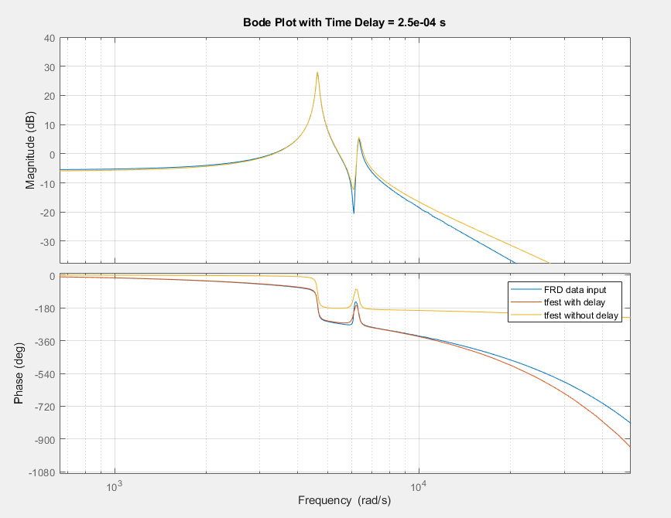
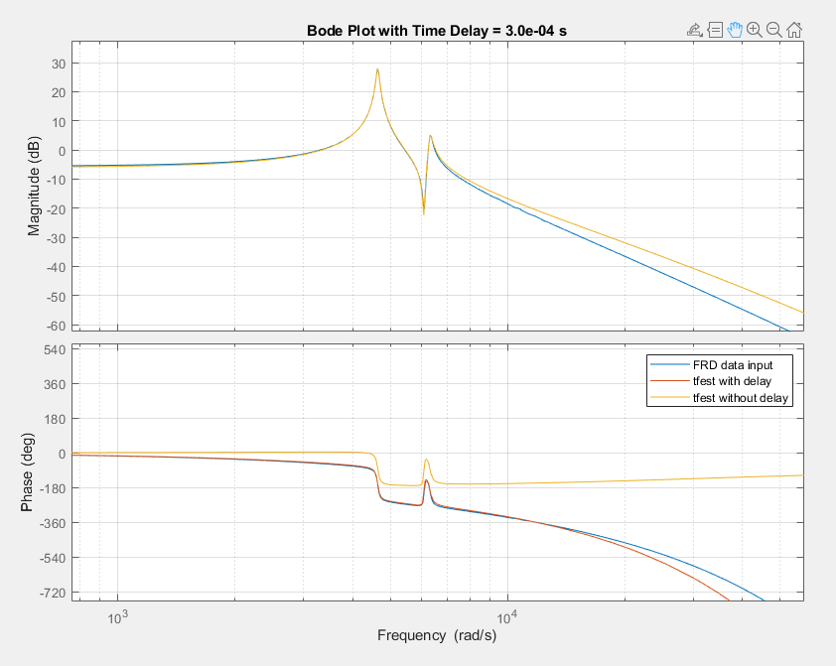
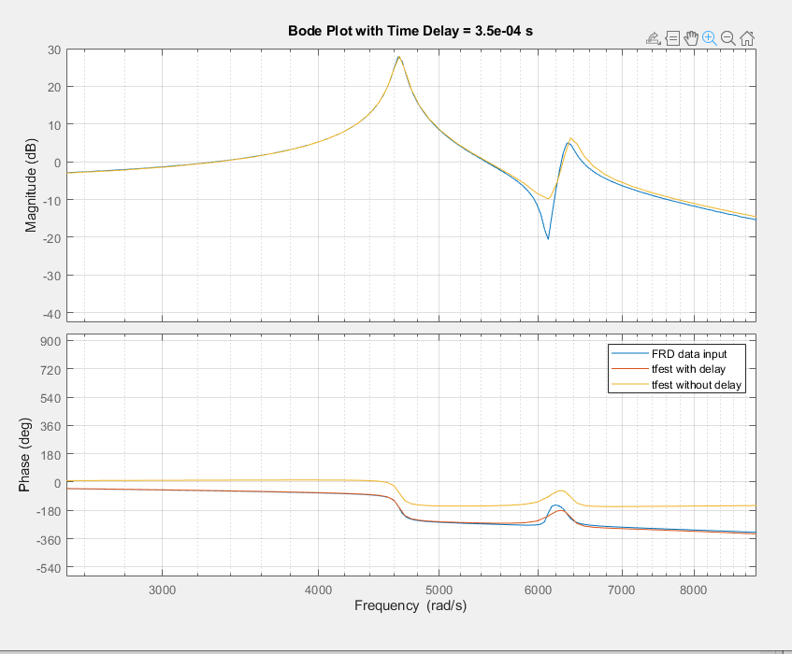

Last check with 30e-6, scaling
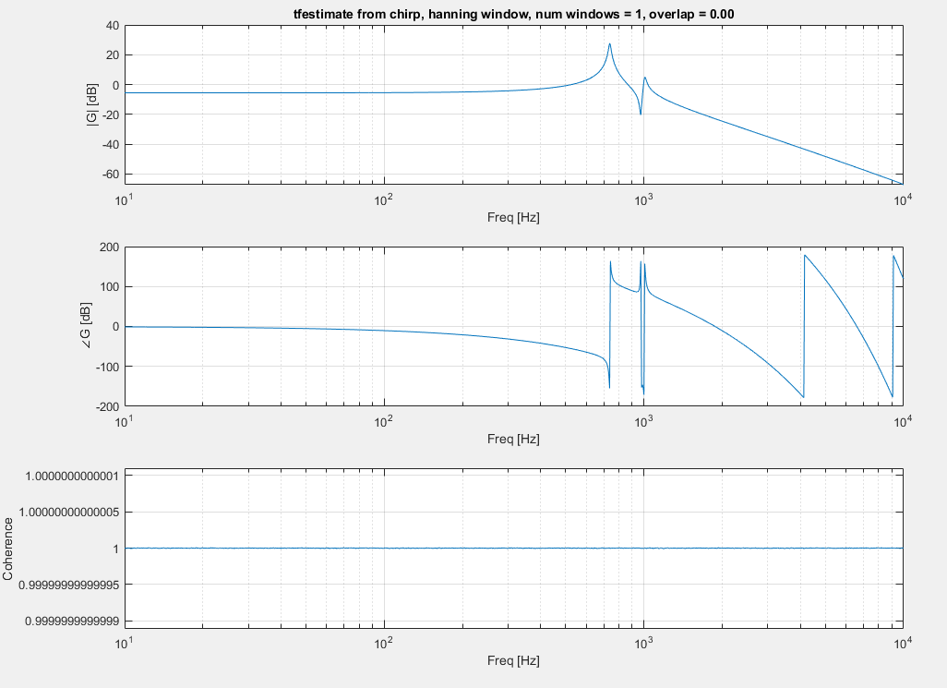
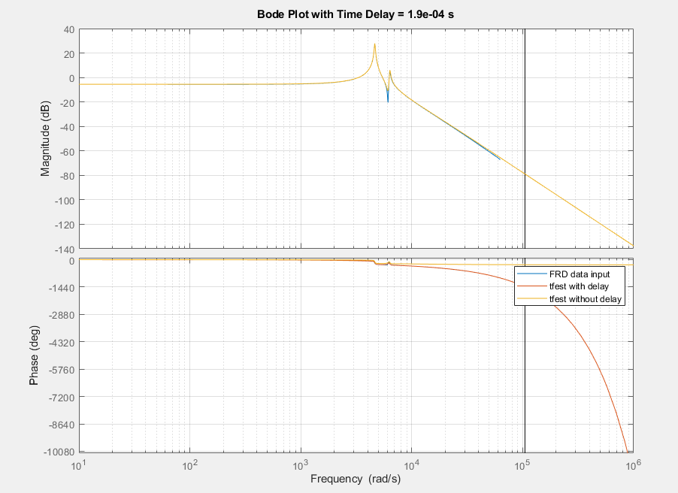
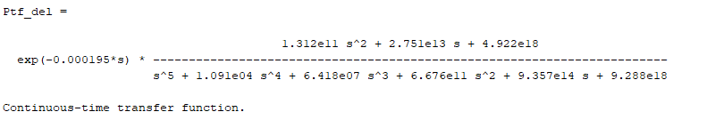

Now back to higher fs
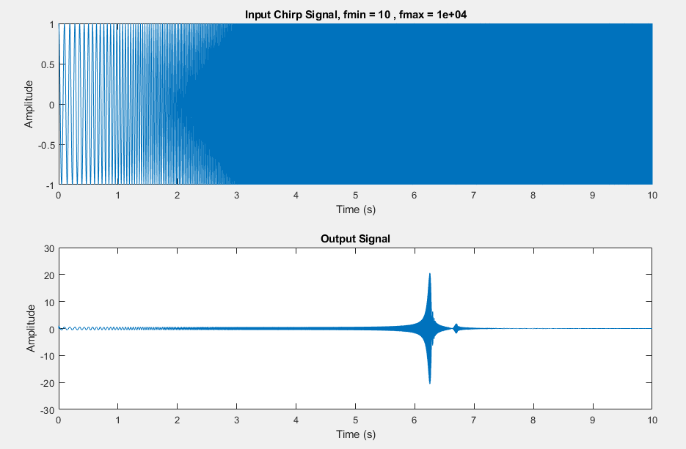
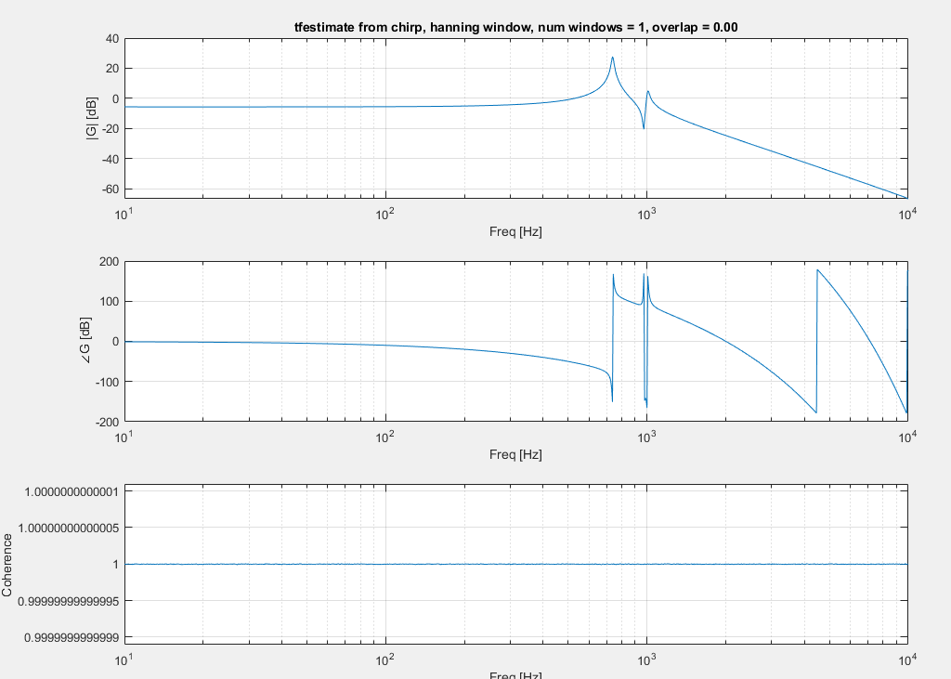
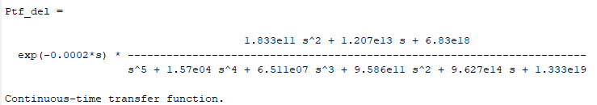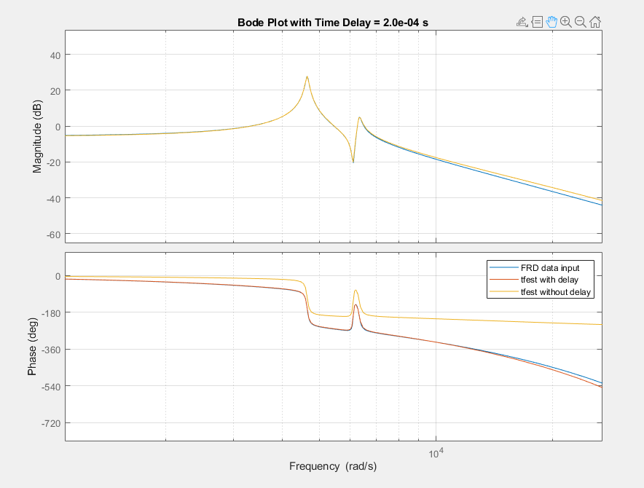

FINAL TRANSFER FUNCTION
Ptf =

1.833e11 s^2 + 1.207e13 s + 6.83e18
-----------------------------------------------------------------------
s^5 + 1.57e04 s^4 + 6.511e07 s^3 + 9.586e11 s^2 + 9.627e14 s + 1.333e19

Continuous-time transfer function.
Model Properties

Ptf_corr =

1.375e-08 s^2 + 9.056e-07 s + 0.5124
-------------------------------------------------------------------------------
7.502e-20 s^5 + 1.178e-15 s^4 + 4.885e-12 s^3 + 7.191e-08 s^2 + 7.222e-05 s + 1

Adding Time Delay

10 to 3e3, chirp, w time delay
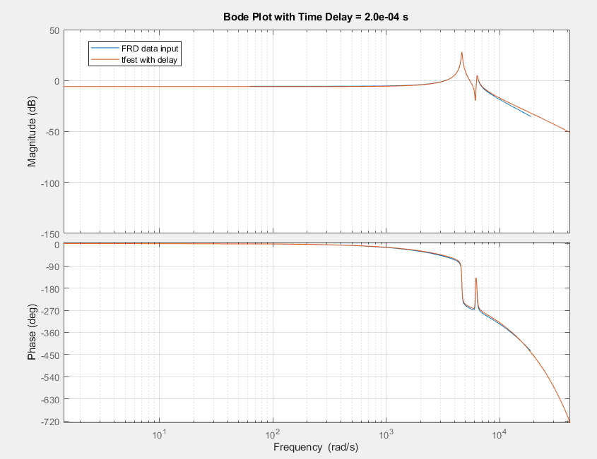
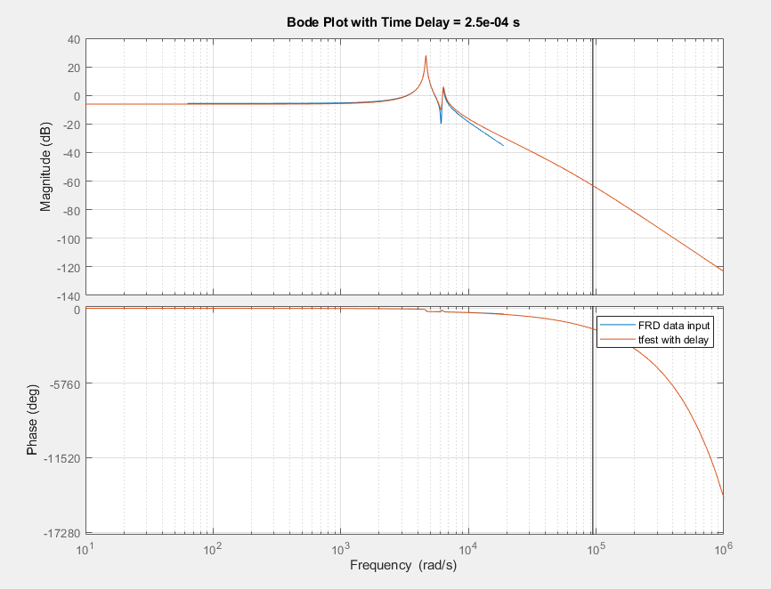
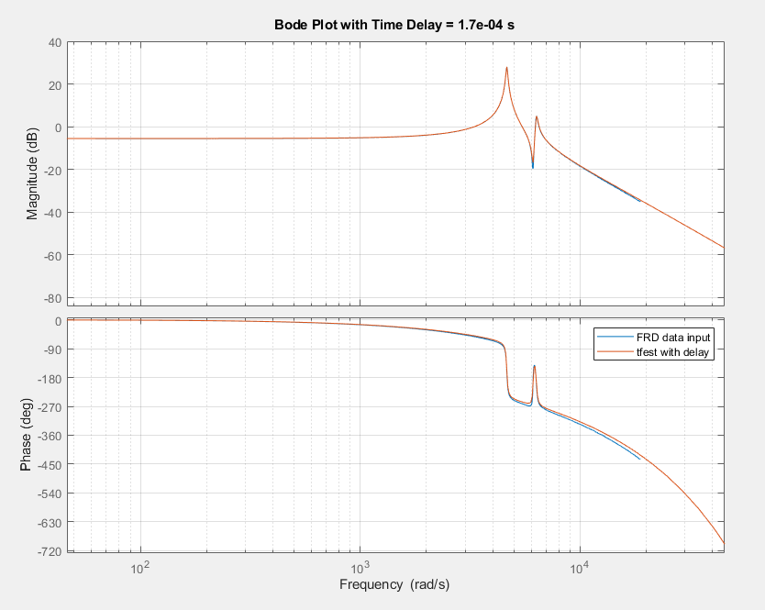
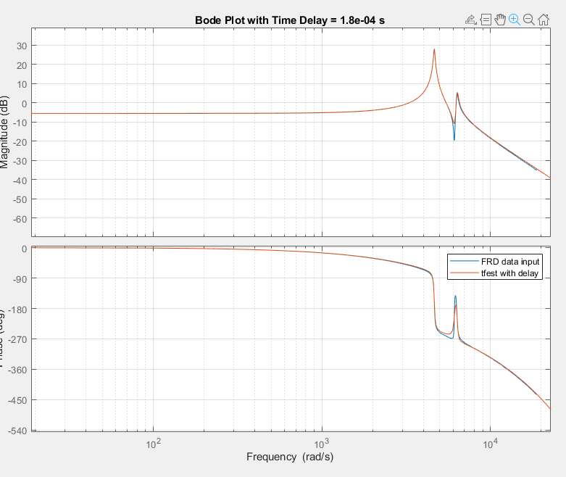
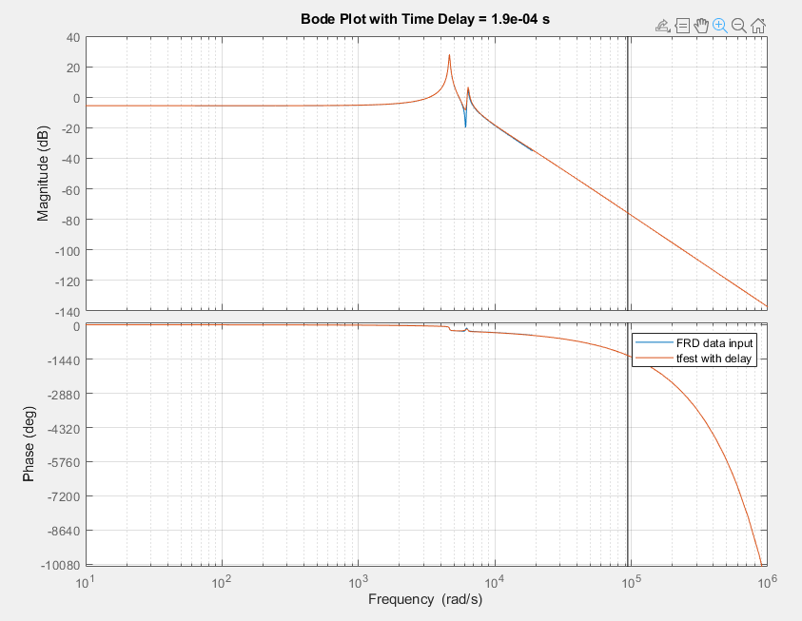
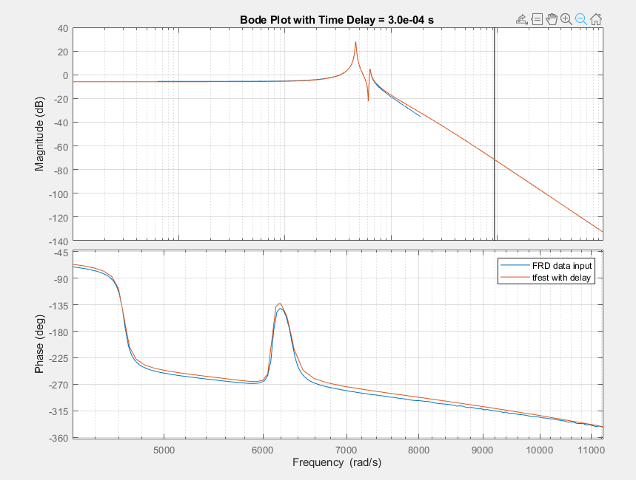
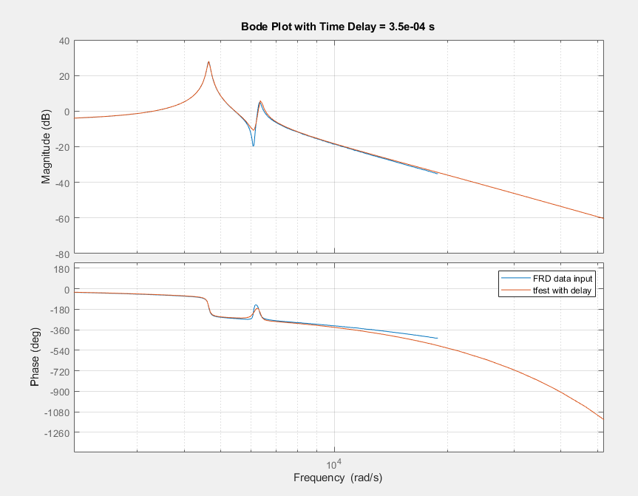

Good Stuff

Tfest with Chirp
Iodelay = 2e-4


Tfest with White noise, no windowing
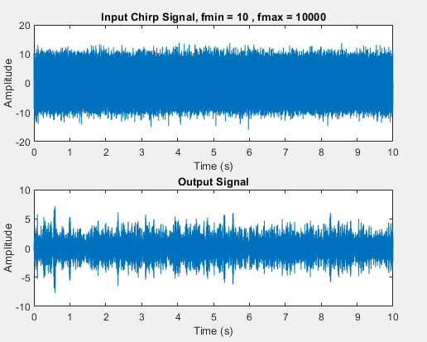
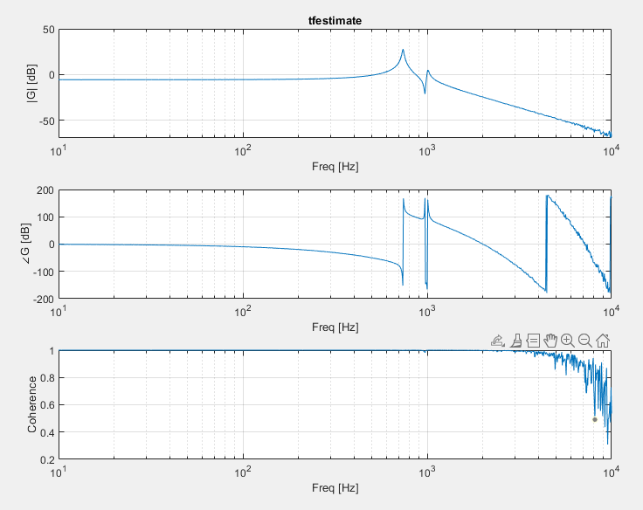
Tfest 2e-4
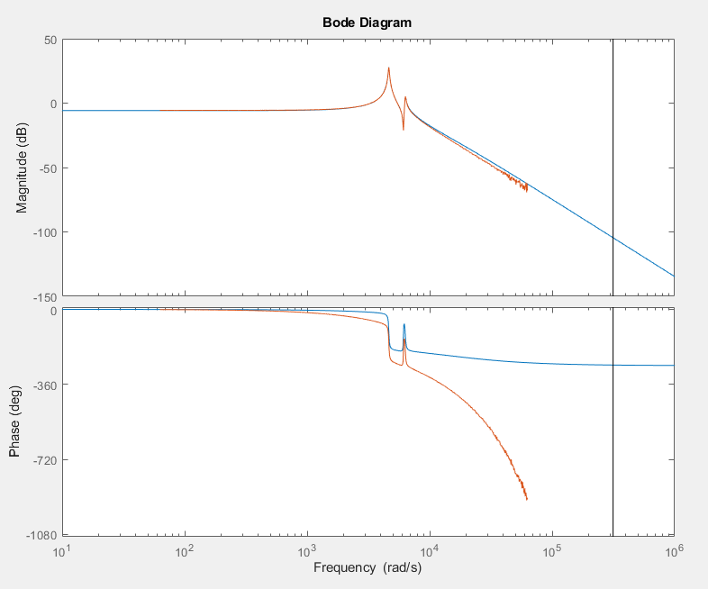
Same thing

With windowing
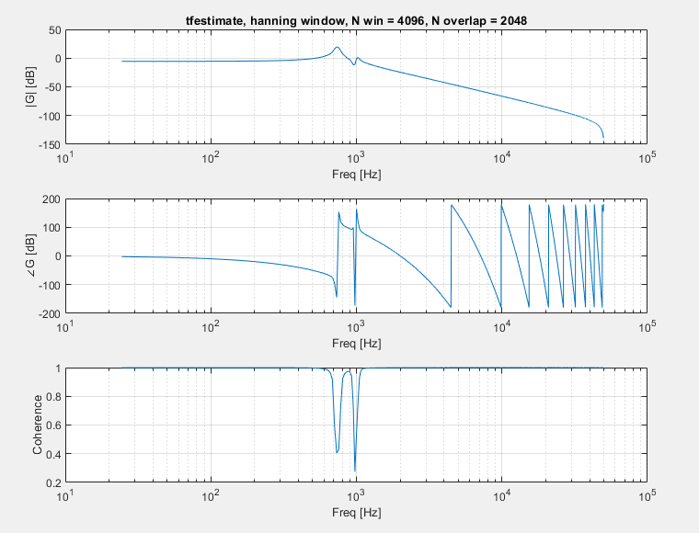
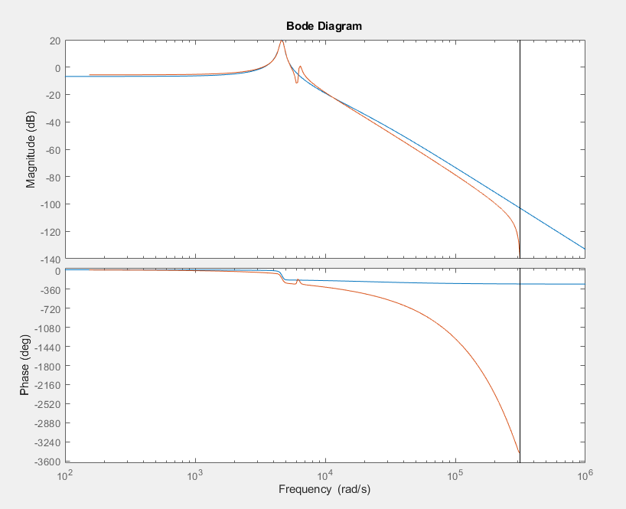
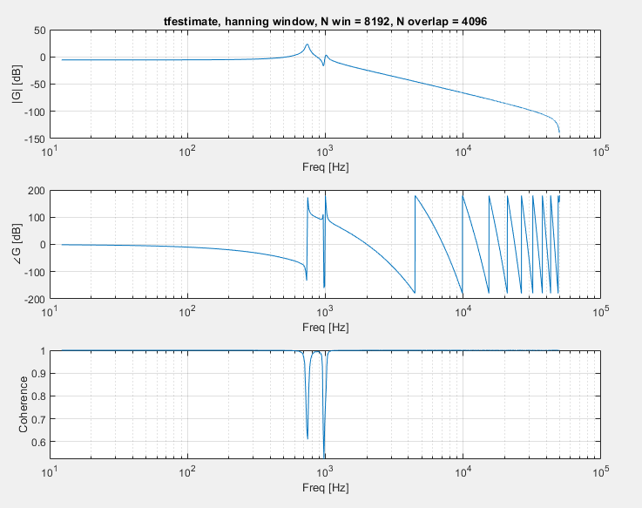
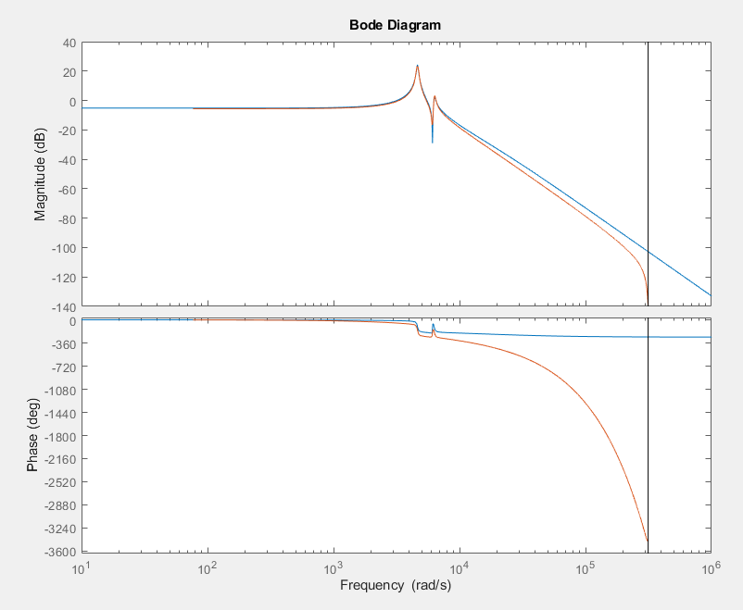
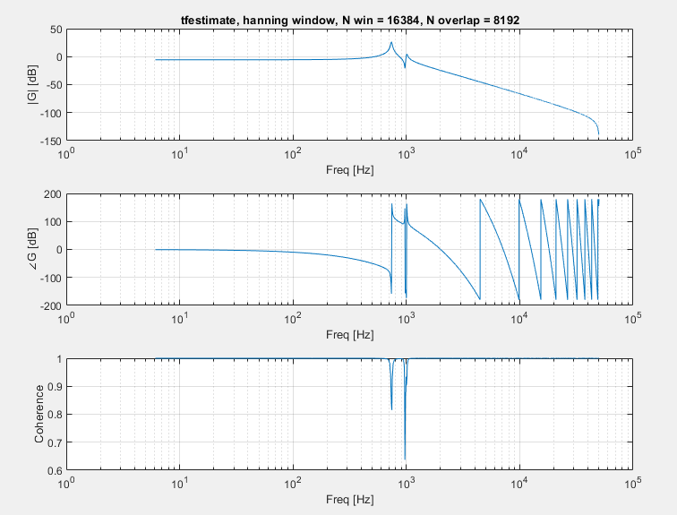
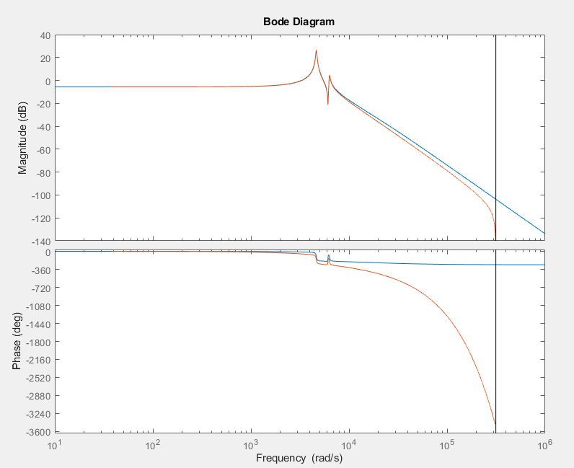
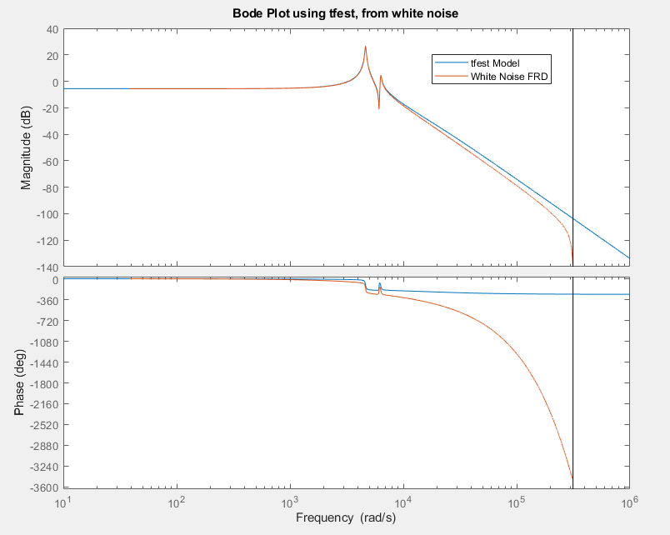

Questions for Jesse
- Amplitude increasing at high freq?
- Taking multiple chirps and then averaging?
- What windowing

Things to do

- Try Jesse’s python settings and seeing if diff results
  - 120s long chirp signal, 10 to 5e3, ts = 30us

